

Functional design

Equinox – Unified Front-End

Sales

**Author:** Celfocus

**Last Update:** 2017-01-03

**Version:** 1.26

Table of Contents

1. Summary 4

2. Business Scenarios & Features 19

How Business Scenarios & Features are structured? 19

Functional Specification 20

BS #1: Subscribe a mobile offer 20

BS #2: Subscribe a fixed or convergent offer 61

BS #3: Buy an equipment 100

BS #4: Buy an accessory 106

BS #5: Buy a top up voucher 111

BS #6: Buyback an equipment 114

BS #7: Subscribe a Retention or Upgrade campaign 116

FEAT #1: Save process 119

FEAT #2: Recover process 122

Screen Specification 126

BS #1: Subscribe a mobile offer 126

BS #2: Subscribe a fixed or convergent offer 198

BS #3: Buy an equipment 208

BS #4: Buy an accessory 208

BS #5: Buy a top up voucher 209

BS #6: Buy back an equipment 209

BS #7: Subscribe a Retention or Upgrade campaign 209

FEAT #1: Save process 209

FEAT #2: Recover process 209

Integration Specification 210

BS #1: Subscribe a mobile offer 210

BS #2: Subscribe a fixed or convergent offer 212

BS #3: Buy an equipment 215

BS #4: Buy an accessory 215

BS #5: Buy a top up voucher 215

BS #6: Buyback an equipment 216

BS #7: Subscribe a Retention or Upgrade campaign 216

FEAT #1: Save process 216

FEAT #2: Recover process 216

3. Security Constraints 218

User Profiling 218

Data Audit 218

4. Reference Data 222

5. Messages 223

Error messages 223

Success messages 226

Warning messages 226

6. Technical Design 229

Introduction 229

Purpose 229

Conventions 229

Structure 229

Technical Overview 230

Description 230

System Interfaces 230

Service Calls 231

Reference Data 246

Users Messages 249

7. Open Items 268

Acronyms and abbreviations 281

Annex 290

Referenced Documents 291

Document Control 293

Required Sign-Offs 294

Revision History 295

# Summary

|  |  |  |  |  |  |  |  |  |  |
| --- | --- | --- | --- | --- | --- | --- | --- | --- | --- |
| Audience | | | | | | | | | |
| CBU | **COP’s** | **MKT** | **EBU** | **CXP** | **FIN** | **FRD** | **ONL** | **SALES** | **IT** |
| ✓ | ✓ |  |  |  |  |  |  | ✓ | ✓ |

|  |
| --- |
| Sales |
| Through the Sales process, the user is able to assist customers on offer activations and product acquisitions. The user can add the following types of offers and products to the basket:   * Mobile offers, that include single and bundle offers, PAYG and Pay on Bill * Fixed and convergent offers, that include single and bundle offers * Mobile equipment * Accessories * Top up vouchers * Buy backs   The Sales process guides the user through a sequential set of steps, which can be available or not depending on the scenario. These are the steps for the most complex scenario:   1. Select Products 2. Shared Equipment 3. Billing profile details 4. Installation details 5. Delivery details 6. Confirmation & Self-Confirm 7. Documentation 8. Payment 9. Interaction |

|  |  |
| --- | --- |
| Business Scenarios and Features | |
| Business Scenarios | **Features** |
| BS #1: Subscribe a mobile offer  BS #2: Subscribe a fixed or convergent offer  BS #3: Buy an equipment  BS #4: Buy an accessory  BS #5: Buy a top up voucher  BS #6: Buyback an equipment  BS #7: Subscribe a Retention or Upgrade campaign | - |

|  |  |  |  |  |  |  |  |  |  |  |  |  |  |  |  |  |  |  |  |  |  |  |  |  |  |  |  |  |  |  |  |  |  |  |
| --- | --- | --- | --- | --- | --- | --- | --- | --- | --- | --- | --- | --- | --- | --- | --- | --- | --- | --- | --- | --- | --- | --- | --- | --- | --- | --- | --- | --- | --- | --- | --- | --- | --- | --- |
| Business Scenarios / Features available per Channel | | | | | | | | | | | | | | | | | | | | | | | | | | | | | | | | | | |
|  | **Customer Facing** | | | | | | | | | **Personal Contact** | | **Distance Contact** | | | | | | | | | | | | | **Self Service** | | | | | | | | | |
| BS / FEAT | Store | Dealer | Sub-Dealer | | Door to door | | Field Service | | | Account  Manager | | **Call Centre** | | | | | | | | Social Network | | Outbound Communications | | | eCustomer Care | | eShopping | | Kiosks | IVR | USSD | SMS | TV | Exposure |
| Customer Support | | Back office | | | Technical Support | | |
| *BS #1* | ✓ | ✓ |  | |  | |  | | |  | | ✓ | |  | | |  | | |  | |  | | |  | |  | |  |  |  |  |  |  |
| *BS #2* | ✓ | ✓ |  | |  | |  | | |  | | ✓ | |  | | |  | | |  | |  | | |  | |  | |  |  |  |  |  |  |
| *BS #3* | ✓ | ✓ |  | |  | |  | | |  | | ✓ | |  | | |  | | |  | |  | | |  | |  | |  |  |  |  |  |  |
| *BS #4* | ✓ | ✓ |  | |  | |  | |  | | ✓ | |  | | |  | | |  | |  | | |  | |  | |  | |  |  |  |  |  |
| *BS #5* | ✓ | ✓ | |  | |  | |  | |  | |  | |  | | |  | | |  | |  | | |  | |  | |  |  |  |  |  |  |
| *BS #6* | ✓ | ✓ | |  | |  | |  | |  | |  | |  | | |  | | |  | |  | | |  | |  | |  |  |  |  |  |  |
| *BS #7* | ✓ | ✓ | |  | |  | |  | |  | | ✓ | | |  | | |  | |  | | |  | |  | |  | |  |  |  |  |  |  |

|  |
| --- |
| Actor(s) involved |
| CSR in Call Centre  Agent in Shops |

|  |
| --- |
| Back-end systems to integrate with |
| AMDD  ANM  ASRM  CherryPoints  Credit Vetting  CRM  DMaaS  ESB  IBM ADM  MCCM  MCCM  OMS  ORSIM  SIRO  VM |

The capture of a BuyBack trough integration with Fonua is pending Commercial Agreement, once is not in scope of UFE Workorder. The BR’s are marked in the RTM as “Non-Complaint”, pending a CR to be raised in order for the process to be delivered.

As comments were made in an older version, they have been extracted from it and answered in an Excel File in the chapter Annex.

|  |  |  |  |  |
| --- | --- | --- | --- | --- |
| Requirements in Scope | | | | |
| REQ ID | **Requirement** | **Sub-Requirement** | **Business Scenario / Feature** | **RTM Final Comments** |
| AQ0009 | A digitial copy of the signed contract will be retained and accessed via a link to be accessed by CSR as required | - | All | - |
| AQ0017 | The system will support eligibility rules per Dealers, Shops and Personal | - | All | 17/7 Paulo - 1st scenario: Both Vodafone Shops where Shop A can sell new Iphone 7 Lauch Campaign and Shop B cannot.  Besides user role/position we have also to consider Shop ID, when calling MEC for a specific campaign  2nd scenario: One Vodafone Shop can sell Samsung Edge, while a Retail/Franchise cannot  We have to consider Shop Type when calling MEC for a specific campaign  In both scenarios the logic must come from MEC when UFE is querying for a specific campaign. We can pass Shop Id or Shop Type to MEC, and it’s it that determines which campaigns are eligible to be sell in that specific shop. |
| AQ0017.01 | It should be possible to restrict products and offers sales to specific Dealers e.g. Iphone 6 only sold in VF stores | The restriction will use the dealer code based on the dealer model to restrict offers | All | Product filters should be restricted by store type. Not impossible to be done, but requires development. 30/7 Paulo - Assuming UFE will be at Dealeres, it will be possible, but is about to MEC to validate elible offers by Store Type or even Agent. |
| AQ0017.02 | It should be possible to restrict products and offers sales to specific Shops e.g. Iphone 6 only sold in VF store Grafton St | The restriction will use the dealer code based on the dealer model to restrict offers | All | Product filters should be restricted by store type. Not impossible to be done, but requires development. 30/7 Paulo - Assuming UFE will be at Dealeres, it will be possible, but is about to MEC to validate elible offers by Store Type or even Agent. |
| AQ0019 | The functionality to identify an existing customers or a new customers will be displayed on to the agent- e.g. give different prices | This logic will be done in MCCM - to be confirmed | All | - |
| AQ0022 | The solution should allow the agents to filter the suggested offers based on category (Fix, Wireless, bundles, etc.) | - | All | - |
| AQ0037 | All bill pay customers should receive a contract. Either printed in shop or sent by mail in hard copy | - | All | - |
| AQ0052 | There should be 2 types of credit vetting: initial - with customer details, and full with the basket info. For full credit vetting the proposition and device info will be sent to Transact including the points/value associated with the handset in the MEC | - | All | Credit vetting services must have performance |
| AQ0053 | Delivery address will include an imdication on whether it is the customer's home or office address | - | - | Dependant on address classification of the backend system |
| AQ0190.01 | The system should allow the user/customer to enter a coupon ID and based on the coupon id the relevant discount should be applied to the order | - | All | - |
| AQ0201 – CR020 | Customers can request printed top up vouchers in VF stores and applicable retail outlets | - | All | 01/14/2016 Paulo: In the purchase of a Voucher, UFE will request to VM the Voucher ID/PIN/Exp Date and when sending the Order Payment to POS, will send these details so that POS can print them in the payment receipt. |
| AQ0202 | Discount coupons should be redeemable on purchases via all channels | - | All | - |
| AQ0207 | When adding connections to a customer who connected <3 months ago the system will treat these connections as new connections for credit vetting | - | All | - |
| AQ0257 | Credit vetting is a mandatory for any order, purchase, upgrade or downgrade that creates an line item on the bill; including recurring charge and once off charge, add-on, hardware or accessory. | - | All | - |
| AQ0269 | The system should provide ability to the CSR to schedule/reschedule/cancel technician visit if the resolution of problem reported by customer needs a technician.  CSR should be able to view the technician appointment details on the Case screen for the reported problem. | - | All | - |
| AQ0286 – CR112 | It will be possible to complete an order in a retail store for delivery to home address | - | All | - |
| AQ0289 | UFE requirement - for retail store purchases - it must be possible to scan the item directly into the sales order flow without changing screens. The solution must not be limited to scanning from Oracle POS, it must be possible to scan devices into CRM at accreds who do not have POS | UFE will need to support scanning in addition to that possible in POS | All | Clarify how Oracle POS interacts in UFE if similar processes exist in both systems |
| AQ0290 | It must be possible for accreditated agents who do not have ePOS to scan transactions into CRM as part of order flow and then update Oracle SIM | UFE will have the ability to scan and store scanned bar code information for items purchased in the order flow.  Assumption: this BR assumes that dealers and accredited agents will not have OR-POS | All | Clarify how Oracle POS interacts in UFE if similar processes exist in both systems  12/08 UFE will have the ability to scan and store scanned bar code information for items purchased in the order flow. |
| AQ0299 | It will be possible to complete an order in a retail store and receive part of the order by delivery to home address i.e. part of a multi-item order isnt in stock such TV box, modem etc. | - | All | - |
| AQ0308 | Managers in-store can give a discount to VF employees | - | All | 17/7 Paulo - there will be the ability to give discounts according to User Profile |
| AQ0308.01 | The discount can be applied on accessories only | - | All | - |
| AQ0308.02 | The discount will have have a maximum discount value of 20% | It should be possible for high level admin to configure discount %'s | All | - |
| AQ0308.03 | Discounts cannot be applied on purchases below a configurable threshold i.e. the systerm should not give a discount on any transaction below 15e | - | All | - |
| AQ0512 | The requesting channel will send the customer account id and the subscriber id in eligibility requests to MCCM. | - | All | 02/09 Paulo - When calling MCCM to ask for relevnt campai+gns, UFE will send these parameters. |
| AQ0520 | In the sales flow there will be a prompt to the user to ask them if the customer wishes to avail of a buy back | - | All | - |
| AQ0561 | It will be possible to deliver an order (including pre and back orders) to home from all channels | - | All | 29/09 Paulo - In the Sales process UFE will have the ability to choose the delivery method "Delivery at Home" for the all order within the Basket. |
| AQ0564 – CR042 | The solution will ensure that customers are informed of stock thresholds and options as part of an order entry e.g. where items are not available the solution should inform the customer if they can place a pre order, back order or choose to collect in store / at a different store | - | All | 29/09 Paulo- UFE is not the Owner of Stock Managemnt. This should be addressed to ORSIM (IBM). UFE will not manage thos notifications.  30/09 New RTM update  13710 Paulo: UFE will alert User according to the notifications received from ORSIM when trying to add a product into the basket |
| AQ0623 – CR044 | ORPOS extension to franchisee stores | - | All | - |
| AQ0677 | All Fixed Ancillary services offered by Vodafone via Eircom will be modelled in the MEC and agents or customers will be able to switch them on and off by adding or removing the relevant product | Part of negotiate product configuration | All | 02/10 Paulo: UFE will replicate in Product Catalogue the rules defined in MEC  23/10 Paulo: If Ancilliary servcices are moduled as products in MEC, it will be possible for an Agent do swicth On/Off trough UFE. |
| AQ0678 | The following VOIP ancillary services will be modelled in the MEC and agents or customers will be able to switch them on and off by adding or removing the relevant product:  1. Twinning of VOIP number with another number  2. Second Line/Channel | The agent or customer will have the ability to enter the number to twin with | All | 02/10 Paulo: UFE will replicate in Product Catalogue the rules defined in MEC  21/10 Paulo: Trough products moduled in MEC, it will possible for the Agent in UFE to activate/deactivate services |
| AQ0681 | The solution will automatically select the correct equipment (modem, STB) for the order based on the product the customer is purchasing and the underlying access for that product | Front should call BSS API to retriever the correct modem , STB | All | 23/09 Paulo - These rules should be defined in MEC. UFE will only behave according to those rules |
| AQ0682 | The solution should display the correct fields and options when a port in is being processed as part of an order i.e. for a mobile port in the customer/agent should be asked to select their network operator from a list of mobile operators and for a fixed port in the customer/agent should be asked to select their current provider from a list of fixed providers | - | All | 29/09 Paulo: Fields are being captured within BPT CRM sessions |
| AQ0698 – CR042 | The Ordering channel will have the ability to switch on and off the Click and Collection option per stock item regardless of stock availability | - | All | 29/09 Paulo: UFE will only be responsible to display the Click&Collect Orders for that specific store. Within Amdocs system there will be a service that will allow UFE to push all Open Orders for a specific store. On-Off capability will be in scope of Ordering System, not in UFE  12/24 Paulo - This requirements shoud be address to Portal, whici is the entry point of Click and Collect. UFE is only a delivery point, of orders already payd and submitted by Portal  12/29 Paulo: In call centre, Agents will be able to submit an order and seklect to be delivered at a specific store, ans this will be manage as a Click&Collect. Changed to Compliant. |
| AQ0780.1 | If customer is obtaining equipment and the option to pay on bill is available to them then the system should be configurable to give the option to:-1. Pay immediately2. Generate a separate immediate invoice for the hardware3. Put on next bill. | It will be clear for the CSR or sales agent if a customer must pay immediately or whether they can defer payment to a separate invoice or on next bill. | All | - |
| AQ0804 | The ability to scan the customer documentation as part of the order flow process – should be part of contracting flow with focus on design so that Agent error is minimised to max. | The scanning should automatically populate and send relevant searchable field info (ie Customer ID, Order ID, Dealer Code, Order Type) with the documentation. Agents should not have to enter info to identify/link the scanned information to the customer id and order id Within Documentum the ability to search so that orders can be identified and documentation that was submitted viewed for compliancy based on specific search items. Ability to see orders that do not have contract/customer id documentation attached Data protection and archiving has to comply with VF requirements (ie in the case of change of mind customers we need to agree and detail what should happen to records stored in Documentum – may need to delete them once change of mind is processed TBC with Legal) | All | 05/3172016 Paulo: UFE OOTB does not support such requirement. There is no direct connection between UFE and any Scanner, and OOTB UFE doesn’t have a process to scan documents and automatically fill the relevant information of the document in the workflow. |
| AQ0899 | It will be possible for an agent to log a BuyBack/Trade-In with Fonua via UFE | - | All | 20151020 Paulo: This will be available trough iFrame. So far no webservices were identified in Equinox to support this automatically.  29/10 Paulo: CF already replayed confirming that UFE is COMPLAINT with this requirement. Whatelse is required here? |
| AQ0204 | For known customers who do not have a registered payment card, there will be a tick box on payment screens that allows them to save their card for future use | - | All | - |
| AQ0391 | It will be possible for an agent to flag a customer as age verified when the customer presents with proof of age in store | - | All | - |
| AQ1248 | The solution will support offering additional benefit at a product level whereby the additional benefit can be realised on the Fixed or Mobile Subscription in a 4P or 3P + P bundle | The system must restrict the additional benefit being added to both subcriptions | All | 19/11 Paulo: Will these Add-Ons being moduled as products in MEC?  12/15 Paulo: According to PSI these products will be built in MEC and provisioned via Ordering. Changed to Compliant. |
| AQ1485 | The solution will have the functionality for a Security code(Port in Security Number) to be sent through SMS when an order is placed to verify the customer is who they say they are. | - | All | - |
| AQ1486 | The solution will have the functionality for a Security code(Port in Security Number) to be captured and validated to complete order and allow port-in process to continue. | - | All | - |
| AQ1582 | No gift cards/cheques can be used in the verification process for new connections Credit checking req | do not take prepaid/gift/Store cards or One4all / cheques in any contractual sign up flows, as part of the signing up of a customer involves a credit check | All | 12/15 Paulo: In Shops, payments and pay means will be managed by ePOS, not by UFE.  12/24 Paulo: Pay Means are not habdled by UFE. UFE will pass payment order to POS/PSP and they will manage the paymens.  12/28 Paulo: UFE doesn't handle Gift Cards. Payments will be managed in Shop by POS/PSP. Definition of Payments in UFE is exclusivley in the definition of Recurring Payment, not in a standalone payment.  12/29 Paulo: Once the execution of Payment in store is done immediatly IN POS, and it is at this moment, that the Customer will present his paymeans which may include a Gift Card, how will UFE enforce a Rule over this Pay Mean when this is managed outside UFE?  Regarding the definition of a Recurring Payment at the BAR level, it’s the only process where UFE can enforce eligible Pay Means which are already defined to be Debit Card, Credit Card or SEPA.  As we explained already regarding UFE/POS integration, UFE will pass the payment order to POS with the total amount, and POS will execute the payment. It is POS/PSP that will have to manage Rules regarding the elegible pay means.  12/30 Paulo: The discussion has been re-open to TDA and IBM, raising the need to review the HLIA_UFE_POS SIM_Integration_CR_nnn_for TDA.v0.6.pptx", once integration btween UFE and POS as to be reassessed. Email sent to all parties on the 12/30 with the subject "Giftcards - how is it handled" |
| AQ1721 | The solution must NOT accept any Prepaid Gift card as payment for devices, in any contractual sign up flow, through the following business channels  Shop  - New Connections  - Port Ins  - RTG Migrations  Portal  - New Connections  - Port Ins  - RTG Migrations | do not take prepaid/gift/Store cards or One4all / cheques in any contractual sign up flows, as part of the signing up of a customer involves a credit check | All | 12/18 Paulo: UFE doesn't manage Pay Means. Once the basket is transfer to POS/PSP they will hadled the several Pay Means, including Gift Cards.  12/28 Paulo: UFE doesn't handle Gift Cards. Payments will be managed in Shop by POS/PSP. Definition of Payments in UFE is exclusivley in the definition of Recurring Payment, not in a standalone payment.  12/29 Paulo: Once the execution of Payment in store is done immediatly IN POS, and it is at this moment, that the Customer will present his paymeans which may include a Gift Card, how will UFE enforce a Rule over this Pay Mean when this is managed outside UFE?  Regarding the definition of a Recurring Payment at the BAR level, it’s the only process where UFE can enforce eligible Pay Means which are already defined to be Debit Card, Credit Card or SEPA.  As we explained already regarding UFE/POS integration, UFE will pass the payment order to POS with the total amount, and POS will execute the payment. It is POS/PSP that will have to manage Rules regarding the elegible pay means. |
| CR029 | UFE and POS/SIM Integration | - | All | - |
| CR107 | Zero value authorisation | - | All | - |

|  |  |  |
| --- | --- | --- |
| Assumptions | | |
| Assumption | **Reason** | **Impact** |
| The following elements are products defined in MEC:   * Coupon, which has an attribute with the available values. * Buy back * Advanced payment (for Credit Vetting support) * Deposit (for Credit Vetting support) | - | - |
| Relevant products in MEC have the information if they need or not the technician intervention for the installation. | - | - |
| Products in MEC have the information if they can be paid on the next bill or not. | - | - |

|  |  |  |  |
| --- | --- | --- | --- |
| Out of Scope Considerations | | | |
| Consideration | **Reason** | **Impact** | **Req. ID** |
| This HLD does not cover the following processes:   * Click & Collect, described in HLD Click and Collect [12] * Pre order, dependent of CR042 * Back order, dependent of CR042 | - | - | - |
| Scheduling the installation visit within the provide flow in the Sales process is in scope. However installation technical visit within the fault flow is out of scope. | - | - | - |

# Business Scenarios & Features

## How Business Scenarios & Features are structured?

To make it easier to translate client's business requirements into business solutions, we specify customer journeys and business processes into Business scenarios. They represent real life situations, in which end customers and telco employees experience a flow of activities in order to reach a certain goal. We use them to specify the solution in scope, considering real life events and the “happy path” (e.g. New customer activate new line).

Each business scenario is divided in phases, in order to identify the major moments of the experience detailed. Whenever applicable, a Phase can be reused in different business scenarios.

In addition, whenever applicable in the Specify stage, we list every feature that is going to be implemented. We use features to specific system capabilities. Features are out-of-the-box and customizable by configuration. They may or may not have a flow of activities and can usually be used in different business scenarios (e.g. of a feature: invoice printing).

Considering this context, the specification, is structured in the following way: 

Reading this document should be done through the navigation pane (click View - check Navigation Pane). It will ease out the navigation through the document.

## Functional Specification

### BS #1: Subscribe a mobile offer

|  |  |
| --- | --- |
| Business Scenario Specification | |
| Description | Through this business scenario, the user is able to assist the customer on a mobile offer subscription. In this scenario, UFE covers mobile single offers and bundle offers only with mobile products under it. |
| Entry Points | * “Sales” menu option * “Campaigns” process, when accepting a campaign * “Product catalogue” process, when adding a mobile offer to the basket |
| Pre-conditions | - |
| Post-conditions | The chosen mobile offer is subscribed to the customer. |

#### Phase I – Type of offer selection

##### Activity 1 » Add mobile offer to the basket

|  |  |  |
| --- | --- | --- |
| Activity Specification | | |
| Actor(s) | CSR in Call Centre  Agent in Shop | |
| System | UFE | |
| Screen Name | Select type of offer step | |
| Description | The user enters on the Sales process, chooses to add a PAYG or Pay on Bill mobile offer to the basket. The delivery method will be chosen automatically according to the flow the user makes. | |
| Automations | **Business Validations & other Automations** | **Messages (Error & Warnings)** |
| 1a. Get available offers  For **existing customers**,UFE will call a service from OMS to get the eligible products list, in case of a replace offer scenario. If an existing customer, subscribe a new service, in addition to an existing one, while not modifying this existing service, UFE **will not** call the get eligible products list.  With the response from this service, UFE filters with UFE_Catalogue the available mobile single and bundle offers, as well as PAYG and Pay on Bill for activations, considering:   * user role * billing type of the contextualized billing customer (if any) * Channel Type * Dealer ID / Shop ID * Dealer Type * Is anonymous (in case of identified customer, this flag is Y. Some offers will only be shown if customer is identified)   For a Pay on Bill offer, UFE will only get the available offers after having the customer details (done in Activity 2 for **new customers**).  For **new customers**, UFE will not call the service (get eligible products list) from OMS and will only call UFE Catalogue.  Offers are previously loaded from MEC to UFE through the UFE Catalogue component (for full details on this component, please see [2]). | If there are no offers, UFE shows the warning message WM_SAL_1. |
| 1b. Collections  If a Customer is in collections, UFE will not open the process and will display the warning message EM_SAL_55. | - |
| 1c. Loyalty Points  The user must have a subscription in context in order to UFE to present the pricing options with loyalty points. With other contexts, UFE will not present the LPs pricing options.  UFE will validate if the subscription in context has loyalty points active, only calling once the loyalty points interface to get the current LPs available. In affirmative case, when adding an equipment with loyalty points to the basket, UFE will validate if there are enough points to add the selected item. The "deduction" will be made internally without calling any interface, in order to not allow the user to add equipment’s that overcome the current available LPs.  If there are enough points, UFE will deduce from the total of points of the customer and once there are not enough points, UFE will warn the user with the message WM_SAL_15.  **Note:** Loyalty points are exclusive for PAYG mobile offer, top up vouchers, accessories and equipment’s or BillPay for accessories and equipment’s purchase. | If any error occurs trying to get the loyalty points, UFE warns the user with the error message EM_SAL_65 and the business scenario ends. |
| 1d. Upgrade or new offer  When there is a contextualized billing customer, UFE will ask the user if the Customer wishes to upgrade an existing offer or subscribe a new one. **Only active subscriptions will be eligible for selection, meaning suspended or terminated services will not appear.**  In the upgrade case, the user must select which one of the single product offers is to be considered. Only one upgrade may be made per basket. | - |
| 1e. Get Pending Orders  With a customer contextualized, UFE will call a service from OMS to see if there are any pending orders.  For non-PR (Provide) Oas (Order Actions), OMS will expose the API – isValidAction.  This API will take as input the following,   * Sales Channel of calling application * APID of the product * Action type to be initiated (CH, SU, CE, RS)   The output will be   * Valid – The process will continue. * Invalid - UFE will show the error message EM_SAL_60   **Note: This step is pending of commercially agreement.** | - |
| 1f. Buyback information  The warning message WM_SAL_13 will be presented to the user to inform them if the customer wishes to make a buyback. | - |

#### Phase II – Create Customer and Billing Profile

##### Alternate Activity 2 » Enter customer details

|  |  |  |
| --- | --- | --- |
| Activity Specification | | |
| Actor(s) | CSR in Call Centre  Agent in Shop | |
| System | UFE | |
| Screen Name | New Customer details step | |
| Description | This activity is only performed when the basket has, any type of pay on bill offer. If the basket has only tangible products (mobile equipment, accessories and top up vouchers),this activity is **skipped.**  In case of a PAYG offer, UFE creates a dummy customer and will associate the PAYG subscription to the contact itself. In this scenario, this activity will be **skipped**.  For existing customer, meaning that there is a contextualized billing customer, this step will be **skipped**. If the customer wants to update the details, the user needs to go to the Customer Information process (for full details on this process, please see [3]).  For new customers, meaning that there is no contextualized billing customer, the user needs to provide the relevant customer details.  For further details on this Activity, please refer to *FEAT #1: Customer details* on [3]. | |
| Automations | **Business Validations & other Automations** | **Messages (Error & Warnings)** |
| 2a. VIP Customers  The user may select in this step if the customer is VIP. | - |

##### Alternate Activity 3 » Enter billing profile details

|  |  |  |
| --- | --- | --- |
| Activity Specification | | |
| Actor(s) | CSR in Call Centre  Agent in Shop | |
| System | UFE | |
| Screen Name | New Billing profile details for new Customer step | |
| Description | This activity is only performed when the basket has, any type of pay on bill offer. If the basket has only tangible products (mobile equipment, accessories and top up vouchers),this activity is **skipped.**  On this activity, the user is able to define the billing profile (financial account and billing arrangement) on which the subscriptions on the basket will be on which the subscriptions on the basket will be charged.  For new customer, meaning that there is no contextualized billing customer, the user needs to create a new billing profile, providing the relevant financial account and billing arrangement details, namely:   * Contact. By default, UFE chooses the billing customer’s primary contact but the user is able to search for another existing contact or create a new one. * Address. By default, UFE chooses the billing customer’s address, but the user is able to create a new one. * Pay Means.   After all information is confirmed/provided, the user moves on to the basket configuration step. UFE will automatically contextualize the new billing customer ID.  In case of a PAYG subscription, this activity will **not be visible**. For further details on this Activity, please refer to *FEAT #2: Billing details* on [3]. | |
| Automations | **Business Validations & other Automations** | **Messages (Error & Warnings)** |
| 3a. Direct Debit Mandatory  The pay by direct debit will be mandatory in the scenarios of an offer (Mobile or Fixed).  Direct debit may be by IBAN, with Credit Card or Debit Card. | - |
| 3b. Create Customer and Billing profile  UFE creates the new billing profile under the new billing customer on CRM, associating or creating the corresponding contact.  When successful, UFE shows the success message SM_SAL_2.  In case of a PAYG, UFE will create a dummy customer.  A topic will be added to the interaction that is already open. For more information, about interaction, please refer the HLD Interactions on [6]. | If any error occurred on the customer/billing profile creation, UFE warns the user with the error message EM_SAL_15 and the business scenario ends. |

#### Phase III – Basket Configuration

##### Activity 4 » Choose offer

|  |  |  |
| --- | --- | --- |
| Activity Specification | | |
| Actor(s) | CSR in Call Centre  Agent in Shop | |
| System | UFE | |
| Screen Name | Offer Component | |
| Description | The user chooses one of the available mobile offers.  For bundle offers, the Activities between 5 and 11 are performed once per mobile product under it. | |
| Automations | **Business Validations & other Automations** | **Messages (Error & Warnings)** |
| 4a. Decompose offer  If the chosen offer is a bundle offer, first UFE decomposes it into its products (in this business scenario, UFE covers bundles with multiple mobile products). Then, for each product, UFE decomposes it into its components, billing offers and attributes.  Otherwise, when the chosen offer is a single offer, UFE just decomposes it into its components, billing offers and attributes.  All components (configured on Reference Data UFE_RD148) are displayed the same way, with the exception of the following that have a special treatment on the screen:   * Plan * Commitment * SIM * Device * Insurance   Please see the Screen Specification section for full detail on the components display information.  **Note:** Offer’s detail is previously loaded from MEC to UFE through the UFE Catalogue component (for full details on this component, please see [2]). Details like “Shipping Method” and “Delivery Method” will be under the component of “Device” and set as described in activity 10f. | - |
| 4b. Get available MSISDN  For each mobile product in the offer, UFE gets one available MSISDN from the SRM system.  In case of portability, this will be disabled and UFE will fill in with a temporary phone number. | If any error occurs trying to get the MSISDN, UFE warns the user with the error message EM_SAL_1. |
| 4c. Reserve MSISDN  For each mobile product in the offer, and in order to MSISDN not be used by another process/user, UFE reserves the MSISDN obtained on the previous step on the SRM system. | If the MSISDN is not available when trying to reserve it, the business scenario goes back to the step 4b.  In case of any other error, UFE warns the user with the error message EM_SAL_2. |
| 4d. No gift cards/cheques can be used in the verification process for new connections  When adding a New Line, Mobile or Fixed, it is not possible to receive payments by Cash or by Gift Cards. | - |
| 4e. Selecting/Changing another offer  If the user selects or change another offer, UFE will cancel all reserved content in the basket.  If any product was previously reserved, UFE will call a service to cancel all reservations made in the affected offer. | If any error occurs while cancelling the reservations, UFE will show the error message EM_SAL_54 and the user must retry selecting/changing the offer. |

##### Activity 5 » Choose Plan billing offer

|  |  |  |
| --- | --- | --- |
| Activity Specification | | |
| Actor(s) | CSR in Call Centre  Agent in Shop | |
| System | UFE | |
| Screen Name | Equipment’s Component | |
| Description | The user chooses the billing offer under the Plan component. If the billing offer has a commitment duration different from 0, and the user role allows it, the user is able to change the end date for a more early date. This is controlled by UFE, without any dependencies. | |
| Automations | **Business Validations & other Automations** | **Messages (Error & Warnings)** |
| - | - |

##### Alternative Activity 6 » Choose another MSISDN

|  |  |  |
| --- | --- | --- |
| Activity Specification | | |
| Actor(s) | CSR in Call Centre  Agent in Shop | |
| System | UFE | |
| Screen Name | Equipment’s Component | |
| Description | UFE shows a list of available MSISDN, from where the user can choose one. | |
| Automations | **Business Validations & other Automations** | **Messages (Error & Warnings)** |
| 6a. Get available MSISDN  UFE gets a list of available MSISDN from SRM. The user may refresh this list manually with the available refresh button. | If any error occurs trying to get the MSISDN, UFE warns the user with the error message EM_SAL_1. |
| 6b. Search MSISDN  UFE will load 10 MSISDN´s for each refresh, and may suggest one of them to the Customer. In this case, UFE will perform a **reserve** against SRM for the chosen number.  If the user decides to change the reserved, UFE will perform a **release** against SRM. | If any error occurs trying to get the MSISDN, UFE warns the user with the error message EM_SAL_1.  If UFE receives the information that the MSISDN exists but it is not available, UFE shows the error message EM_SAL_3.  If any error occurs trying to release the reserved MSISDN, UFE warns the user with the error message EM_SAL_56. |

##### Activity 7 » Provide SIM card

|  |  |  |
| --- | --- | --- |
| Activity Specification | | |
| Actor(s) | CSR in Call Centre  Agent in Shop | |
| System | UFE | |
| Screen Name | Equipment’s Component | |
| Description | When the business scenario is running at a shop, the user associates a SIM card to the offer, entering its number.  When the business scenario is running at a Call Centre, user only selects the SIM card type, since the SIM card association is done only at order handling time. | |
| Automations | **Business Validations & other Automations** | **Messages (Error & Warnings)** |
| 7a. Get SIM card details  Only applicable when the process is running at a shop.  In order to check the SIM card status, UFE gets the SIM card details from SRM, by scanning a SIM pack and sending the SIM card number.  At the end of the process, when the final order is submitted, these obtained SIM card details are used to configure the SIM component under the mobile offer.  **Note:** In case of a retail shop, where the inventory is not passed by ORSIM, UFE will not get the details from ORSIM. In this case, the SIM card number will be captured manually by the Agent within the relevant attribute and passed to BSS. There will be no interaction with ORSIM. | If an error occurs trying to get the SIM card details, UFE warns the user with the error message EM_SAL_4.  If the SIM card is not available, UFE warns the user with the error message EM_SAL_5. |
| 7b. Reserve SIM card  Only applicable when the process is running at a shop.  Once the SIM card is validated as available, UFE reserves it on SRM to be allocated to the new mobile subscription.  **Note:** In case of a retail shop, where the inventory is not passed by ORSIM, UFE will not reserve it in ORSIM. In this case, the SIM card number will be captured manually by the Agent within the relevant attribute and passed to BSS. There will be no interaction with ORSIM. | If an error occur trying to reserve the SIM card number, UFE warns the user with the error message EM_SAL_6. |
| 7c. Cancel SIM card reservation  Only applicable when the process is running at a shop.  If the user changes the SIM card number by scanning a different pack (step 7a), UFE cancels the previous SIM card reservation on SRM and the business scenario goes back to step 7a. | If an error occur trying to cancel the reservation on the previous SIM card, UFE warns the user with the warning message WM_SAL_2 but the business scenario does not end.  In the scenario where the number was not successfully **released,** will not be cleared off and new number will not be reserved. |

##### Alternative Activity 8 » Choose portability

|  |  |  |
| --- | --- | --- |
| Activity Specification | | |
| Actor(s) | CSR in Call Centre  Agent in Shop | |
| System | UFE | |
| Screen Name | Equipment’s Component | |
| Description | The user chooses to port in the customer mobile phone number, providing the requested data (corresponding to Number Portability component’s attributes).  Note 1: this activity is only available if the chosen offer has the Number Portability component under it.  Note 2: Offer’s structure, including Number Portability’s attributes, is previously loaded from MEC to UFE through the UFE Catalogue component (for full details on this component, please see [2]). | |
| Automations | **Business Validations & other Automations** | **Messages (Error & Warnings)** |
| 8a. Validate port-in number  Through the check port contact from ADM, UFE will validate to which operator the number belongs and will populate the fields accordingly. | If the service returns the information that the port-in number is already a VFIE number, UFE warns the user with the error message EM_SAL_7 and the user must to provide another port-in number.  If any other error occurs trying to validate the port-in number, UFE warns the user with the error message EM_SAL_8. |
| 8b. Generate port-in code  Once the user presses the Send SMS button in the portability component, UFE will generate a random code of 4 digits and will call a service from ANM to send the code via SMS to the Customer. This code will serve the purpose to verify that the customer requesting the port, has control of the SIM to which the MSISDN is currently assigned.  UFE will warn the user with the message WM_SAL_14.  Once the Customer receives the SMS, the agent must insert it in the respective port-in code area to be validated.  **Note: This step is pending of commercially agreement.** | If the SMS sending fails, UFE will warn the user with the error message EM_SAL_35 and the user can retry it again.  If the code is not correct, UFE will show the error message EM_SAL_62.  If the portability component is enabled and the code has not been inserted, UFE will show the error message EM_SAL_63 |

##### Activity 9 » Configure offer components

|  |  |  |
| --- | --- | --- |
| Activity Specification | | |
| Actor(s) | CSR in Call Centre  Agent in Shop | |
| System | UFE | |
| Screen Name | Component management confirmation | |
| Description | The user configures all eligible components under the chosen offer, covering:   * Component activation, only for optional components. By optional components, we mean that the user will only be able to activate the components under an offer that aren´t already automatically active by being mandatories. * Required and visible attributes * Required and selectable eligible billing offers   Note: Offer’s structure is previously loaded from MEC to UFE through the UFE Catalogue component (for full details on this component, please see [2]). | |
| Automations | **Business Validations & other Automations** | **Messages (Error & Warnings)** |
| 9a. Validate offer add-on management  When adding/removing an add-on, UFE via UFE Catalogue will validate if the change is aligned with the product structure.  If it is possible but has impact in another component or add-on, with the response from UFE Catalogue, UFE will be prepared to ask the user for confirmation of the action (the affected component or add-on will be added/removed).  If this management is not possible, UFE will warn the user with the warning message WM_SAL_7 and it won´t be added/removed.  All this logic is based on information that we receive from MEC, namely:   * Component Cardinalities - During catalogue importation process UFE Catalogue will analyse the relationships between components and extract two different indicators (Min, Max).   + With these information we can infer some (not all) component dependencies. * Inclusion Indicator - During catalogue import process adapter component will extract all relations between Billing Offers and their components, in Product Offers" xml file. For each element there is an "inclusion" flag that indicates if Billing Offer is optional, default or Mandatory. In case it is mandatory adaptor will infer a compatibility rule   Finally, UFE invokes SalesQuote API and OMS will apply all required validations. (OMS is the system responsible for OrderValidation), as illustrated in the annex “Gowing Front & Gowing Core Integration”. | - |

##### Alternative Activity 10 » Associate an equipment

|  |  |  |
| --- | --- | --- |
| Activity Specification | | |
| Actor(s) | CSR in Call Centre  Agent in Shop | |
| System | UFE | |
| Screen Name | Mobile Equipment’s Component & Check Stock and Delivery method | |
| Description | The user chooses to associate a mobile equipment to the offer.  When the process is running at a shop, the user just needs to scan the equipment barcode.  When the process is running at a call centre, the user searches for the equipment and can only associate it to the offer when there is available stock.  When scanning the barcode in the basket, we are doing the pre-reserve.  Note: this activity is only available if the chosen offer has the Device component under it. | |
| Automations | **Business Validations & other Automations** | **Messages (Error & Warnings)** |
| 10a. Filter products  UFE will show the equipment based on the eligibility from “TBFILTER_OFFER_BY_CRITERIA”.  The price will be based on the device price rate table (Physical GRT “Device OC Rate”)  **Note:** Products are previously loaded from MEC to UFE side through the UFE Catalogue component (for full details on this component, please see [2]). | If there are no products, UFE shows the warning message WM_SAL_8. |
| 10b. Get stock  For each returned product on the previous search, UFE gets the corresponding stock from ORSIM. Equipment details including all relevant information for Device component configuration will come from UFE Catalogue.  When the user selects a store, UFE will display the currently available stock of that store. | If some product is not available on the selected store, UFE will not show that product on the available offers.  If any error occurs trying to check the available stock, UFE warns the user with the error message EM_SAL_32. |
| 10c. Get equipment details  Only applicable when the process is running at a shop.  UFE gets the equipment details including all relevant information for configuration from UFE Catalogue in order to be sent to the POS on a later stage.  Each time the user selects a different **colour** of an equipment, UFE will get from UFE Catalogue the corresponding product associated to the chosen colour.  **Note:** Products are previously loaded from MEC to UFE side through the UFE Catalogue component (for full details on this component, please see [2]). | If any error occurs, UFE warns the user with the error message EM_SAL_10.  If the corresponding equipment is not found in the catalogue, UFE warns the user with the error message EM_SAL_30 and the process cannot continue. |
| 10d. Reminder regarding buyback  UFE will remind the user to inform the customer regarding the buyback campaign when purchasing a mobile equipment. | - |
| 10e. Equipment price  The price conditions will be based on the device price rate table (Physical GRT “Device OC Rate”). Each time the user selects a different **colour** of an equipment, UFE will get from UFE Catalogue the corresponding product associated to the chosen colour with the corresponding price conditions..  When associating the chosen equipment to the offer, the price of the equipment may be checked in the “Show Summary” – Request Quotation Component. More info about this component can be found in Activity 17 – Request basket quotation.  **Note:** Products are previously loaded from MEC to UFE side through the UFE Catalogue component (for full details on this component, please see [2]). | If the price list service returns an error, UFE warns the user with the error message EM_SAL_47 and the equipment will not be associated. |
| 10f. Delivery method  There will be three possible flows:   * To Go * Home Delivery * Store Delivery   In the flow “To Go”, the Agent only needs to scan the reference from the products of the store and UFE will set the delivery method to **Delivered in Hand** under the device component.  In the flow “Home Delivery”, the user will need to select the desired catalogue (e.g Equipment’s). Once chosen, a search as you type field will appear and the user may search the product. With the selected product, the user needs to select the Online stock and reserves it, adding it to the basket. The user must then set the delivery method to **Shipping** or **Courier**. In this flow, the shipping method will also be captured.  In the latest, the user will need to select the desired catalogue (e.g Equipment’s). Once chosen, a search as you type field will appear and the user may search the product. With the selected product, a search as you type field will appear for the user to select a store to be delivered. For each “space” or “enter”, UFE will show the stores address that have similarities with the one provided.  In call centre, the flow “To Go” won´t be available and the delivery place will be by default for Home (address of the customer in BSS), but the CSR will be able to change it during the product reservation.  UFE will retrieve the stock of that product for that store and reserves it, adding it to the basket and also setting the delivery method to **Pick Up in Store**. If the user adds other equipment’s, UFE will lock the store search field and all equipment’s will be delivered in the same store. | If any error occurs trying to get the available stores, UFE warns the user with the error message EM_SAL_31.  If the user tries to add an equipment by reference scanning, when one is already in the basket to be picked up in another store or to be delivered at home, UFE warns the user with the error message EM_SAL_37.  If the user tries to add an equipment to be by picked up in another store or to be delivered at home, when one is already in the basket by reference scanning, UFE warns the user with the error message EM_SAL_37. |
| 10g. Reference Scanning  When the Agent scan a reference from a tangible product, UFE will automatically assume that the delivery method will be **Delivered in Hand** and it won´t be possible to select another delivery method.  The IMEI must be then captured by the user in the respective IMEI attribute under the device component. | - |
| 10h. Products Reservation  This step will only occur for Home and Store Delivery.  UFE will validate if the desired product is still in stock and will reserve it.  The reservation will be done with the basket ID.  **Note:** In case of a retail shop, where the inventory is not passed by ORSIM, UFE will not reserve it in ORSIM. Instead, the IMEI will be captured manually by the Agent within the relevant attribute, under the component “Device”, and passed to BSS. There will be no interaction with ORSIM. | If an error occurs trying to reserve the selected products, UFE warns the user with the error message EM_SAL_44 and may retry again.  If a product went out of stock during the process, UFE will warn the user with the warning message WM_SAL_19 |

##### Alternative Activity 11 » Associate insurance

|  |  |  |
| --- | --- | --- |
| Activity Specification | | |
| Actor(s) | CSR in Call Centre  Agent in Shop | |
| System | UFE | |
| Screen Name | Equipment’s Component | |
| Description | The user chooses to add insurance to the chosen equipment, providing the relevant details and choosing a billing offer.  Note 1: this activity is available only if the chosen offer has the Insurance component under it and only after an equipment be associated to the offer.  Note 2: Offer’s structure, including Insurance’s attributes and billing offers, is previously loaded from MEC to UFE through the UFE Catalogue component (for full details on this component, please see [2]). | |
| Automations | **Business Validations & other Automations** | **Messages (Error & Warnings)** |
| 11a. Device Rank and Coverage Level  UFE will request device rank and coverage level information from quotation during Activity 17. | - |
| 11b. Add/Change Insurance  Adding an insurance will only be possible in the context of a Device that is bought in the context of a Billing Offer.  **It will not be possible to add Insurance to a Device bought as a standalone.** | - |

##### Alternative Activity 12 » Search for NBA campaigns

**This activity is no longer valid and is pending of commercial agreement to be removed.**



##### Activity 13 » Validate offer configuration

|  |  |  |
| --- | --- | --- |
| Activity Specification | | |
| Actor(s) | CSR in Call Centre  Agent in Shop | |
| System | UFE | |
| Screen Name | Equipment’s Component | |
| Description | The user requests to validate the offer configuration until the moment. | |
| Automations | **Business Validations & other Automations** | **Messages (Error & Warnings)** |
| 13a. Validate offer configuration  UFE validates the offer configuration, based on configured rules on UFE Catalogue (for full details on this component, please see [2]). | In case of any unconformity detected, UFE warns the user with the corresponding information:   * Mandatory billing offers, and why * Incompatible billing offers, and why   The user is able to apply the corrections automatically or reject them. However, the process does not continue while the offers in the basket are not correctly configured regarding billing offers, components and attributes.  If by the rules defined it is not possible to identify which billing offers are in conflict, UFE will show the warning message WM_SAL_7 and the user must proceed to the corrections manually. |
| 13b. Apply configuration corrections  In case of any unconformity was detected for a single add-on/component, UFE automatically select the mandatory billing offers and deselect the incompatible billing offers warning the user with the message WM_SAL_16.  The user needs to request to validate the offer configuration again in order to proceed with the process. | - |

##### Alternative Activity 14 » Add other products/offers to basket

|  |  |  |
| --- | --- | --- |
| Activity Specification | | |
| Actor(s) | CSR in Call Centre  Agent in Shop | |
| System | UFE | |
| Screen Name | Select products step | |
| Description | The user chooses to add other products or offers to the basket.  For further details on this activity, depending on the product/offer type, please refer to the corresponding business scenarios. | |
| Automations | **Business Validations & other Automations** | **Messages (Error & Warnings)** |
| - | - |

##### Alternative Activity 15 » Apply Coupon

|  |  |  |
| --- | --- | --- |
| Activity Specification | | |
| Actor(s) | CSR in Call Centre  Agent in Shop | |
| System | UFE | |
| Screen Name | Apply Coupon Component | |
| Description | The user chooses to apply a coupon to one respective subscription.  Only one coupon may be used per order. | |
| Automations | **Business Validations & other Automations** | **Messages (Error & Warnings)** |
| 15a. One coupon per order  Only one coupon is allowed per order. If a coupon has already been applied once in the order, you cannot apply again same or another coupon | - |
| 15b. Apply Coupon  Once the user enters a coupon ID, UFE will validate if a coupon has already been applied.  UFE will get coupon info by passing all needed MCCM inputs. In this info, it is expected the coupon to be applied on UFE side. By applied, it means the coupon is added to the current basket and the related benefits.  UFE applies coupon on current order based on the MEC extract. | If the coupon has already been applied, UFE will warn the user with the warning message WM_SAL_18.  If any error occurs trying to validate the coupon, UFE warns the user with the error message EM_SAL_43. |
| 15c. Campaign and Coupon  Using a campaign and a coupon in the same basket will not be allowed. | If a campaign is already in the basket and the user tries to apply a coupon or vice-versa, UFE will show the error message EM_SAL_39. |

##### Alternative Activity 16 » Clear Basket / Abandon Basket

|  |  |  |
| --- | --- | --- |
| Activity Specification | | |
| Actor(s) | CSR in Call Centre  Agent in Shop | |
| System | UFE | |
| Screen Name | Process closure popup | |
| Description | The user clears the basket by pressing the “Trash Icon” in the respective screen.  The user closed the sales process.  The user closes UFE in browser. | |
| Automations | **Business Validations & other Automations** | **Messages (Error & Warnings)** |
| 16a. Basket clear  UFE will clear all content in the basket.  If any product was previously reserved, UFE will call a service to cancel all reservations made. | If any error occurs while cancelling the reservations, UFE will show the error message EM_SAL_54 and the user must retry emptying the basket. |
| 16b. Process closure  UFE will clear all content in the basket if the user close the process.  If any order was created, UFE will prompt the user if he wishes to keep editing or cancel the order. Cancelling the order will clear all contents in the basket and the user will be redirected to the interaction creation step, where it will be stated that the sales order was cancelled with the content of the basket.  **Note:** If the user saves the basket, UFE will not cancel the reservations made. | If any error occurs while cancelling the reservations, UFE will show the error message EM_SAL_54 and the user must retry emptying the basket.  If any error occurs while cancelling the order, UFE will show the error message EM_SAL_21 and the user must retry cancelling the order. |
| 16c. Abandon Shopping Cycle (Browser Closure)  When the user closes the browser, the default popup will be shown.  If the user chooses the option “Stay”, UFE will remain open in the same state.  If the user chooses “Leave”, UFE will lose all changes made since the last manual or automatic save (Feat#1). | - |

##### Activity 17 » Request basket quotation

|  |  |  |
| --- | --- | --- |
| Activity Specification | | |
| Actor(s) | CSR in Call Centre  Agent in Shop | |
| System | UFE | |
| Screen Name | Request Quotation Component | |
| Description | The user requests the basket quotation (by pressing the next button or the summary button), in order to validate the real quoted price (one time charges and recurring charges) associated to the products in the basket.  Prices and costs displayed until this moment are merely indicative. The real costs and prices are only known by the Quotation system.  After the quotation response, the user chooses to move on to the next step. | |
| Automations | **Business Validations & other Automations** | **Messages (Error & Warnings)** |
| 17a. Request quotation  UFE requests quotation for all items on the basket to Quotation system. For orderable items, UFE will call the quotation and for the others, UFE Catalogue will provide the price based on the physical GRT “Device OC Rate”. UFE sends the delivery information to OMS, in order for the delivery to be considered in the calculation.  Since quotation also validates the basket configuration, UFE will validate against it if the current set is valid.  With the responses, UFE informs the user about the total amount for one-time charges and recurring charges. The detailed information about prices are also available on the Confirmation step, later in the process.  Quotation may return a message stating that a component may need to be added or removed. The text of the message returned will be presented by UFE as an error message and will instruct the user what to do. This also means that quotation could return any extra charge or fee not initially expected. | If any error occurred on the quotation request, UFE warns the user with the error message EM_SAL_11.  The process cannot continue until the basket quotation is done. |
| 17b. Go to the next step  When the basket contains, at least, one single or bundle offer, UFE sends the user to the Billing profile details step.  Otherwise, when the basket only contains tangible products (mobile equipment, accessories, top up vouchers), depending on where the process is running:   * Call Centre: UFE send the user to the Provide Delivery details (Activity 19). * Shop: UFE sends the user to Confirmation step (Activity 20) if in a flow “To Go”. If the delivery is to be made at home or picked in another store, UFE send the user to the Provide Delivery details (Activity 19).   All offers in the basket must be validated before the user is allowed to proceed. | - |



#### Phase IV – Billing profile details and Credit Vetting



##### Alternate Activity 18 » Confirm/Choose billing profile details and credit vetting

|  |  |  |
| --- | --- | --- |
| Activity Specification | | |
| Actor(s) | CSR in Call Centre  Agent in Shop | |
| System | UFE | |
| Screen Name | Choose Billing profile details step and Credit Vetting workaround popup and Credit Vetting override popup and Credit vetting get referral results button | |
| Description | On this activity, the user is able to define the billing profile (financial account and billing arrangement) for existent customers, on which the subscriptions in the basket will be charged. If a new customer was created at the beginning of the process, the BAR selection **will be locked** to the one provided in that step.  In this step, the user is able to:   * Choose an existing billing profile. In this case, if the customer wants to update the billing profile details, the user needs to go to the Customer Information process (for full details on this process, please see [3]). * Create a new billing profile, providing the relevant financial account and billing arrangement details, namely:   + Contact. By default, UFE chooses the billing customer’s primary contact but the user is able to search for another existing contact or create a new one.   + Address. By default, UFE chooses the billing customer’s address, but the user is able to search for another existing address or create a new one.   + Pay Means.   After billing profile details confirmed/provided, the user moves on to the next step.  In case of an upgrade of an existing subscription (e.g 3P to 4P), the BAR used will be the same of the upgradable existing subscription, and the BAR selection **will be locked**.  In case of a PAYG subscription, this activity will **not be visible**.  If the basket does not contain, one single or bundle pay on bill offer, this activity will **not be visible**.  In case the Customer does not have a Billing profile defined, it must be defined in this step by selecting “New Billing Profile”.  For further details on this Activity, please refer to *FEAT #2: Billing details* on [3]. | |
| Automations | **Business Validations & other Automations** | **Messages (Error & Warnings)** |
| 18a. Create billing profile  If the details of a new billing profile were collected, UFE creates the new billing profile under the billing customer on CRM, associating or creating the corresponding contact.  The billing profile creation will be made before the credit vetting.  When successful, UFE shows the success message SM_SAL_3. | If any error occurred on the billing customer creation, UFE warns the user with the error message EM_SAL_16 and the business scenario ends. |
| 18b. Check credit vetting  UFE checks the credit vetting on ESB system, sending the relevant details:   * Billing customer information * Billing profile information * Basket content, with the price and cost values obtained from quotation (Activity 17)   When the credit vetting check result is Approved, UFE shows the success message SM_SAL_1.  When the credit vetting check result is advanced payment or deposit, UFE shows a warning message depending on the condition:   * Advanced payment: WM_SAL_3 * Deposit: WM_SAL_4   The process continues only when the credit vetting result is Approved or Approved with one of the conditions above. | If the credit vetting check result is Referral, UFE warns the user with the warning message WM_SAL_5 with the referral ID. In this case the user may manually save the process.  In this scenario, the user will need to call PowerCurve manually, by pressing the “Get Referral Results” button that will appear for this scenario. The result will then be shown to the user via warning message WM_SAL_10. If the user press the “Next” button, in case of the result of the referral returns advanced payment or deposit, an amount will also be in the response. UFE will then proceed to adding the respective SP´s from UFE Catalogue into the basket as a non-orderable item.  **Note: This feature is pending for commercial agreement.**  If the credit vetting check result is Rejected, UFE warns the user with the error message EM_SAL_13 and the business scenario ends. |
| 18c. Credit Vetting Workaround  Credit vetting workaround will only be possible for a specific user role. If the credit vetting is down due to, for example, technical failure or time out, a manual request must be made.  UFE will show in this case a popup for the user to input the results.  Once the response is obtained via manual process (email), the credit check result must be applied in this popup to resume the process.  There are three possible outcomes:   * **Accept:** User will retrieve the order based on an order ID, override the credit vetting step, and proceed. * **Rejected:** User will retrieve the order based on an order ID and cancel it. * **Advanced Payment / Deposit:** User will retrieve the order based on an order ID and will manually override the credit vetting step by selecting the relevant charge type (advance payment or deposit with the associated MEC ID defined in UFE_RD_183 in order to get from UFE Catalogue the respective product). The amount is also required in order to proceed.   One of these values must be picked from the list and provide the additional details depending on the result type selected. | If any error occurs trying to check credit vetting in *step 18a*, UFE warns the user with the error message EM_SAL_12 and a specific user will be able to input the result manually. |
| 18d. Credit Vetting Override  It will be possible to override the credit vetting, for a specific user role.  This means that UFE will not call make the check credit vetting and will proceed with the flow.  The user can enable/disable credit vetting override by toggling the respective button in the upper right corner of the process. By toggling the button, UFE will show the respective warning messages:   * Enabling: WM_SAL_25 * Disabling: WM_SAL_26 | - |
| 18e. Go to the next step  Depending on where the process is running:   * Call Centre: UFE send the user to the Provide Delivery details (Activity 19). * Shop: UFE sends the user to Confirmation step (Activity 20) if in a flow “To Go”. If the delivery is to be made at home or picked in another store, UFE send the user to the Provide Delivery details (Activity 19). | - |
| 18f. Direct Debit Mandatory  The pay by direct debit will be mandatory in the scenarios of an offer (Mobile or Fixed).  Direct debit may be by IBAN, with Credit Card or Debit Card. | - |



#### Phase V – Delivery

##### Activity 19 » Provide delivery details

|  |  |  |
| --- | --- | --- |
| Activity Specification | | |
| Actor(s) | CSR in Call Centre  Agent in Shop | |
| System | UFE | |
| Screen Name | Delivery details step | |
| Description | Since the delivery method type was already chosen during the basket configuration, if the flow is home delivery, he must fill the corresponding details, according to the business validations below.  For store delivery method, UFE will display the information of the store that was selected during the basket configuration. | |
| Automations | **Business Validations & other Automations** | **Messages (Error & Warnings)** |
| 19a. To Go Flow  If the customer wants to take the products with him from the current store, this step won´t appear. | - |
| 19b. Home Delivery Flow  When associating an equipment, if “Home Delivery” flow was followed, the user will have to input all fields regarding the address of the Customer.  All the information collected in this step will be communicated at line item level as part of the order:   * Street – 30 chars long restricted by Fonua * Sub Street – 30 chars long restricted by Fonua * Sub Locality * City * County * Country * EirCode * Address type – Values are: Residential or Business * Contact Phone 1 * Contact Phone 2 * Shipping Instructions – 30 chars long | - |
| 19c. Store Delivery Flow  UFE displays the address of the store that was selected during the basket configuration from CRM.  Stores are stored in a reference data in UFE DB and are selected in the beginning of the sales process, described in BS#1 Activity 10f. | - |
| 19d. Validate address  When the user inserts the shipping address, UFE validates the address on CRM system, **except** for the “Address Type”.  This validation is used for Home Delivery.  If more than one address is returned, it is shown under the respective address field a dropdown with the addresses. The user must choose one of them. | If the address is not found on CRM system, UFE will warn the user with the error message EM_SAL_48. |

#### Phase VI – Confirmation

##### Activity 20 » Confirm

|  |  |  |
| --- | --- | --- |
| Activity Specification | | |
| Actor(s) | CSR in Call Centre  Agent in Shop | |
| System | UFE | |
| Screen Name | Confirmation step | |
| Description | UFE shows the main data collected until the moment, namely:   * Basket content, with the prices and costs obtained from quotation and the corresponding lead time frame * Advanced payment or deposit needed from the customer, for the cases when the credit vetting was accepted with these conditions   The user confirms all the information and goes to the next step. The request for contract generation will be done after the user confirms. | |
| Automations | **Business Validations & other Automations** | **Messages (Error & Warnings)** |
| 20a. Get top up voucher ID  Only applicable if there is, at least, one top up voucher in the basket.  For each top up voucher in the basket, UFE requests the generation of the top up voucher ID, PIN, expiration date and amount from Voucher Management system, sending the top up voucher amount. | If any error occurs trying to get the voucher ID, UFE warns the user with the error message EM_SAL_34 and the process cannot proceed. |
| 20b. Go to the next step and Create order  If there are contracts, UFE send the user to the Contract download step.  UFE create **(step 20e and 20f)** or update the order, checking if a contract is necessary according to the step 20d below and will save the basket.  If there aren´t any contracts, nor payments to be made, UFE will proceed to submitting the order after. For full details on this step, please see Activity 24.  At this point, if an order hasn´t been created, it will be in BSS. | After the order is created, when UFE saves automatically the basket, if an error occurs while saving it, the error message EM_SAL_40 will be displayed and the user may retry saving it again manually.  If any error occurred on the order creation/update, UFE warns the user with the error message EM_SAL_61. The user may retry the order creation by pressing the button “Next” again. UFE will not save the basket, since it failed to save in OMS. |
| 20c. On Behalf  By default, UFE will submit/save the Order on behalf of the user in session. In the confirmation step the user can change this behaviour by selecting a different user in the “Submit on behalf of” field. | - |
| 20d. Create Customer Agreement (Contract Generation Request)  UFE will call a service from OSB in order to request the contract generation:   * If no contracts are needed, the service won´t return any ID and the documentation step will be skipped. * If one or more contracts are needed, the service must return the correspondent IDs and document name for each contract.   UFE will gather all parameters needed for contract generation relevant from any BSS/UFE DB and send all consolidated parameters to AMDD for Contract Generation using CSM Service over OSB.  AMDD will receive all parameters and will decide according to the respective template, which parameters will be used to generate the contract. **UFE will not hold any logic over this.** | If an error occurs trying to call the contract generation, UFE warns the user with the error message EM_SAL_41 and may retry again. |
| 20e. Order Creation  UFE will create an order by passing the following information:   * Originator of the order – Information of who created the order   For each ordering-related item in the basket, UFE sends the following information to OMS:   * Chosen offer * Chosen components under the offer * Chosen billing offers under the components * Basket ID * Application ID – Not passed if credit vetting was bypassed or worked around. * Direct Debit Indicator * Components’ attributes defined by the user * Applied coupon ID – if applicable * Order Action (**see step 24b. Order Action for more details**)   Non-Ordering items are not sent to OMS. | If any error occurred on the order creation/update, UFE warns the user with the error message EM_SAL_61. The user may retry the order creation by pressing the button “Next” again. UFE will not save the basket, meaning it will not save non-orderable items nor orderable items are saved in OMS. |
| 20f. Order Action  UFE will capture the reason-codes at each line item at basket related to ordering items and at basket level. Order action types considered for UFE are:   * Provide – Activate new service. * Change – Change existing service features   At each order-action level, UFE will send the following information   * Service required date * Reason-code * ORSIM fulfilment order-number (that was used for reservation)   **Note:** The exact reason codes will be discussed in session with VF and Amdocs Ordering BPT FP during development phase. | - |

##### Activity 21 » Self-Confirm

|  |  |  |
| --- | --- | --- |
| Activity Specification | | |
| Actor(s) | CSR in Call Centre | |
| System | UFE | |
| Screen Name | Confirmation step for new customer & Confirmation step for existing customer | |
| Description | The user reads the Self-Confirm to the customer, accepts them and proceed to the next step.  Note: This activity only occurs when the basket contains, at least, one single or bundle offer.  In Call Centre, the contracts will be sent to the Customer Email Address, defined in the Chooser. | |
| Automations | **Business Validations & other Automations** | **Messages (Error & Warnings)** |
| 21a. Go to the next step  If there is one-time charges, UFE sends the user to the Payment step.  Otherwise, UFE submits the sales order. For full details on this step, please see Activity 24. | - |
| 21b. Send Communication (Send contract to Customer)  UFE will call a service from CSM in order to send the contract list to his defined address in the primary contact. After success, UFE will show the corresponding SM_SAL_10 message. | If any error occurred while call the service from CSM to send the contracts to the Customer, UFE warns the user with the error message EM_SAL_49 and the business scenario ends. |

#### Phase VII – Contracts and documentation

##### Activity 22 » Contract download and documentation upload

|  |  |  |
| --- | --- | --- |
| Activity Specification | | |
| Actor(s) | Agent in Shop | |
| System | UFE | |
| Screen Name | Documentation step | |
| Description | UFE will request the contracts from DMAAS and the user uploads the needed documentation for the process to continue.  The document is printed, handed to the customer to sign, and then the user uploads the signed version.  Depending on the previous steps, the following document types can be uploaded:   * Contracts, only available when the basket contains products/offers that imply a contract. This information, as the number of contracts that must be generated (for instance, one bundle with two products can originate one or two contracts, depending on the offer definition), is returned by the API Contract. * Any document type, defined through Reference Data UFE_RD132   After uploading the documentation, the user goes to the next step.  Note: This step is always performed if there are new contracts that are generated as part of the order in step 20d  For the Call Centre scenario, the contract will be sent to the billing customer address. | |
| Automations | **Business Validations & other Automations** | **Messages (Error & Warnings)** |
| 22a. Get Document List (Contract Download)  For each available contract, if the user press the corresponding download contract button, UFE will call a service from CSM to get the respective contract, by sending the DMAAS document ID received before (i.e.: step 20d).  To continue the process, the user needs to upload a signed version of all contracts returned.  If an error is returned when getting the contract(s), **the Sales process stops**. In this case, the user may save the basket to continue later.  This step will only happen in store. | In case of an error occurs and a contract cannot be downloaded, UFE will warn the user with the error message EM_SAL_46 and the business scenario ends. The user is allowed to save the basket to proceed in the future. |
| 22b. Save uploaded documents  UFE will get the contracts described in the step above, give them to the customer to sign and will upload them to DMasS.  When all documents are successfully uploaded, UFE shows the success message SM_SAL_4. | If any path of the contracts is undefined, the “Next” button will be enabled but if the user press it, UFE will show the warning message WM_SAL_28 informing that all contracts must be uploaded. Once all path for the documents to be uploaded are filled, the user press next button and UFE will show its pre-defined loading screen.  If any error occurs while uploading a contract, UFE warns the user with the error message EM_SAL_17 and the business scenario ends. |
| 22c. Go to the next step  If there is one-time charges, UFE send the user to the Payment step.  If not, UFE will proceed to submitting the order after. For full details on this step, please see Activity 24. | - |

#### Phase IX – Payment

##### Activity 23 » Pay

If the process is running at a shop, please refer to *BS #1: Pay at Store* description on [5]. Otherwise, if the process is running at the Call Centre, please refer to *BS #2: Pay at Call Centre* description on [5]. For both scenarios, please consider the following configuration:

* Line items: basket content
* Total amount: total basket amount to pay now, retrieved from quotation (Activity 17)
* Subtotal: total basket amount to pay now without VAT value, retrieved from quotation (Activity 17)
* VAT: VAT value of the total basket amount to pay now, retrieved from quotation (Activity 17)
* Total discount: N/A
* Mandatory amount to pay now: amount returned by credit vetting validation (Activity 18) when the result is Advanced Payment or Deposit. If there is no mandatory deposit nor advanced payment, this value is N/A.
* Multiple pay methods are allowed for the entire order, not individual items, and not for recurring payments.
* Loyalty points will be deduced before the payment is made. After success, even if the payment is only with loyalty points, this must be passed to POS for an invoice to be printed and handled to the Customer.
* Top up vouchers information’s are sent to the POS for printing.
* Allowed pay methods:
  + Pay now: If adding a New Line, Mobile or Fixed, it is not possible to receive payments by Cash or by Gift Cards.
  + Pay on bill: this method is only available if, at least, one product/offer in the basket allows it (this configuration is obtained from MEC). In this case, the maximum allowed value to pay on bill corresponds to the sum of prices/costs of all products/offers in the basket that allow this method. If a Customer is less than 3 months old (information that UFE gets from BSS), than in UFE we will not present the option Pay on Bill.
* For known customers who do not have a registered payment card, a button will be available at store that will allow them to save their card for future use.
* When saving the payment request on UFE to be handled on POS (see *BS #1: Pay at Store* description on [5] for further details), UFE automatically saves the Sales process internally, according to *FEAT #1: Save process* in this document. With that, if the user lose the process because any external error, he can recover it and proceed with it.
* Pay by direct debit will be mandatory in the scenarios of a mobile or fixed offer.
* In case of click and collect (store delivery flow), UFE will show with the warning message WM_SAL_24 the basket ID which the Customer must use to collect his order.

#### Phase X – Finalization

##### Activity 24 » Submit

|  |  |  |
| --- | --- | --- |
| Activity Specification | | |
| Actor(s) | CSR in Call Centre  Agent in Shop | |
| System | UFE | |
| Screen Name | Depending on the scenario, the final submit of the Sales process can occur at one of the following screens:   * Confirmation step * Payment step | |
| Description | The user finalizes the basket.  Depending on the scenario (detailed on the following steps), UFE will submit the order (details in step below). | |
| Automations | **Business Validations & other Automations** | **Messages (Error & Warnings)** |
| 24a. Submit order  If the basket contains, at least, one single or bundle offer, UFE submits one order to OMS.  At the order-action level UFE will send information about   * Originator of the order – Information of who created the order * On Behalf Of – Information on whose behalf current order was captured. * Shipping Information – if applicable * Lead time frame – current date + highest lead time from the products in the basket   For each ordering-related item in the basket, UFE sends the following information to OMS in one invocation of the CSM service:   * Chosen offer * Chosen components under the offer * Chosen billing offers under the components * Basket ID * Application ID – Not passed if credit vetting was bypassed or worked around. * Direct Debit Indicator * Components’ attributes defined by the user * Installation scheduling, for the cases when it was provided by BS#2 Activity 20 * Applied coupon ID – if applicable * Order Action (**see step 24b. Order Action for more details**)   Non-Ordering items are not sent to OMS.  When successful, UFE shows the success message SM_SAL_5. | If any error occurred on the order submission, UFE warns the user with the error message EM_SAL_18 and the business scenario ends. |
| 24b. Order Action  UFE will capture the reason-codes at each line item at basket related to ordering items and at basket level. Order action types considered for UFE are:   * Provide – Activate new service. * Change – Change existing service features   When a MSISDN is on quarantine (Bill Pay to PAYG – aging), UFE will activate the PAYG by submitting the provide action type as part of the submit order service call.  At each order-action level, UFE will send the following information   * Service required date * Reason-code * Provider (Eircom, Siro or BT) * Shipping instructions * Shipping Address * ORSIM fulfilment order-number (that was used for reservation)   **Note:** The exact reason codes will be discussed in session with VF and Amdocs Ordering BPT FP during development phase. | - |
| 24c. Order submission rollback  In case of OMS returns an error, UFE will be responsible of calling the respective services to rollback the loyalty points deduction. | If any error occurred on the rollback of the loyalty points, UFE warns the user with the error message EM_SAL_64.  The user may retry by pressing the previous button again that triggered the order creation. |
| 24d. Campaigns replace offer (full blown campaign)  For the components under the offer for campaigns purpose, UFE will submit the changes in the order according to the following:   * Keep – Used to keep the already existing components to the new offer. * Cease – Used to deactivate the existing components that aren´t in the new offer. * Provide – Used to activate the new components that aren´t in the current offer. | - |
| 24e. Portability information  UFE will send in the order what is the portability information and OMS will manage with the portability system. | If there is any wrong information, the M&P system will return an error message and UFE warns the user with the error message EM_SAL_9 and the user must correct the provided data. |
| 24f. Apply Coupon  Once the order is submitted, UFE will send and update request to MCCM informing that the coupon was applied. | If any error occurs trying to send the confirmation of the coupon, UFE warns the user with the error message EM_SAL_36. |
| 24g. Go to the next step  UFE sends the user to the Interaction step (Activity 25). | - |

##### Activity 25 » Add topic to interaction

This activity is performed only if there is a contextualized billing customer or a billing customer has been created in the process. In these cases, please refer to *FEAT #1: Create interaction topic in process* on [6], considering:

* Default topic’s reason 1, 2 and 3: Reference Data UFE_RD59
* Default entity to link interaction with submitted order at the end of the process, if any. If there was no order submitted, the default entity is empty.
* Comment (configurable through Reference Data UFE_RD133)

### BS #2: Subscribe a fixed or convergent offer

|  |  |
| --- | --- |
| Business Scenario Specification | |
| Description | Through this business scenario, the user is able to assist the customer on a fixed or convergent offer subscription. In this scenario, UFE covers fixed single offers and bundle offers with, at least, one fixed product under it. On the bundle constitution, UFE covers the following elements:   * Mobile single offer * TV offer * BB offer * Landline offer * Equipment |
| Entry Points | * “Sales” menu option * “Serviceability” process, when adding a fixed or convergent offer to the basket |
| Pre-conditions | - |
| Post-conditions | The chosen offer is subscribed to the customer. |

#### Phase I – Type of offer selection

##### Activity 1 » Add fixed or convergent offer to the basket

|  |  |  |
| --- | --- | --- |
| Activity Specification | | |
| Actor(s) | CSR in Call Centre  Agent in Shop | |
| System | UFE | |
| Screen Name | Select products step | |
| Description | The user enters on the Sales process and chooses to add a fixed or convergent offer to the basket. The user will be sent to the serviceability process for serviceability check and will return with an offer from there. | |
| Automations | **Business Validations & other Automations** | **Messages (Error & Warnings)** |
| 1a. Validate basket content  The basket can only contain one fixed or convergent offer. | If the basket already contain one fixed or convergent offer, UFE warns the user with the warning message WM_SAL_12 and does not add the new offer to the basket. |
| 1b. Upgrade or new offer  When there is a contextualized billing customer, UFE will ask the user if the Customer wishes to upgrade an existing offer or subscribe a new one. **Only active subscriptions will be eligible for selection, meaning suspended or terminated services will not appear.**  In the upgrade case, the user must select which one of the subscriptions is to be considered. Only one upgrade may be made per basket. | - |
| 1c. Loyalty Points  The user must have a subscription in context in order to UFE to present the pricing options with loyalty points. With other contexts, UFE will not present the LPs pricing options.  UFE will validate if the subscription in context has loyalty points active, only calling once the loyalty points interface to get the current LPs available. In affirmative case, when adding an equipment with loyalty points to the basket, UFE will validate if there are enough points to add the selected item. The "deduction" will be made internally without calling any interface, in order to not allow the user to add equipment’s that overcome the current available LPs.  If there are enough points, UFE will deduce from the total of points of the customer and once there are not enough points, UFE will warn the user with the message WM_SAL_15.  **Note:** Loyalty points are exclusive for PAYG mobile offer, top up vouchers, accessories and equipment’s or BillPay for accessories and equipment’s purchase. | If any error occurs trying to get the loyalty points, UFE warns the user with the error message EM_SAL_65 and the business scenario ends. |
| 1d. Send to serviceability check  UFE **send the user to the Serviceability process** in order to validate if the fixed service is available on the customer address.  The full details on Serviceability process can be found on [7]. | - |
| 1e. Get Pending Orders  With a customer contextualized, UFE will call a service from OMS to see if there are any pending orders.  For non-PR (Provide) Oas (Order Actions), OMS will expose the API – isValidAction.  This API will take as input the following,   * Sales Channel of calling application * APID of the product * Action type to be initiated (CH, SU, CE, RS)   The output will be   * Valid – The process will continue. * Invalid – UFE will show the error message EM_SAL_60   **Note: This step is pending of commercially agreement.** | - |
| 1f. Buyback information  The warning message WM_SAL_13 will be presented to the user to inform them if the customer wishes to make a buyback. | - |
| 1g. Collections  If a Customer is in collections, UFE will not open the process and will display the warning message EM_SAL_55. | - |

#### Phase II – Create Customer and Billing Profile



##### Alternate Activity 2 » Enter customer details

|  |  |  |
| --- | --- | --- |
| Activity Specification | | |
| Actor(s) | CSR in Call Centre  Agent in Shop | |
| System | UFE | |
| Screen Name | New Customer details step | |
| Description | This activity is only performed when an offer was added to the basket. If the basket has only tangible products (mobile equipment, accessories and top up vouchers),this activity is **skipped.**  For existing customer, meaning that there is a contextualized billing customer, this step will be **skipped**. If the customer wants to update the details, the user needs to go to the Customer Information process (for full details on this process, please see [3]).  For new customers, meaning that there is no contextualized billing customer, the user needs to provide the relevant customer details.  After customer details confirmed/provided, the user moves on to the offer selection.  For further details on this Activity, please refer to *FEAT #1: Customer details* on [3]. | |
| Automations | **Business Validations & other Automations** | **Messages (Error & Warnings)** |
| 2a. VIP Customers  The user may select in this step if the customer is VIP. | - |

##### Alternate Activity 3 » Enter billing profile details

|  |  |  |
| --- | --- | --- |
| Activity Specification | | |
| Actor(s) | CSR in Call Centre  Agent in Shop | |
| System | UFE | |
| Screen Name | New Billing profile details for new Customer step | |
| Description | This activity is only performed when the basket has, any type of pay on bill offer. If the basket has only tangible products (mobile equipment, accessories and top up vouchers),this activity is **skipped.**  On this activity, the user is able to define the billing profile (financial account and billing arrangement) on which the subscriptions on the basket will be on which the subscriptions on the basket will be charged.  For new customer, meaning that there is no contextualized billing customer, the user needs to create a new billing profile, providing the relevant financial account and billing arrangement details, namely:   * Contact. By default, UFE chooses the billing customer’s primary contact but the user is able to search for another existing contact or create a new one. * Address. By default, UFE chooses the billing customer’s address, but the user is able to create a new one. * Pay Means.   After billing profile details confirmed/provided, the user moves on to the basket configuration step. | |
| Automations | **Business Validations & other Automations** | **Messages (Error & Warnings)** |
| 3a. Direct Debit Mandatory  The pay by direct debit will be mandatory in the scenarios of an offer (Mobile or Fixed).  Direct debit may be by IBAN, with Credit Card or Debit Card. | - |
| 3b. Create Customer and Billing profile  UFE creates the new billing profile under the new billing customer on CRM, associating or creating the corresponding contact.  When successful, UFE shows the success message SM_SAL_2. | If any error occurred on the customer/billing profile creation, UFE warns the user with the error message EM_SAL_15 and the business scenario ends. |

#### Phase III – Basket Configuration

##### Activity 4 » Choose offer

|  |  |  |
| --- | --- | --- |
| Activity Specification | | |
| Actor(s) | CSR in Call Centre  Agent in Shop | |
| System | UFE | |
| Screen Name | Select products step | |
| Description | The offer selection occurs on Serviceability process. For full details on Serviceability process, please see [7]. In case of upgrade, the address in serviceability used, will be the one associated with the subscription. | |
| Automations | **Business Validations & other Automations** | **Messages (Error & Warnings)** |
| 4a. Decompose offer  For single offers, UFE decomposes the chosen offer into its components, billing offers and attributes.  For bundle offers, first UFE decomposes the chosen offer into its products and then, for each product, UFE decomposes it into its components, corresponding billing offers and attributes.  All components (configured on Reference Data UFE_RD148) are displayed the same way, with the exception of the following that have a special treatment on the screen:   * Plan, SIM, Device and Insurance, on mobile products * TV Plan, on TV products * Landline plan, on landline products * Broadband Plan, on BB products   Please see the Screen Specification section for full detail on the components display information.  **Note**: Offer’s detail is previously loaded from MEC to UFE through the UFE Catalogue component (for full details on this component, please see [2]). Details like “Shipping Method” and “Delivery Method” will be under the component of “Device” and set as described in activity 10f. | - |
| 4b. Get available fixed phone number  For each fixed voice (VOIP) product in the offer, UFE gets the available fixed phone number from the SRM system. The user may then select one. The user may refresh this list manually with the available refresh button.  In case of non-VOIP, UFE will not allow the user to choose an available fixed phone number.  In case of portability, this will also be disabled and UFE will fill in with a temporary phone number. | If any error occurs trying to get the fixed phone number, UFE warns the user with the error message EM_SAL_19. |
| 4c. Reserve fixed voice number  For each fixed voice product in the offer, and in order to the fixed phone number not be used by another process/user, UFE reserves the fixed phone number obtained on the previous step on the SRM system (only for VOIP). | If the fixed phone number is not available when trying to reserve it, the business scenario has to redo step 4b and the error message EM_SAL_50 will be shown.  In case of any other error, UFE warns the user with the error message EM_SAL_20. |
| 4d. Release fixed voice number  If the user decides to change the reserved fixed voice number, UFE will perform a **release** against SRM. | If any error occurs trying to release the reserved fixed voice number, UFE warns the user with the error message EM_SAL_56. |
| 4e. Get available MSISDN  Please refer to step 4b of Activity 4 on *BS #1: Subscribe a mobile offer* and *Alternative Activity 6 » Choose another MSISDN.* | - |
| 4f. Reserve MSISDN  Please refer to step 4c of Activity 4 on *BS #1: Subscribe a mobile offer* and *Alternative Activity 6 » Choose another MSISDN*. | - |
| 4e. Selecting/Changing another offer  If the user selects or change another offer, UFE will cancel all reserved content in the basket.  If any product was previously reserved, UFE will call a service to cancel all reservations made in the affected offer. | If any error occurs while cancelling the reservations, UFE will show the error message EM_SAL_54 and the user must retry selecting/changing the offer. |

##### Activity 5 » Choose Plan billing offer

|  |  |  |
| --- | --- | --- |
| Activity Specification | | |
| Actor(s) | CSR in Call Centre  Agent in Shop | |
| System | UFE | |
| Screen Name | Select products step | |
| Description | The user chooses the billing offer under the TV Plan component (for TV products), Landline Plan component (for landline products) or the BB Plan component (for BB products). If the billing offer has a commitment duration different than 0, and the user role allows it, the user is able to change the end date. This is controlled by UFE, without any dependencies. | |
| Automations | **Business Validations & other Automations** | **Messages (Error & Warnings)** |
| - | - |

##### Alternative Activity 6 » Choose portability

|  |  |  |
| --- | --- | --- |
| Activity Specification | | |
| Actor(s) | CSR in Call Centre  Agent in Shop | |
| System | UFE | |
| Screen Name | Select products step | |
| Description | The user chooses to port in the customer fixed phone number, providing the requested data (corresponding to Fixed Number Portability component’s attributes). Port-in information already available from the serviceability, will be visible here.  Note 1: this activity is only available if the chosen offer has the Number Portability component under it.  Note 2: Offer’s structure, including Number Portability’s attributes, is previously loaded from MEC to UFE through the UFE Catalogue component (for full details on this component, please see [2]). | |
| Automations | **Business Validations & other Automations** | **Messages (Error & Warnings)** |
| - | - |

##### Activity 7 » Configure fixed product components

|  |  |  |
| --- | --- | --- |
| Activity Specification | | |
| Actor(s) | CSR in Call Centre  Agent in Shop | |
| System | UFE | |
| Screen Name | Component management confirmation | |
| Description | The user configures all eligible components under the chosen offer, covering:   * Component activation, only for optional components. By optional components we mean that the user will only be able to activate the components under an offer that aren´t already automatically active by being mandatories. * Required and visible attributes * Required and selectable eligible billing offers   Note: Offer’s structure is previously loaded from MEC to UFE through the UFE Catalogue component (for full details on this component, please see [2]). | |
| Automations | **Business Validations & other Automations** | **Messages (Error & Warnings)** |
| 7a. Validate offer add-on management  When adding/removing an add-on, UFE via UFE Catalogue will validate if the change is possible.  If it is possible but has impact in another component or add-on, UFE will ask the user for confirmation of the action (the affected component or add-on will be added/removed).  If this management is not possible, UFE will warn the user with the warning message WM_SAL_7 and it won´t be added/removed.  All this logic is based on information that we receive from MEC, namely:   * Component Cardinalities - During catalogue importation process UFE Catalogue will analyse the relationships between components and extract two different indicators (Min, Max).   + With these information we can infer some (not all) component dependencies. * Inclusion Indicator - During catalogue import process adapter component will extract all relations between Billing Offers and their components, in Product Offers" xml file. For each element there is an "inclusion" flag that indicates if Billing Offer is optional, default or Mandatory. In case it is mandatory adaptor will infer a compatibility rule   Finally, UFE invokes SalesQuote API and OMS will apply all required validations. (OMS is the system responsible for OrderValidation), as illustrated in the annex “Gowing Front & Gowing Core Integration”. | - |
| 7b. Wholesale line rental (WLR)  Wholesale line rental (WLR) will be considered with the same behaviour as other components under an offer. This step is only available if the chosen offer has the WLR component under it in UFE_Catalogue [2].  The agent will only be able to add **one** of the following WLR´s to the basket:   * WLR new number – Request for a new number from the WLR service provider * WLR existing number – Keep an existing number owned by the WLR service provider * Port-in to WLR – Request to port in an existing number, from another operator, to the WLR service provider   For each of these WLR´s, UFE will require input of different information:   * WLR new number   + User will not need to input any information   + The request will be sent to the service provider via OMS (passed during order submission). * WLR existing number   + Require inputs:     - CLI     - Donor Operator     - Donor Account ID     - UAN   + Fields already populated during the serviceability will be automatically filled.   + UFE has to validate if the CLI given by the Customer is the same returned by feasibility **(BS #2 – Activity 15)**. If invalid, UFE will not allow to proceed with the error message EM_SAL_58.   + Request to the service provider via OMS (passed during order submission). * Port-in to WLR   + Require inputs:     - CLI     - Donor Operator     - Donor Account ID   + Request to the service provider via OMS (passed during order submission). | - |
| 7c. Ancillary Services  Ancillary Services are defined in UFE_Catalogue as attributes related to the PSTN Features component, for a PSTN fixed line product. Each attribute represents an ancillary service.  Ancillary Services will be considered with the same behaviour as other components under an offer. This step is only available if the chosen offer has the PSTN features component under it in UFE_Catalogue.  If an active WLR PSTN line is in place, the user need to check if the Customer wishes to keep the ancillary services settings as-is in his current active PSTN line.  If positive, the user must configure two components:   * PSTN Features – Displays the ancillary services settings that will be used in the VF PSTN line. * WLR PSTN Features – Displays the ancillary services settings as the customer has in his current active PSTN line. UFE will obtain this information by calling only the QA API from the feasibility check service (CheckServiceFeasibility.CheckServiceFeasibility). In this case, later during the feasibility check, UFE will no longer need to call this API again and will re-use the obtained response.   If negative, the user must only configure the "PSTN Features" component and he must toggle off the WLR PSTN Features. | If any error occurs calling the QA API, UFE warns the user with the error message EM_SAL_59 and the business scenario ends. |
| 7d. Installation Method  Determining if the technician visit is needed or not is based on screen-selection by the user. “Installation Method” is a MEC defined attribute on each product in the order and has the behaviour as any other attribute.  It has 2 valid values: Technician and Self-Install. The user selects one of the values.  Depending on the value selected, the Schedule Installation step will appear or not. | - |

##### Alternative Activity 8 » Search for NBA campaigns

**This activity is no longer valid and is pending of commercial agreement to be removed.**

##### Activity 9 » Configure STB

|  |  |  |
| --- | --- | --- |
| Activity Specification | | |
| Actor(s) | CSR in Call Centre  Agent in Shop | |
| System | UFE | |
| Screen Name | Select products step | |
| Description | The user configures the set up box component under the fixed offer, providing the needed details (corresponding to STB component’s attributes, sub components and billing offers).  Note 1: this activity is only available if the fixed product has the STB component under it.  Note 2: Offer’s structure, including STB’s attributes, sub-components and billing offers, is previously loaded from MEC to UFE through the UFE Catalogue component (for full details on this component, please see [2]). | |
| Automations | **Business Validations & other Automations** | **Messages (Error & Warnings)** |
| 9a. STB Configuration  UFE will get from UFE Catalogue the structure of the offer that the user selected.  As “Main STB” is mandatory, UFE will add automatically this component to basket (If customer wants to give a name to this STB, the user will fill “STB Name” attribute with the name provided by customer).  If the customer wants another or more STBs, UFE will add a new component (Zapper or OTT) for each STB, until reaching the maximum allowed for each STB type (4 for Zapper and 5 for OTT)  **Note:** Products are previously loaded from MEC to UFE side through the UFE Catalogue component (for full details on this component, please see [2]). | - |

##### Alternative Activity 10 » Configure mobile products

For configuration of the mobile products under the chosen offer, please refer to Activities from 5 to 12 on *BS#1: Subscribe a mobile offer*.



##### Activity 11 » Validate offer configuration

|  |  |  |
| --- | --- | --- |
| Activity Specification | | |
| Actor(s) | CSR in Call Centre  Agent in Shop | |
| System | UFE | |
| Screen Name | Equipment’s Component | |
| Description | The user requests to validate the offer configuration until the moment. | |
| Automations | **Business Validations & other Automations** | **Messages (Error & Warnings)** |
| 11a. Validate offer configuration  UFE validates the offer configuration, based on configured rules on UFE Catalogue (for full details on this component, please see [2]). | In case of any unconformity detected, UFE warns the user with the corresponding information:   * Mandatory billing offers, and why * Incompatible billing offers, and why   The user is able to apply the corrections automatically or reject them. However, the process does not continue while the offers in the basket are not correctly configured regarding billing offers, components and attributes. |
| 11b. Apply configuration corrections  In case of any singles unconformity was detected for a single add-on/component, UFE automatically select the mandatory billing offers and deselect the incompatible billing offers warning the user with the message WM_SAL_16.  The user needs to request to validate the offer configuration again in order to proceed with the process. | - |

##### Alternative Activity 12 » Add other products/offers to basket

|  |  |  |
| --- | --- | --- |
| Activity Specification | | |
| Actor(s) | CSR in Call Centre  Agent in Shop | |
| System | UFE | |
| Screen Name | Select products step | |
| Description | The user chooses to add other products or offers to the basket.  For further details on this activity, depending on the product/offer type, please refer to the corresponding business scenarios. | |
| Automations | **Business Validations & other Automations** | **Messages (Error & Warnings)** |
| - | - |



##### Alternative Activity 13 » Apply Coupon

|  |  |  |
| --- | --- | --- |
| Activity Specification | | |
| Actor(s) | CSR in Call Centre  Agent in Shop | |
| System | UFE | |
| Screen Name | Select products step | |
| Description | The user chooses to apply a coupon to one respective subscription.  Only one coupon may be used per order. | |
| Automations | **Business Validations & other Automations** | **Messages (Error & Warnings)** |
| 13a. One coupon per order  Only one coupon is allowed per order. If a coupon has already been applied once in the order, you cannot apply again same or another coupon | - |
| 13b. Apply Coupon  Once the user enters a coupon ID, UFE will validate if a coupon has already been applied.  UFE will get coupon info by passing all needed MCCM inputs. In this info, it is expected the coupon output to apply on UFE side.  UFE applies coupon on current order based on the MEC extract. | If the coupon has already been applied, UFE will warn the user with the warning message WM_SAL_18.  If any error occurs trying to validate the coupon, UFE warns the user with the error message EM_SAL_43. |
| 13c. Campaign and Coupon  Using a campaign and a coupon in the same basket will not be allowed. | If a campaign is already in the basket and the user tries to apply a coupon or vice-versa, UFE will show the error message EM_SAL_39. |

##### Alternative Activity 14 » Clear Basket / Abandon Basket

|  |  |  |
| --- | --- | --- |
| Activity Specification | | |
| Actor(s) | CSR in Call Centre  Agent in Shop | |
| System | UFE | |
| Screen Name | Process closure popup | |
| Description | The user clears the basket by pressing the “Trash Icon” in the respective screen.  The user closed the sales process.  The user closes UFE in browser. | |
| Automations | **Business Validations & other Automations** | **Messages (Error & Warnings)** |
| 14a. Basket clear  UFE will clear all content in the basket.  If any product was previously reserved, UFE will call a service to cancel all reservations made. | If any error occurs while cancelling the reservations, UFE will show the error message EM_SAL_54 and the user must retry emptying the basket. |
| 14b. Process closure  UFE will clear all content in the basket if the user close the process.  If any order was created, UFE will prompt the user if he wishes to keep editing or cancel the order. Cancelling the order will clear all contents in the basket and the user will be redirected to the interaction creation step, where it will be stated that the sales order was cancelled with the content of the basket.  **Note:** If the user saves the basket, UFE will not cancel the reservations made. | If any error occurs while cancelling the reservations, UFE will show the error message EM_SAL_54 and the user must retry emptying the basket.  If any error occurs while cancelling the order, UFE will show the error message EM_SAL_21 and the user must retry cancelling the order. |
| 14c. Abandon Shopping Cycle (Browser Closure)  When the user closes the browser, the default popup will be shown.  If the user chooses the option “Stay”, UFE will remain open in the same state.  If the user chooses “Leave”, UFE will lose all changes made since the last manual or automatic save (Feat#1). | - |

#### Phase IV – Feasibility

##### Activity 15 » Feasibility Check

|  |  |  |
| --- | --- | --- |
| Activity Specification | | |
| Actor(s) | CSR in Call Centre  Agent in Shop | |
| System | UFE | |
| Screen Name | Select products step | |
| Description | After all products configuration have been made, UFE will call the feasibility service in order to evaluate if the chosen configuration is feasible in the address provided during the serviceability process.  Note: this activity will only be performed after the serviceability has been successful. For more details about the serviceability process, please check the document [7]. | |
| Automations | **Business Validations & other Automations** | **Messages (Error & Warnings)** |
| 15a. Feasibility Check  Once the fixed offer is chosen and fully configured, UFE will call the feasibility check service in either **sync** or **a-sync mode**.  This service will return the following:   * QA/EligibilityCheck **is called in sync mode**. The result will be returned to UFE immediately. If this service was already called for ancillary services, UFE will re-use the same response. * NLE/LE **is called in a-sync mode**. UFE will pull the result by dedicate service from OMS in the sales process - CSM Service to ordering.   The NLE/LE (Eircom/BT) will inform UFE the line access status (Insitu/ Non insitu) and existing active/not active lines. It is up to the user to decide based on this information if he wants to proceed or not, UFE will show the result with the warning message WM_SAL_27. User must press “Next” again if he desires to proceed.  In case of QA (Eircom/BT) – called for existing access orders, the response will inform UFE if there are pending orders on Eircom/BT side. In case QA indicates pending orders, the business scenario ends.  For Eligibility Check (SIRO), only if there are pending orders on SIRO side will the business flow end. If there are pending orders, UFE warns the user with the error message EM_SAL_52 and the business scenario ends. | If any error occur trying to validate the line status, UFE warns the user with the error message EM_SAL_53 and the business scenario ends.  In case of a WLR existing number, if the CLI given by the Customer is not the same returned by feasibility check, UFE will not allow the process to continue, showing the error message EM_SAL_58 to the user and the corresponding telephone number returned. |
| 15b. Fetch feasibility status  In the scenario where the call is async (NLE/LE), UFE will fetch if the feasibility status is completed and is **OK**.  If the feasibility is still processing after a determined time in UFE DB, UFE will warn the user with the message WM_SAL_20 that the Customer will be contacted later to make the schedule. A case must be manually created (case creation is detailed in the interaction and correspondence HLD [4]) in this scenario and the user may save the basket, to be retained and re-used later. Since the basket is saved, an order is created as well.  Until the time defined in UFE DB, the user will be kept in wait. | If any error occurs trying to fetch the feasibility status, UFE warns the user with the error message EM_SAL_25. |

#### Phase V – Shared Equipment

##### Activity 16 » Create Order

|  |  |  |
| --- | --- | --- |
| Activity Specification | | |
| Actor(s) | CSR in Call Centre  Agent in Shop | |
| System | UFE | |
| Screen Name | - | |
| Description | UFE will create an order to be able to get the recommended shared equipment´s (described in Activity 17) | |
| Automations | **Business Validations & other Automations** | **Messages (Error & Warnings)** |
| 16a. Order Creation  UFE will create an order by passing the following information:   * Originator of the order – Information of who created the order * Lead time frame – current date + highest lead time from the products in the basket   For each ordering-related item in the basket, UFE sends the following information to OMS:   * Chosen offer * Chosen components under the offer * Chosen billing offers under the components * Basket ID * Components’ attributes defined by the user * Applied coupon ID – if applicable * Order Action (**see step 16b. Order Action for more details**)   Non-Ordering items are not sent to OMS. | If any error occurred on the order creation, UFE warns the user with the error message EM_SAL_61. |
| 16b. Order Action  UFE will capture the reason-codes at each line item at basket related to ordering items and at basket level. Order action types considered for UFE are:   * Provide – Activate new service. * Change – Change existing service features   At each order-action level, UFE will send the following information   * Service required date * Reason-code * Provider (Eircom, Siro or BT) * ORSIM fulfilment order-number (that was used for reservation)   **Note:** The exact reason codes will be discussed in session with VF and Amdocs Ordering BPT FP during development phase. | - |

##### Activity 17 » Setup Shared Equipment Recommendation

|  |  |  |
| --- | --- | --- |
| Activity Specification | | |
| Actor(s) | CSR in Call Centre  Agent in Shop | |
| System | UFE | |
| Screen Name | Shared Equipment Component | |
| Description | The user configures shared equipment, which are returned by the OMS service.  **Note: A shared equipment is considered as a router that will support a fix service, a broadband and a TV.**  **A premises or customer can have multiple fixed lines each with its own associated contract, and a contract can have a piece of equipment which is shared by multiple fixed services, but a piece of equipment cannot be shared across multiple fixed lines or contracts.** | |
| Automations | **Business Validations & other Automations** | **Messages (Error & Warnings)** |
| 17a. Get Shared Equipment’s Recommendation  Shared Equipment´s are considered and in-scope according to the HLD submitted by AMDOCS [9].  UFE will call the service from OMS in order to get the **recommended** shared equipment’s information to be added to the basket. | If any error occurs while getting the shared equipment´s from OMS, UFE warns the user with the error message EM_SAL_45. |
| 17b. Shared Equipment’s Rules  To determine the compatible equipment based on the ordered services and the services which are already installed in the selected customer address, a set of rules are defined in MEC.  UFE will not detain any rule over the shared equipment´s. | - |
| 17c. Shared Equipment’s Return  Recommend shared equipment API from OMS will show current equipment and the target equipment. UFE will display the information returned. | - |

##### Activity 18 » Request basket quotation

|  |  |  |
| --- | --- | --- |
| Activity Specification | | |
| Actor(s) | CSR in Call Centre  Agent in Shop | |
| System | UFE | |
| Screen Name | Request Quotation Component | |
| Description | The user requests the basket quotation (by pressing the next button or the summary button), in order to validate the real quoted price (one time charges and recurring charges) associated to the products in the basket.  Prices and costs displayed until this moment are merely indicative. The real costs and prices are only known by the Quotation system.  After the quotation response, the user chooses to move on to the next step. | |
| Automations | **Business Validations & other Automations** | **Messages (Error & Warnings)** |
| 18a. Request quotation  UFE requests quotation for all items on the basket to Quotation system. For orderable items, UFE will call the quotation and for the others, UFE Catalogue will provide the price based on the physical GRT “Device OC Rate”. UFE sends the delivery information to OMS, in order for the delivery to be considered in the calculation.  Since quotation also validates the basket configuration, UFE will validate against it if the current set is valid.  With the responses, UFE informs the user about the total amount for one-time charges and recurring charges. The detailed information about prices are also available on the Confirmation step, later in the process.  Quotation may return a message stating that a component may need to be added or removed. The text of the message returned will be presented by UFE as an error message and will instruct the user what to do. This also means that quotation could return any extra charge or fee not initially expected. | If any error occurred on the quotation request, UFE warns the user with the error message EM_SAL_11.  The process cannot continue until the basket quotation is done. |
| 18b. Go to the next step  When the basket contains, at least, one single or bundle offer, UFE sends the user to the Billing profile details step.  Otherwise, when the basket only contains tangible products (mobile equipment, accessories, top up vouchers), depending on where the process is running:   * Call Centre: UFE send the user to the Provide Delivery details (Activity 21). * Shop: UFE sends the user to Confirmation step (Activity 22) if in a flow “To Go”. If the delivery is to be made at home or picked in another store, UFE send the user to the Provide Delivery details (Activity 21).   All offers in the basket must be validated before the user is allowed to proceed. | - |

#### Phase VI – Billing profile details and Credit Vetting

##### Alternate Activity 19 » Confirm/Choose billing profile details and credit vetting

|  |  |  |
| --- | --- | --- |
| Activity Specification | | |
| Actor(s) | CSR in Call Centre  Agent in Shop | |
| System | UFE | |
| Screen Name | Choose Billing profile details step and Credit Vetting workaround popup and Credit Vetting override popup and Credit vetting get referral results button | |
| Description | On this activity, the user is able to define the billing profile (financial account and billing arrangement) for existent customers, on which the subscriptions in the basket will be charged. If a new customer was created at the beginning of the process, the BAR selection **will be locked** to the one provided in that step.  In this step, the user is able to:   * Choose an existing billing profile. In this case, if the customer wants to update the billing profile details, the user needs to go to the Customer Information process (for full details on this process, please see [3]). * Create a new billing profile, providing the relevant financial account and billing arrangement details, namely:   + Contact. By default, UFE chooses the billing customer’s primary contact but the user is able to search for another existing contact or create a new one.   + Address. By default, UFE chooses the billing customer’s address, but the user is able to search for another existing address or create a new one.   + Pay Means.   After billing profile details confirmed/provided, the user moves on to the next step.  In case of an upgrade of an existing subscription (e.g 3P to 4P), the BAR used will be the same of the upgradable existing subscription, and the BAR selection **will be locked**.  If the basket does not contains, one single or bundle pay on bill offer, this activity will **not be visible**.  In case the Customer does not have a Billing profile defined, it must be defined in this step by selecting “New Billing Profile”.  For further details on this Activity, please refer to *FEAT #2: Billing details* on [3]. | |
| Automations | **Business Validations & other Automations** | **Messages (Error & Warnings)** |
| 19a. Create billing profile  If the details of a new billing profile were collected, UFE creates the new billing profile under the billing customer on CRM, associating or creating the corresponding contact.  The billing profile creation will be made before the credit vetting.  When successful, UFE shows the success message SM_SAL_3. | If any error occurred on the billing customer creation, UFE warns the user with the error message EM_SAL_16 and the business scenario ends. |
| 19b. Check credit vetting  UFE checks the credit vetting on ESB system, sending the relevant details:   * Billing customer information * Billing profile information * Basket content, with the price and cost values obtained from quotation (Activity 18)   When the credit vetting check result is Approved, UFE shows the success message SM_SAL_1.  When the credit vetting check result is advanced payment or deposit, UFE shows a warning message depending on the condition:   * Advanced payment: WM_SAL_3 * Deposit: WM_SAL_4   The process continues only when the credit vetting result is Approved or Approved with one of the conditions above. | If the credit vetting check result is Referral, UFE warns the user with the warning message WM_SAL_5 with the referral ID. In this case the user may manually save the process.  In this scenario, the user will need to call PowerCurve manually, by pressing the “Get Referral Results” button that will appear for this scenario. The result will then be shown to the user via warning message WM_SAL_10. If the user press the “Next” button, in case of the result of the referral returns advanced payment or deposit, an amount will also be in the response. UFE will then proceed to adding the respective SP´s from UFE Catalogue into the basket as a non-orderable item.  **Note: This feature is pending for commercial agreement.**  If the credit vetting check result is Rejected, UFE warns the user with the error message EM_SAL_13 and the business scenario ends. |
| 19c. Credit Vetting Workaround  Credit vetting workaround will only be possible for a specific user role. If the credit vetting is down due to, for example, technical failure or time out, a manual request must be made.  UFE will show in this case a popup for the user to input the results.  Once the response is obtained via manual process (email), the credit check result must be applied in this popup to resume the order.  There are three possible outcomes:   * **Accept:** User will retrieve the order, override the credit vetting step, and proceed. * **Rejected:** User will retrieve the order and cancel it.   **Advanced Payment / Deposit:** User will retrieve the order based on an order ID and will manually override the credit vetting step by selecting the relevant charge type (advance payment or deposit with the associated MEC ID defined in UFE_RD_183 in order to get from UFE Catalogue the respective product). The amount is also required in order to proceed. | If any error occur trying to check credit vetting in *step 19a*, UFE warns the user with the error message EM_SAL_12 and a specific user will be able to input the result manually. |
| 19d. Credit Vetting Override  It will be possible to override the credit vetting, for a specific user role.  This means that UFE will not call make the check credit vetting and will proceed with the flow.  The user can enable/disable credit vetting override by toggling the respective button in the upper right corner of the process. By toggling the button, UFE will show the respective warning messages:   * Enabling: WM_SAL_25 * Disabling: WM_SAL_26 | - |
| 19e. Go to the next step  If the basket contains, at least, one fixed offer that requires a technician visit (this information is an offer’s attribute in MEC), UFE sends the user to the Schedule Installation step (Activity 20).  Otherwise, depending on where the process is running:   * Call Centre: UFE send the user to the Provide Delivery details (Activity 21). * Shop: UFE sends the user to Confirmation step (Activity 22) if in a flow “To Go”. If the delivery is to be made at home or picked in another store, UFE send the user to the Provide Delivery details (Activity 21). | - |
| 19f. Direct Debit Mandatory  The pay by direct debit will be mandatory in the scenarios of an offer (Mobile or Fixed).  Direct debit may be by IBAN, with Credit Card or Debit Card. | - |

#### Phase VII – Installation

##### Alternative Activity 20 » Schedule installation

|  |  |  |
| --- | --- | --- |
| Activity Specification | | |
| Actor(s) | CSR in Call Centre  Agent in Shop | |
| System | UFE | |
| Screen Name | Installation details step | |
| Description | The user chooses one of the available slots for the technician visit and goes to the next step.  Determining if the technician visit is needed or not is based on screen-selection by the user during the basket configuration. “Installation Method” is a MEC defined attribute on each product in the order.  If the value “Technician” is selected, this step **will be visible**. If the value “Self-Install” is selected, this step **will not be visible**. | |
| Automations | **Business Validations & other Automations** | **Messages (Error & Warnings)** |
| 20a. Get available slots  UFE gets the available slots for the technician visit for SIRO provider (obtained on the Serviceability process). Only SIRO will have a service to know what slots are available. UFE will consider the lead time frame and only present the slots after the lead time.  For non-SIRO, UFE will also consider the lead time frame and only present the slots after the lead time, on a pre-defined slots for AM or PM. | If no available slots are returned, UFE warns the user with the warning message WM_SAL_6 and the business scenario cannot continue.  If any error occurs trying to get the available slots, UFE warns the user with the error message EM_SAL_22. |
| 20b. Reserve slot  If the chosen provider is SIRO, the user may choose any of the available slots.  When moving to the next step, UFE reserves the chosen available slot through OSB.  For non-SIRO, UFE will also consider the lead time frame and only present the slots after the lead time, on a pre-defined slots for AM or PM. | If any error occur trying to reserve the chosen slot, UFE warns the user with the error message EM_SAL_23 and the user needs to try again. |
| 20c. Go to the next step  UFE sends the user to Confirmation step (Activity 22) if in a flow “To Go”. If the delivery is to be made at home or picked in another store, UFE send the user to the Provide Delivery details (Activity 21). | - |
| 20d. Cancel slot reservation  SIRO will automatically cancel appointment reservations after a certain time interval (around 30 minutes) if the appointment has not been associated with an order by then.  UFE will not hold any logic upon cancel of slot reservations. | - |
| 22e. Lead time frame  UFE will calculate the lead time frame based on:  Lead time frame = current date + highest lead time from the products in the basket  The result of this date will be considered when presenting the slot schedule. | - |

#### Phase VIII – Delivery

##### Activity 21 » Provide delivery details

|  |  |  |
| --- | --- | --- |
| Activity Specification | | |
| Actor(s) | CSR in Call Centre  Agent in Shop | |
| System | UFE | |
| Screen Name | Delivery details step | |
| Description | Since the delivery method type was already chosen during the basket configuration, if the flow is home delivery, he must fill the corresponding details, according to the business validations below.  For store delivery method, UFE will display the information of the store that was selected during the basket configuration..  This activity is also visible when a fixed equipment is to be delivered at the customer premises. | |
| Automations | **Business Validations & other Automations** | **Messages (Error & Warnings)** |
| 21a. To Go Flow  If the customer wants to take the products with him from the current store, this step won´t appear. | - |
| 21b. Home Delivery Flow  When associating a mobile equipment to a convergent offer (for “Home Delivery” flow) or if a fixed equipment is to be sent to the customer address, the user will have to input all fields, regarding the address of the Customer.  All the information collected in this step will be communicated at line item level as part of the order:   * Street – 30 chars long restricted by Fonua * Sub Street – 30 chars long restricted by Fonua * Sub Locality * City * County * Country * EirCode * Address type – Values are: Residential or Business * Contact Phone 1 * Contact Phone 2 * Shipping Instructions – 30 chars long | - |
| 21c. Store Delivery Flow  UFE displays the address of the store that was selected during the basket configuration from CRM.  Stores are stored in a reference data in UFE DB and are selected in the beginning of the sales process, described in BS#1 Activity 10f. | - |
| 21d. Validate address  When the user inserts the shipping address, UFE validates the address on CRM system, **except** for the “Address Type”.  This validation is used for Home Delivery. | If the address is not found on CRM system, UFE will warn the user with the error message EM_SAL_48. |

#### Phase IX – Confirmation

##### Activity 22 » Confirm

|  |  |  |
| --- | --- | --- |
| Activity Specification | | |
| Actor(s) | CSR in Call Centre  Agent in Shop | |
| System | UFE | |
| Screen Name | Confirmation step | |
| Description | UFE shows the main data collected until the moment, namely:   * Basket content, with the prices and costs obtained from quotation and the corresponding lead time frame * Advanced payment or deposit needed from the customer, for the cases when the credit vetting was accepted with these conditions * Installation details, when the basket implies an installation scheduling   The user confirms all the information and goes to the next step. The request for contract generation will be done after the user confirms. | |
| Automations | **Business Validations & other Automations** | **Messages (Error & Warnings)** |
| 22a. Get top up voucher ID  Only applicable if there is, at least, one top up voucher in the basket.  For each top up voucher in the basket, UFE requests the generation of the top up voucher ID, PIN, expiration date and amount from Voucher Management system, sending the top up voucher amount. | If any error occurs trying to get the voucher ID, UFE warns the user with the error message EM_SAL_34 and the process cannot proceed. |
| 22b. Go to the next step and Create order  If there are contracts, UFE send the user to the Contract download step.  UFE create **(step 22e and 22f)** or update the order (if already created, e.g before getting recommended shared equipment’s), checking if a contract is necessary according to the step 20d below and will save the basket.  If there aren´t any contracts, nor payments to be made, UFE will proceed to submitting the order after. For full details on this step, please see Activity 26. | After the order is created, when UFE saves automatically the basket, if an error occurs while saving it, the error message EM_SAL_40 will be displayed and the user may retry saving it again manually.  If any error occurred on the order creation/update, UFE warns the user with the error message EM_SAL_61. The user may retry the order creation by pressing the button “Next” again. UFE will not save the basket, since it failed to save in OMS. |
| 22c. On Behalf  By default, UFE will submit/save the Order on behalf of the user in session. In the confirmation step the user can change this behaviour by selecting a different user in the “Submit on behalf of” field. | - |
| 22d. Create Customer Agreement (Contract Generation Request)  UFE will call a service from OSB in order to request the contract generation:   * If no contracts are needed, the service won´t return any ID and the documentation step will be skipped. * If one or more contracts are needed, the service must return the correspondent IDs and document name for each contract.   UFE will gather all parameters needed for contract generation relevant from any BSS/UFE DB and send all consolidated parameters to AMDD for Contract Generation using CSM Service over OSB.  AMDD will receive all parameters and will decide according to the respective template, which parameters will be used to generate the contract. **UFE will not hold any logic over this.** | If an error occurs trying to call the contract generation, UFE warns the user with the error message EM_SAL_41 and may retry again. |
| 22e. Lead time frame  UFE will calculate the lead time frame based on:  Lead time frame = current date + highest lead time from the products in the basket  The result of this date will be added to the order to be submitted. | - |

##### Activity 23 » Self-Confirm

|  |  |  |
| --- | --- | --- |
| Activity Specification | | |
| Actor(s) | CSR in Call Centre | |
| System | UFE | |
| Screen Name | Confirmation step for new customer & Confirmation step for existing customer | |
| Description | The user reads the Self-Confirm to the customer, accepts them and proceed to the next step.  Note: This activity only occurs when the basket contains, at least, one single or bundle offer.  In Call Centre, the contracts will be sent to the Customer Address. | |
| Automations | **Business Validations & other Automations** | **Messages (Error & Warnings)** |
| 23a. Go to the next step  If there is one-time charges, UFE sends the user to the Payment step.  Otherwise, UFE submits the sales order. For full details on this step, please see Activity 26. | - |
| 23b. Send Communication (Send contract to Customer)  UFE will call a service from CSM in order to send the contract list to his defined address in the primary contact. After success, UFE will show the corresponding SM_SAL_10 message. | If any error occurred while call the service from CSM to send the contracts to the Customer, UFE warns the user with the error message EM_SAL_49 and the business scenario ends. |

#### Phase X – Contracts and documentation

##### Activity 24 » Contract download and documentation upload

|  |  |  |
| --- | --- | --- |
| Activity Specification | | |
| Actor(s) | Agent in Shop | |
| System | UFE | |
| Screen Name | Documentation step | |
| Description | UFE will request the contracts from DMAAS and the user uploads the needed documentation for the process to continue.  Depending on the previous steps, the following document types can be uploaded:   * Contracts, only available when the basket contains products/offers that imply a contract. This information, as the number of contracts that must be generated (for instance, one bundle with two products can originate one or two contracts, depending on the offer definition), is returned by the API Contract. * Any document type, defined through Reference Data UFE_RD132   After uploading the documentation, the user goes to the next step.  Note: This step is always performed if there are new contracts that are generated as part of the order in step 22d  For the Call Centre scenario, the contract will be sent to the billing customer address. | |
| Automations | **Business Validations & other Automations** | **Messages (Error & Warnings)** |
| 24a. Get Document List (Contract Download)  For each available contract, if the user press the corresponding download contract button, UFE will call a service from CSM to get the respective contract, by sending the DMAAS document ID received before (i.e.: step 22d).  To continue the process, the user needs to upload a signed version of all contracts returned.  If an error is returned when getting the contract(s), **the Sales process stops**. In this case, the user may save the basket to continue later.  This step will only happen in store. | In case of an error occurs and a contract cannot be downloaded, UFE will warn the user with the error message EM_SAL_46 and the business scenario ends. The user is allowed to save the basket to proceed in the future. |
| 24b. Save uploaded documents  UFE will get the contracts described in the step above, give them to the customer to sign and will upload them to DMasS.  When all documents are successfully uploaded, UFE shows the success message SM_SAL_4. | If any path of the contracts is undefined, the “Next” button will be enabled but if the user press it, UFE will show the warning message WM_SAL_28 informing that all contracts must be uploaded. Once all path for the documents to be uploaded are filled, the user press next button and UFE will show its pre-defined loading screen.  If any error occurs while uploading a contract, UFE warns the user with the error message EM_SAL_17 and the business scenario ends. |
| 24c. Go to the next step  If there is one-time charges, UFE send the user to the Payment step.  If not, UFE will proceed to submitting the order after. For full details on this step, please see Activity 26. | - |

#### Phase XI – Payment

##### Activity 25 » Pay

Please refer to *Activity 23 » Pay* on *BS #1: Subscribe a mobile offer*.

#### Phase XII – Finalization

##### Activity 26 » Submit

|  |  |  |
| --- | --- | --- |
| Activity Specification | | |
| Actor(s) | CSR in Call Centre  Agent in Shop | |
| System | UFE | |
| Screen Name | Depending on the scenario, the final submit of the Sales process can occur at one of the following screens:   * Confirmation step * Payment step | |
| Description | The user finalizes the basket.  Depending on the scenario (detailed on the following steps), UFE will submit the order (details in step below). | |
| Automations | **Business Validations & other Automations** | **Messages (Error & Warnings)** |
| 26a. Submit order  If the basket contains, at least, one single or bundle offer, UFE submits one order to OMS.  At the order-action level UFE will send information about   * Originator of the order – Information of who created the order * On Behalf Of – Information on whose behalf current order was captured. * Shipping Information – if applicable * Lead time frame – current date + highest lead time from the products in the basket   For each ordering-related item in the basket, UFE sends the following information to OMS in one invocation of the CSM service:   * Chosen offer * Chosen components under the offer * Chosen billing offers under the components * Basket ID * Application ID – Not passed if credit vetting was bypassed or worked around. * Direct Debit Indicator * Components’ attributes defined by the user * Installation scheduling, for the cases when it was provided on Activity 20 * Applied coupon ID – if applicable * Order Action (**see step 26b. Order Action for more details**)   Non-Ordering items are not sent to OMS.  When successful, UFE shows the success message SM_SAL_5. | If any error occurred on the order submission, UFE warns the user with the error message EM_SAL_18 and the business scenario ends. |
| 26b. Order Action  UFE will capture the reason-codes at each line item at basket related to ordering items and at basket level. Order action types considered for UFE are:   * Provide – Activate new service. * Change – Change existing service features   When a MSISDN is on quarantine (Bill Pay to PAYG – aging), UFE will activate the PAYG by submitting the provide action type.  At each order-action level, UFE will send the following information   * Service required date * Reason-code * Provider (Eircom, Siro or BT) * Shipping instructions * Shipping Address * ORSIM fulfilment order-number (that was used for reservation)   **Note:** The exact reason codes will be discussed in session with VF and Amdocs Ordering BPT FP during development phase. | - |
| 26c. Order submission rollback  In case of OMS returns an error, UFE will be responsible of calling the respective services to rollback the loyalty points deduction. In case of success, UFE will show the message SM_SAL_9. | If any error occurred on the rollback of the loyalty points, UFE warns the user with the error message EM_SAL_64.  The user may retry by pressing the previous button again that triggered the order creation. |
| 26d. Campaigns replace offer (full blown campaign)  For the components under the offer for campaigns purpose, UFE will submit the changes in the order according to the following:   * Keep – Used to keep the already existing components to the new offer. * Cease – Used to deactivate the existing components that aren´t in the new offer. * Provide – Used to activate the new components that aren´t in the current offer. | - |
| 26e. Portability information  UFE will send in the order what is the portability information and OMS will manage with the portability system. | If there is any wrong information, the M&P system will return an error message and UFE warns the user with the error message EM_SAL_9 and the user must correct the provided data. |
| 26f. Apply Coupon  Once the order is submitted, UFE will send and update request to MCCM informing that the coupon was applied. | If any error occurs trying to send the confirmation of the coupon, UFE warns the user with the error message EM_SAL_36. |
| 26g. Go to the next step  UFE sends the user to the Interaction step (Activity 27). | - |

##### Activity 27 » Add topic to interaction

This activity is performed only if there is a contextualized billing customer or a billing customer has been created in the process. In these cases, please refer to *FEAT #1: Create interaction topic in process* on [6], considering:

* Default topic’s reason 1, 2 and 3: Reference Data UFE_RD59
* Default entity to link interaction with: submitted order at the end of the process, if any. If there was no order submitted, the default entity is empty.
* Comment (configurable through Reference Data UFE_RD133)

### BS #3: Buy an equipment

|  |  |
| --- | --- |
| Business Scenario Specification | |
| Description | Through this business scenario, the user is able to assist the customer on a mobile equipment purchase. |
| Entry Points | * “Sales” menu option * “Product catalogue” process |
| Pre-conditions | Contextualized Customer |
| Post-conditions | The customer buys the mobile equipment. |

#### Phase I – Products selection

##### Activity 1 » Add equipment to the basket

|  |  |  |
| --- | --- | --- |
| Activity Specification | | |
| Actor(s) | CSR in Call Centre  Agent in Shop | |
| System | UFE | |
| Screen Name | Mobile Equipment’s Component & Check Stock and Delivery method | |
| Description | The user enters on the Sales process and adds an equipment to the basket:   * If the process is running at a shop, the user must scan the barcode (reference) of the equipment. * If the process is running at a Call Centre, the user searches for the equipment and can only add it to the basket if there is available stock.   **Note: By “standalone” we are referring to Accessories and to Mobile Standalone Hard Good. Not connected with any billing offer, like in a campaign or Loyalty (Cherry Points).** | |
| Automations | **Business Validations & other Automations** | **Messages (Error & Warnings)** |
| 1a. Filter products  UFE will show the equipment based on the eligibility from “TBFILTER_OFFER_BY_CRITERIA”.  The price will be based on the device price rate table (Physical GRT “Device OC Rate”).  Each time the user selects a different **colour** of an equipment, UFE will get from UFE Catalogue the corresponding product associated to the chosen colour with the corresponding price conditions.  Note: Products are previously loaded from MEC to UFE side through the UFE Catalogue component (for full details on this component, please see [2]). | If there are no products, UFE shows the warning message WM_SAL_8.  If the price list service returns an error, UFE warns the user with the error message EM_SAL_47 and the equipment will not be added. |
| 1b. Get stock  For each returned product on the previous search, UFE gets the corresponding stock from ORSIM. Equipment details including all relevant information for Device component configuration will come from UFE Catalogue.  When the user selects the store, UFE will display the currently available stock of that store.  **Note:** In case of a retail shop, where the inventory is not passed by ORSIM, UFE will not reserve it in ORSIM. Instead, the IMEI will be captured manually by the Agent within the relevant attribute, under the component “Device”, and passed to BSS. There will be no interaction with ORSIM. | If some product is not available on the selected store, UFE will not show that product on the available offers.  If any error occurs trying to check the available stock, UFE warns the user with the error message EM_SAL_32. |
| 1c. Get equipment details  UFE gets the equipment details including all relevant information for configuration from UFE Catalogue.  UFE gets the corresponding product on the catalogue, in order to be sent to the POS on a later stage.  Note: Products are previously loaded from MEC to UFE side through the UFE Catalogue component (for full details on this component, please see [2]). | If any error occurs, UFE warns the user with the error message EM_SAL_10.  If the corresponding equipment is not found in the catalogue, UFE warns the user with the error message EM_SAL_30 and the process cannot continue. |
| 1d. Reminder regarding buyback  UFE will remind the user to inform the customer regarding the buyback campaign when purchasing a mobile equipment. | - |
| 1e. Loyalty Points  The user must have a subscription in context in order to UFE to present the pricing options with loyalty points. With other contexts, UFE will not present the LPs pricing options.  UFE will validate if the subscription in context has loyalty points active, only calling once the loyalty points interface to get the current LPs available. In affirmative case, when adding an equipment with loyalty points to the basket, UFE will validate if there are enough points to add the selected item. The "deduction" will be made internally without calling any interface, in order to not allow the user to add equipment’s that overcome the current available LPs.  If there are enough points, UFE will deduce from the total of points of the customer and once there are not enough points, UFE will warn the user with the message WM_SAL_15.  **Note:** Loyalty points are exclusive for PAYG mobile offer, top up vouchers, accessories and equipment’s or BillPay for accessories and equipment’s purchase. | If any error occurs trying to get the loyalty points, UFE warns the user with the error message EM_SAL_65 and the business scenario ends. |
| 1f. Delivery method  There will be three possible flows:   * To Go * Home Delivery * Store Delivery   In the flow “To Go”, the Agent only needs to scan the reference from the products of the store and UFE will set the delivery method to **Delivered in Hand** under the device component.  In the flow “Home Delivery”, the user will need to select the desired catalogue (e.g Equipment’s). Once chosen, a search as you type field will appear and the user may search the product. With the selected product, the user needs to select the Online stock and reserves it, adding it to the basket. The user must then set the delivery method to **Shipping** or **Courier**. In this flow, the shipping method will also be captured. **In this flow, UFE will create an order for the equipment to be shipped.**  In the latest, the user will need to select the desired catalogue (e.g Equipment’s). Once chosen, a search as you type field will appear and the user may search the product. With the selected product, a search as you type field will appear for the user to select a store to be delivered. For each “space” or “enter”, UFE will show the stores address that have similarities with the one provided. **In this flow, UFE will create an order for click and collect.**  In call centre, the flow “To Go” won´t be available and the delivery place will be by default for Home (address of the customer in BSS), but the CSR will be able to change it during the product reservation.  UFE will retrieve the stock of that product for that store and reserves it, adding it to the basket and also setting the delivery method to **Pick Up in Store**. If the user adds other equipment’s, UFE will lock the store search field and all equipment’s will be delivered in the same store.  UFE will maintain internally a reference data list (UFE_RD169) of the stores to be shown. | If any error occurs trying to get the available stores, UFE warns the user with the error message EM_SAL_31.  If the user tries to add an equipment by reference scanning, when one is already in the basket to be picked up in another store or to be delivered at home, UFE warns the user with the error message EM_SAL_37.  If the user tries to add an equipment to be by picked up in another store or to be delivered at home, when one is already in the basket by reference scanning, UFE warns the user with the error message EM_SAL_37. |
| 1g. Reference Scanning  When the Agent scan a reference from a tangible product, UFE will automatically assume that the delivery method will be **Delivered in Hand** and it won´t be possible to select another delivery method.  The IMEI must be then captured by the user in the respective IMEI attribute under the device component. | - |
| 1h. Products Reservation  This step will only occur for Home and Store Delivery.  UFE will validate if the desired product is still in stock and will reserve it.  The reservation will be done with the basket ID.  **Note:** In case of a retail shop, where the inventory is not passed by ORSIM, UFE will not reserve it in ORSIM. Instead, the IMEI will be captured manually by the Agent within the relevant attribute, under the component “Device”, and passed to BSS. There will be no interaction with ORSIM. | If an error occurs trying to reserve the selected products, UFE warns the user with the error message EM_SAL_44 and may retry again.  If a product went out of stock during the process, UFE will warn the user with the warning message WM_SAL_19 |
| 1i. Only existing customers are allowed  A customer must be contextualized for UFE to be able to sell a standalone.  When the user add the equipment to the basket, UFE will verify that a Customer is contextualized and will proceed. | If the user tries to add a standalone with no contextualized customer, UFE will show the error message EM_SAL_28 and the business scenario will end.  Sales for non-existing customers are made directly through POS. |

##### Alternative Activity 2 » Change quantity

|  |  |  |
| --- | --- | --- |
| Activity Specification | | |
| Actor(s) | CSR in Call Centre | |
| System | UFE | |
| Screen Name | Select products step | |
| Description | The customer wants more than one of the selected equipment, so the user changes the item quantity. | |
| Automations | **Business Validations & other Automations** | **Messages (Error & Warnings)** |
| 2a. Validate stock  UFE validates that the entered amount does not exceed the available product stock, previously obtained on step 1b.  For each quantity changed, UFE will check again the stock (same as **Step 1h – Products Reservations**) | - |

##### Activity 3 » Continue

The business scenario continues on *Activity 14 » Add other products/offer to basket* of *BS #1: Subscribe a mobile offer*.

### BS #4: Buy an accessory

|  |  |
| --- | --- |
| Business Scenario Specification | |
| Description | Through this business scenario, the user is able to assist the customer on an accessory purchase. |
| Entry Points | * “Sales” menu option * “Product catalogue” process |
| Pre-conditions | Contextualized Customer |
| Post-conditions | The customer buys the accessory. |

#### Phase I – Products selection

##### Activity 1 » Add accessory to the basket

|  |  |  |
| --- | --- | --- |
| Activity Specification | | |
| Actor(s) | CSR in Call Centre  Agent in Shop | |
| System | UFE | |
| Screen Name | Accessory component & Check Stock and Delivery method | |
| Description | The user enters on the Sales process and adds an accessory to the basket:   * If the process is running at a shop, the user just needs to scan the reference code. * If the process is running at a Call Centre, the user searches for the accessory and can only add it to the basket if there is available stock.   **Note: By “standalone” we are referring to Accessories and to Mobile Standalone Hard Good. Not connected with any billing offer, like in a campaign or Loyalty (Cherry Points).** | |
| Automations | **Business Validations & other Automations** | **Messages (Error & Warnings)** |
| 1a. Filter products  UFE will show the equipment based on the eligibility from “TBFILTER_OFFER_BY_CRITERIA”.  The price will be based on the device price rate table (Physical GRT “Device OC Rate”).  Each time the user selects a different **colour** of an accessory, UFE will get from UFE Catalogue the corresponding product associated to the chosen colour with the corresponding price conditions.  Note: Products are previously loaded from MEC to UFE side through the UFE Catalogue component (for full details on this component, please see [2]). | If there are no products, UFE shows the warning message WM_SAL_8. |
| 1b. Get stock  For each returned product on the previous search, UFE gets the corresponding stock from ORSIM. Equipment details including all relevant information for Device component configuration will come from UFE Catalogue.  When the user selects the store, UFE will display the currently available stock of that store. | If any error occur, UFE warns the user with the error message EM_SAL_24. |
| 1c. Get accessory details  UFE gets the accessory details including all relevant information for configuration from UFE Catalogue.  UFE gets the corresponding product on the catalogue, in order to be sent to the POS on a later stage.  Note: Products are previously loaded from MEC to UFE side through the UFE Catalogue component (for full details on this component, please see [2]). | If any error occurs, UFE warns the user with the error message EM_SAL_10.  If the corresponding equipment is not found in the catalogue, UFE warns the user with the error message EM_SAL_30 and the process cannot continue. |
| 1d. Loyalty Points  The user must have a subscription in context in order to UFE to present the pricing options with loyalty points. With other contexts, UFE will not present the LPs pricing options.  UFE will validate if the subscription in context has loyalty points active, only calling once the loyalty points interface to get the current LPs available. In affirmative case, when adding an accessory with loyalty points to the basket, UFE will validate if there are enough points to add the selected item. The "deduction" will be made internally without calling any interface, in order to not allow the user to add accessories that overcome the current available LPs.  If there are enough points, UFE will deduce from the total of points of the customer and once there are not enough points, UFE will warn the user with the message WM_SAL_15.  **Note:** Loyalty points are exclusive for PAYG mobile offer, top up vouchers, accessories and equipment’s or BillPay for accessories and equipment’s purchase. | If any error occurs trying to get the loyalty points, UFE warns the user with the error message EM_SAL_65 and the business scenario ends. |
| 1e. Delivery method  There will be three possible flows:   * To Go * Home Delivery * Store Delivery   In the flow “To Go”, the Agent only needs to scan the reference from the products of the store and UFE will set the delivery method to **Delivered in Hand** under the device component.  In the flow “Home Delivery”, the user will need to select the desired catalogue (e.g Equipment’s). Once chosen, a search as you type field will appear and the user may search the product. With the selected product, the user needs to select the Online stock and reserves it, adding it to the basket. The user must then set the delivery method to **Shipping** or **Courier**. In this flow, the shipping method will also be captured. **In this flow, UFE will create an order for the equipment to be shipped.**  In the latest, the user will need to select the desired catalogue (e.g Equipment’s). Once chosen, a search as you type field will appear and the user may search the product. With the selected product, a search as you type field will appear for the user to select a store to be delivered. For each “space” or “enter”, UFE will show the stores address that have similarities with the one provided. **In this flow, UFE will create an order for click and collect.**  In call centre, the flow “To Go” won´t be available and the delivery place will be by default for Home (address of the customer in BSS), but the CSR will be able to change it during the product reservation.  UFE will retrieve the stock of that product for that store and reserves it, adding it to the basket and also setting the delivery method to **Pick Up in Store**. If the user adds other equipment’s, UFE will lock the store search field and all equipment’s will be delivered in the same store.  UFE will maintain internally a reference data list (UFE_RD169) of the stores to be shown. | If any error occurs trying to get the available stores, UFE warns the user with the error message EM_SAL_31.  If the user tries to add an equipment by reference scanning, when one is already in the basket to be picked up in another store or to be delivered at home, UFE warns the user with the error message EM_SAL_37.  If the user tries to add an equipment to be by picked up in another store or to be delivered at home, when one is already in the basket by reference scanning, UFE warns the user with the error message EM_SAL_37. |
| 1f. Reference Scanning  When the Agent scan a reference from a tangible product, UFE will automatically assume that the delivery method will be **Delivered in Hand** and it won´t be possible to select another delivery method. | - |
| 1g. Products Reservation  This step will only occur for Home and Store Delivery.  UFE will validate if the desired product is still in stock and will reserve it.  The reservation will be done with the basket ID. | If an error occurs trying to reserve the selected products, UFE warns the user with the error message EM_SAL_44 and may retry again.  If a product went out of stock during the process, UFE will warn the user with the warning message WM_SAL_19 |
| 1h. Only existing customers are allowed  A customer must be contextualized for UFE to be able to sell a standalone.  When the user add the accessory to the basket, UFE will verify that a Customer is contextualized and will proceed. | If the user tries to add a standalone with no contextualized customer, UFE will show the error message EM_SAL_28 and the business scenario will end.  Sales for non-existing customers are made directly through POS. |

##### Alternative Activity 2 » Change quantity

|  |  |  |
| --- | --- | --- |
| Activity Specification | | |
| Actor(s) | CSR in Call Centre | |
| System | UFE | |
| Screen Name | Accessory component & Check Stock and Delivery method | |
| Description | The customer wants more than one of the selected accessory, so the user changes the item quantity. | |
| Automations | **Business Validations & other Automations** | **Messages (Error & Warnings)** |
| 2a. Validate stock  UFE validates that the entered amount does not exceed the available product stock, previously obtained on step 1b.  For each quantity changed, UFE will check again the stock (same as **Step 1g – Products Reservation**) | - |

##### Activity 3 » Continue

The business scenario continues on *Activity 14 » Add other products/offer to basket* of *BS #1: Subscribe a mobile offer*.











### BS #5: Buy a top up voucher

|  |  |
| --- | --- |
| Business Scenario Specification | |
| Description | Through this business scenario, the user is able to assist the customer on a top up voucher purchase. |
| Entry Points | * “Sales” menu option |
| Pre-conditions | - |
| Post-conditions | The customer buy the top up voucher. |

#### Phase I – Products selection

##### Activity 1 » Add top up voucher to the basket

|  |  |  |
| --- | --- | --- |
| Activity Specification | | |
| Actor(s) | Agent in Shop | |
| System | UFE | |
| Screen Name | Select products step | |
| Description | The user enters on the Sales process and chooses to add a top up voucher to the basket. | |
| Automations | **Business Validations & other Automations** | **Messages (Error & Warnings)** |
| 1a. Get top up voucher product  UFE gets the product in MEC that represents the top up voucher.  Note: Products are previously loaded from MEC to UFE through the UFE Catalogue component (for full details on this component, please see [2]). | If any error occur trying to get the product, UFE warns the user with the error message EM_SAL_26 and the process cannot continue. |
| 1b. Loyalty Points  **Bill Pay** subscriptions are not eligible to purchase top up vouchers with loyalty points.  The user must have a PAYG subscription in context in order to UFE to present the pricing options with loyalty points. With other contexts, UFE will not present the LPs pricing options.  UFE will validate if the subscription in context has loyalty points active, only calling once the loyalty points interface to get the current LPs available. In affirmative case, when adding a top up voucher with loyalty points to the basket, UFE will validate if there are enough points to add the selected item. The "deduction" will be made internally without calling any interface, in order to not allow the user to add top up vouchers that overcome the current available LPs.  If there are enough points, UFE will deduce from the total of points of the customer and once there are not enough points, UFE will warn the user with the message WM_SAL_15.  **Note:** Loyalty points are exclusive for PAYG mobile offer, top up vouchers, accessories and equipment’s or BillPay for accessories and equipment’s purchase. | If any error occurs trying to get the loyalty points, UFE warns the user with the error message EM_SAL_65 and the business scenario ends. |

##### Activity 2 » Choose amount

|  |  |  |
| --- | --- | --- |
| Activity Specification | | |
| Actor(s) | Agent in Shop | |
| System | UFE | |
| Screen Name | Select products step | |
| Description | The user chooses the amount to configure the top up voucher.  The available amounts correspond to the available value to the corresponding attribute in the MEC product. | |
| Automations | **Business Validations & other Automations** | **Messages (Error & Warnings)** |
| 2a. Loyalty Points  Available top up voucher amount with loyalty points will depend on the points available. Meaning that, if a top up amount exceeds the points available, it will be disabled. | - |

##### Activity 3 » Continue

The business scenario continues on *Activity 14 » Add other products/offer to basket* of *BS #1: Subscribe a mobile offer*.

### BS #6: Buyback an equipment

|  |  |
| --- | --- |
| Business Scenario Specification | |
| Description | Through this business scenario, the user is able to assist the customer when he wants to buy back an equipment, changing it or not by a new one.  This scenario is only available at shops. |
| Entry Points | “Sales” menu option |
| Pre-conditions | Contextualized Customer |
| Post-conditions | - |

#### Phase I – Products selection

##### Activity 1 » Add buyback to the basket

|  |  |  |
| --- | --- | --- |
| Activity Specification | | |
| Actor(s) | Agent in Shop | |
| System | UFE | |
| Screen Name | Select products step | |
| Description | The user enters on the Sales process and chooses to add a buyback to the basket. | |
| Automations | **Business Validations & other Automations** | **Messages (Error & Warnings)** |
| 1a. Get buyback product  UFE gets the product in MEC that represents the buyback.  Note: Products are previously loaded from MEC to UFE through the UFE Catalogue component (for full details on this component, please see [2]). | If any error occur trying to get the product, UFE warns the user with the error message EM_SAL_27 and the process cannot continue. |
| 1b. Buyback to PAYG  Buyback for PAYG is not added into the basket. The handset is sent to Fonua and only after their validation, a credit is offered to the Customer.  For PAYG the business scenario ends here and from now on, the scenario only apply to pay on bill. | - |

##### Activity 2 » Configure buyback

|  |  |  |
| --- | --- | --- |
| Activity Specification | | |
| Actor(s) | Agent in Shop | |
| System | UFE | |
| Screen Name | Select products step | |
| Description | The user provides de buyback information, namely:   * Equipment IMEI * Buyback value.   Note: UFE does not integrate with Fonua system to get the buyback value. The user should access Fonua system, independently on UFE, to get the buyback value and provide that value on the basket. Credit is applied manually by the CSR on the basket. UFE launch Fonua via relevant link, described in the Agent Dashboard HLD [13] to calculate the buyback credit. | |
| Automations | **Business Validations & other Automations** | **Messages (Error & Warnings)** |
| - | - |

##### Activity 3 » Continue

The business scenario continues on *Activity 14 » Add other products/offer to basket* of *BS #1: Subscribe a mobile offer*.







### BS #7: Subscribe a Retention or Upgrade campaign

|  |  |
| --- | --- |
| Business Scenario Specification | |
| Description | Through this business scenario, the user is able to assist the customer when he accepts a Retention or Upgrade campaign within the following scenarios:   * A new equipment is being proposed; and/or * A new subscription is being proposed.   For other scenarios of a Retention or Upgrade campaign, please refer to [8] to check in which process the campaign is handled.  When accepting a campaign, UFE won´t validate with UFE Catalogue the configuration. |
| Entry Points | * “Campaigns” menu option * “Serviceability” process, when coming from the “Campaigns” process and adding a fixed or convergent offer to the basket |
| Pre-conditions | - |
| Post-conditions | - |

#### Phase I – Products/Offers selection

##### Activity 1 » Accept campaign

|  |  |  |
| --- | --- | --- |
| Activity Specification | | |
| Actor(s) | CSR in Call Centre  Agent in Shop | |
| System | UFE | |
| Screen Name | Campaign detail step | |
| Description | The user accepts a Retention or Upgrade campaign and UFE adds that campaign to the basket.  This activity occurs on Campaigns process. For full detail on Campaigns process, please refer to [8].  Since the campaigns are treated as **hard bundles**, when decomposing the campaign into the basket, the following points are considered:   * Products: only products defined on the campaign are decomposed and available for configuration in the basket. The user may add other products but UFE won´t validate with UFE Catalogue the configuration, since it is MCCM who will give all information regarding the products defined under a campaign. * Components: the components defined on the campaign are decomposed and shown in the basket. * Billing offers: only the billing offers defined on the campaign are available for selection under the corresponding component. * Attributes: attributes may be edited but UFE won´t validate with UFE Catalogue the configuration. * Existing services: for services that already belong to the customer, the main attributes – MSISDN for mobile services and fixed phone number for fixed services – are not manageable in this process. | |
| Automations | **Business Validations & other Automations** | **Messages (Error & Warnings)** |
| 1a. Add campaign  UFE adds the offer defined on the campaign to the basket, decomposing it and considering:   * *Please see this activity description depending on the type of activity*. *For mobile offer, check BS #1, fixed and convergent offers BS#2.*   The presentation of the products, components, billing offers and attributes on the basket follows the structure of UFE Catalogue [2] and the corresponding business scenario in this document.  UFE will call a service from OMS via CSM to analyse the selected campaign. The response from this service will allow UFE to know what is needed to be kept, ceased or provided. This call **will only be made** for campaigns that trigger a replace offer. UFE will determine if it is a replace offer by consulting the MEC. This would be no different than if a change would be started in the frontend without being prompted by MCCM.  UFE will submit namely:   * Campaign ID * IDs for the assigned products in question   With this configuration, UFE must implement the logic to add the missing components and remove the ones incompatibles (keep/cease/provide). | If UFE does not find the offer defined on the campaign, it warns the user with the error message EM_SAL_8. |

##### Activity 2 » Configure mobile products

Considering only the components defined on the campaign are configurable in this business scenario, meaning that each campaign for a mobile offer must replicate all MEC components information. For full details on the mobile product configuration, please refer to *BS #1: Subscribe a mobile offer*. For the Device component under a mobile offer, the available equipment that can be associated to it depend on the *Tier* and *Upgrade type* attributes defined on the campaign.

##### Activity 3 » Configure fixed products

Considering that only the components defined on the campaign are configurable in this business scenario, for full details on the fixed product configuration, please refer to *BS #2: Subscribe a fixed or convergent offer*.

##### Activity 4 » Continue

The business scenario continues on *Activity 17 » Request basket quotation* of *BS #1: Subscribe a mobile offer*, considering:

* Campaign ID is sent in the quotation request
* Campaign ID is sent in the final order submission to OMS
* The order action types on the final order submission depend on the scenario, as follow:
  + For subscription where the offer on the campaign is the same as the current offer: change order action
  + For subscription where the offer on the campaign is different from the current offer: replace order action
  + For new subscriptions: provide order action

### FEAT #1: Save process

|  |  |
| --- | --- |
| Feature Specification | |
| Description | UFE allows the user to save the Sales process in order to continue later.  The user can save the process at any step, until the order submission. That means the only steps where is not possible to save the process is the Interaction step.  When saving the process, UFE saves all information collected so far internally on UFE database, namely:   * Basket content (non-orderable items), including accepted campaigns * Information collected in all steps * Added coupons * Payment status * Installation scheduling status   The saved process relates with the following entities:   * Billing customer: only if the process is running for an existing customer, meaning that there is a contextualized billing customer. UFE allows the user to save multiple Sales process for the same billing customer. If there is not a contextualized billing customer, it will not be possible to save the process   When the user saves a previously saved process, UFE updates the saved process internally instead of create a new one. |
| Entry Points | Any Sales process step, with the exception of the interaction step. |
| Pre-conditions | The basket contains, at least, one item of any type. |
| Post-conditions | The process is saved internally in UFE. |

#### Phase I – Save Process

##### Activity 1 » Manually Save Process Execution

|  |  |  |
| --- | --- | --- |
| Activity Specification | | |
| Actor(s) | CSR in Call Centre, Agent in Shop | |
| System | UFE | |
| Screen Name | At any step except the interaction step | |
| Description | The user clicks the save button on top of the screen and the process information provided until that point is stored in UFE.  The information is saved with the following context:   * Subscription in context. | |
| Automations | **Business Validations & other Automations** | **Messages (Error & Warnings)** |
| 1a. Save process  The application gathers all the process information provided by the user and saves it in UFE database. | In case of any error saving the process execution, UFE warns the user with the error message EM_MC_19. |
| 1b. Update OMS order  UFE will maintain internally a reference data list (UFE_RD164) with the channels that don’t allow the order takeover (e.g.: Orders that are being handled in CRM cannot be resumed in UFE. In this CRM will be an entry in that reference data). UFE will only make orders available for resumption if they are not excluded based on the reference data mentioned.  If those channels do not currently own the order (meaning they did not change the order, thus taking ownership of them), UFE will create or update the sales order to include all the OMS supported information provided by the user at the saving point.  Only orderable items will be sent to OMS and non-orderable items will be saved in UFE internal database. |

##### Activity 2 » Automatic Save Process Execution

|  |  |  |
| --- | --- | --- |
| Activity Specification | | |
| Actor(s) | CSR in Call Centre, Agent in Shop | |
| System | UFE | |
| Screen Name | Payment step | |
| Description | The application automatically saves an existing process execution. | |
| Automations | **Business Validations & other Automations** | **Messages (Error & Warnings)** |
| 2a. Save automatic process  UFE will automatically save the process in the following activities/actions:   * Payments * Credit Vetting * Customer Creation * Reservations * Other operations that imply a call to services, which may result in changes in applications or backends. | In case of any error saving the process execution, UFE warns the user with the error message EM_MC_19. |

#### Phase II – Remove Saved Process When Completed

##### Activity 3 » Remove Saved Process

|  |  |  |
| --- | --- | --- |
| Activity Specification | | |
| Actor(s) | CSR in Call Centre, Agent in Shop | |
| System | UFE | |
| Screen Name | - | |
| Description | The application automatically removes an existing process execution upon submission. | |
| Automations | **Business Validations & other Automations** | **Messages (Error & Warnings)** |
| 3. Remove saved process  The application removes the process execution from UFE database. | Not applicable. |

### FEAT #2: Recover process

|  |  |
| --- | --- |
| Feature Specification | |
| Description | UFE allows the user to recover a previously saved Sales process in order to continue it.  The saved Sales processes can be accessed when there is a contextualized billing customer, the customer dashboard shows all Sales processes related with it. |
| Entry Points | Customer dashboard. |
| Pre-conditions | A Billing Customer is in context. For additional information refer to the HLD Customer 360 document [11]. |
| Post-conditions | The process is recovered and the user can continue it. |

#### Phase I – Recover process

##### Activity 1 » Load pending processes

|  |  |  |
| --- | --- | --- |
| Activity Specification | | |
| Actor(s) | CSR in Call Centre  Agent in Shop | |
| System | UFE | |
| Screen Name | Pending processes. | |
| Description | When a billing customer is successfully contextualized in UFE the application will load UFE internal “Pending processes” as described in “BS #1: Display dashboard widgets” of “Customer Dashboard” HLD document. Simultaneously, UFE will search in OMS for an unfinished sales order to the customer in context.  If one or multiple unfinished sales order exists in OMS, UFE will create or update an UFE internal “pending process” that allows the agent / CSR to resume the sale in “Select products step" with the basket automatically filled with the items included in OMS order. | |
| Automations | **Business Validations & other Automations** | **Messages (Error & Warnings)** |
| 1a. Get pending sales orders  UFE will search in OMS for unfinished sales orders (UFE will get the list of orders based on status = INITITAL) to the customer in context and, if required, create or update the necessary UFE internal “pending process” that allows the agent / CSR to resume the sale.  UFE will maintain internally a reference data list (UFE_RD164) with the channels that don’t allow the order takeover (e.g.: Orders that are being handled in CRM cannot be resumed in UFE. In this CRM will be an entry in that reference data). The orders from those channels won’t be created as “pending process”.  UFE will merge the orderable items from OMS with the non-orderable items from UFE internal database and will present them to the user. | - |

##### Activity 2 » Recover process

|  |  |  |
| --- | --- | --- |
| Activity Specification | | |
| Actor(s) | CSR in Call Centre  Agent in Shop | |
| System | UFE | |
| Screen Name | Select products step. | |
| Description | The user chooses one of the Sales process to recover. | |
| Automations | **Business Validations & other Automations** | **Messages (Error & Warnings)** |
| 2a. Campaigns check  When there are campaigns associated with the order, UFE validates on MCCM if the campaigns are still valid for the scenario of the customer (new or existing). | If a campaign is not valid anymore, UFE warns the user with the warning message WM_SAL_22 and only the campaign line item will be dropped. The user may proceed with the other items in the order or replace the expired campaign item. |
| 2b. Offers configuration validation  When there are offers in the basket, UFE validates the offers configuration according to Activity 13 of BS #1. | If the offers are not available anymore, UFE warns the user with the error message EM_SAL_38.  If the basket does not contain any other item, UFE does not recover the process and will show the warning message WM_SAL_21 to the user.  Otherwise, if there are other items in the basket, the flow continues. |
| 2c. Stock validation  UFE will validate that the products previously added to the basket are still in stock. | If any product is now out of stock, UFE will warn the user with the warning message WM_SAL_11 stating which products are now out of stock and they will be removed from the basket. |
| 2d. Price validation  UFE will validate that between the date of the “Save Basket” and the “Retrieve Basket”, there wasn´t any change on the base price. | If any base price is different (lower or higher), UFE will warn the user with the warning message WM_SAL_23 and will state in this message which products have a different base price. |
| 2e. Take Over  UFE will call a service from OMS to take over a previous order.  UFE can take over from:   * Online eShop   Amdocs can take over from:   * Online eShop * UFE based orders   This will be defined in the reference data UFE_RD164. | If the takeover fails, UFE will warn the user with the error message EM_SAL_51 and the business scenario ends. |
| 2f. Go to basket step  UFE loads the basket from OMS, in the Select products step, to recover the Orderable Items, which were saved.  The user is able to change any basket configuration according to the business scenarios from 1 to 7, previously described.  When moving on to the next steps, the saved information in the order is available on each corresponding step. | - |

## Screen Specification

### BS #1: Subscribe a mobile offer

#### Phase I – Type of offer selection

##### Select type of offer step

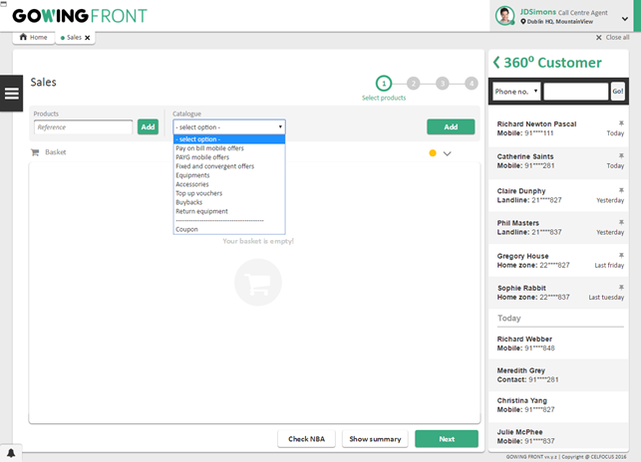

|  |  |
| --- | --- |
| Screen Description | |
| Display Name | Process name: Sales  Step name: Select products |

|  |  |  |  |  |
| --- | --- | --- | --- | --- |
| Field Description | | | | |
| Label | **Type** | **Description** | **Read Only** | **Mandatory** |
| Header area | | | | |
| Products | Textbox | Allows the scan of the product reference code, for mobile equipment and accessories.  **Only available on shops. For call centre it will be disabled.** | No | Yes |
| Add | Button | Adds the scanned product on **Reference** to the basket.  **Only available on shops. For call centre it will be disabled.** | - | - |
| Catalogue | Dropdown | Allows the search on the catalogue.  Available values:   * PAYG mobile offer * Pay on Bill mobile offer * Fixed and convergent offer * Equipment’s * Accessories * Top up vouchers * Buyback (only at Shops) * Return equipment [10] * Coupon (apply coupon to basket) | No | Yes |
| *Search box* | Textbox | Allows the search on the catalogue by mobile equipment and accessories name.  Only visible when **Catalogue** is Equipment or Accessories. | No | Yes |
| Search | Button | Performs the search on the catalogue.  Only visible when **Catalogue** is Equipment or Accessories. | - | - |
| Add | Button | Adds the chosen product/offer to the basket.  Only visible when **Catalogue** is Mobile offer, Fixed and convergent offer, Top up vouchers or Buyback. | - | - |
| Basket area | | | | |
| Validate offer | Link | Allows the offer configuration validation. | - | - |
| Semaphore icon | Image | Represents the status of the offer validation.  When an offer is added to the basket, the icon is yellow informing the user that he needs to request the offer validation.  As the offer validation occurs and is successfully, the icon changes to green.  If any changes are made in the basket configuration, after the validation, the icon returns to yellow and the user needs to perform the validation again.  If the quotation is called, since it validates all the offers in the basket, the icons will change accordingly. | - | - |
| Expand/Collapse offer | Icon | Will expand or collapse all the offers in the basket. | - | - |
| *Trash icon* | Icon | Removes all items from the basket.  **Only visible when the basket is not empty.** | - | - |
| *Basket content*  Basket content is a list of components, representing the added products and offers. For each product/offer detail, please see the corresponding screen specification:   * Offer component * Manage component * Mobile equipment component * Accessory component * Top up vouchers component * Buyback component | | | | |
| Actions area | | | | |
| Next | Button | Sends the user to the next step | - | - |
| Check NBA | Button | Shows the user the NBAs available | - | - |
| Summary | Button | Shows the user the summary of all items in the basket along with their real prices. These prices are obtained through a call to quotation. | - | - |

##### Upgrade or new offer component

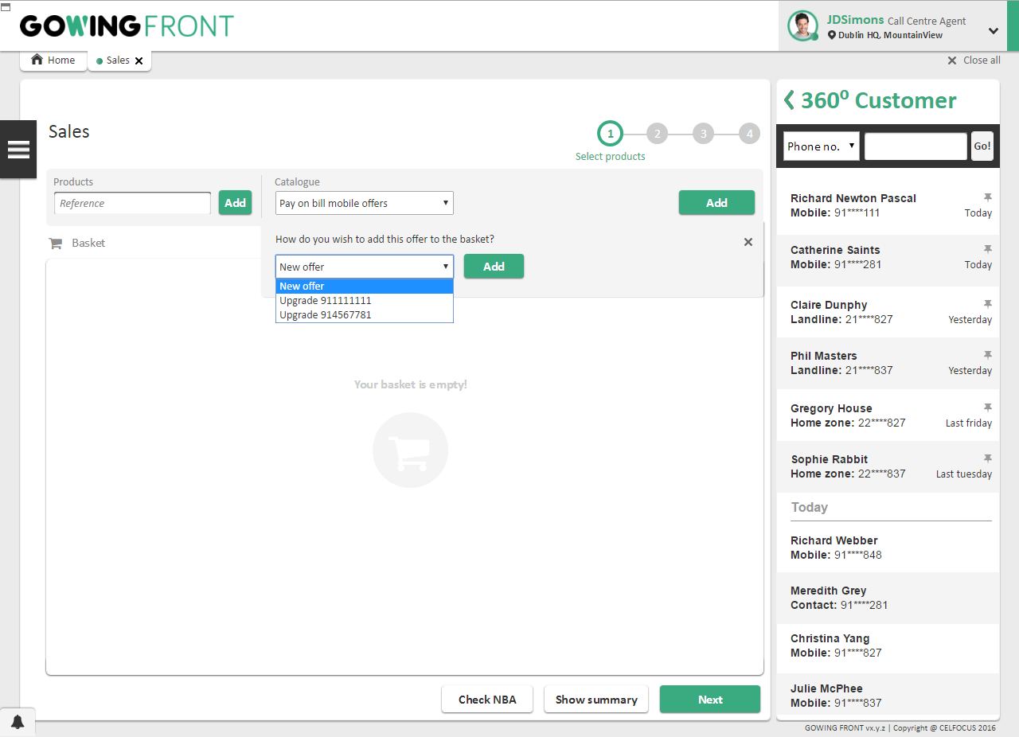

|  |  |
| --- | --- |
| Screen Description | |
| Display Name | Process name: Sales  Step name: Select products |

|  |  |  |  |  |
| --- | --- | --- | --- | --- |
| Field Description | | | | |
| Label | **Type** | **Description** | **Read Only** | **Mandatory** |
| Comfort text | Label | Comfort text. This component will only be visible if a billing customer is contextualized. | - | - |
| Existing Offer / New Offer | Dropdown | List of upgradable offers. If intended, the option “new offer” may be selected.  This component will only be visible if a billing customer is contextualized.  If an upgrade was already added to the basket, only the option “new offer” will be available. | No | Yes |
| Add | Button | Selects the option in the previous dropdown. | - | - |

#### Phase II – Create Customer and billing profile

##### New Customer details step

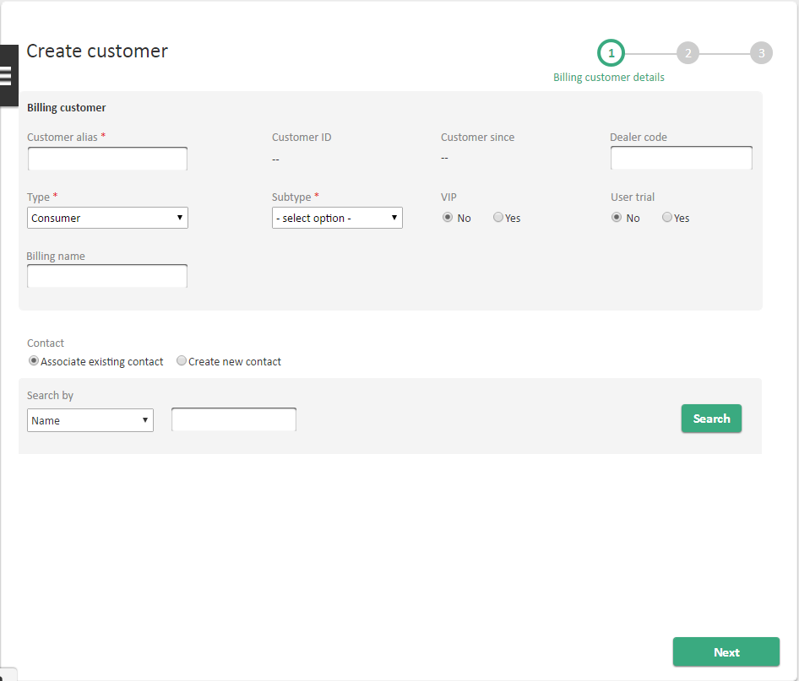

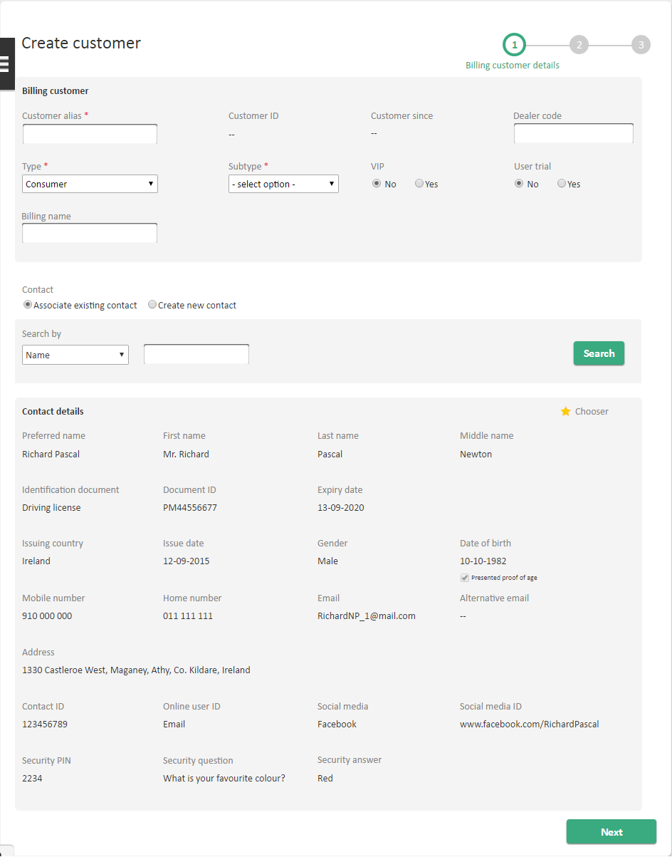

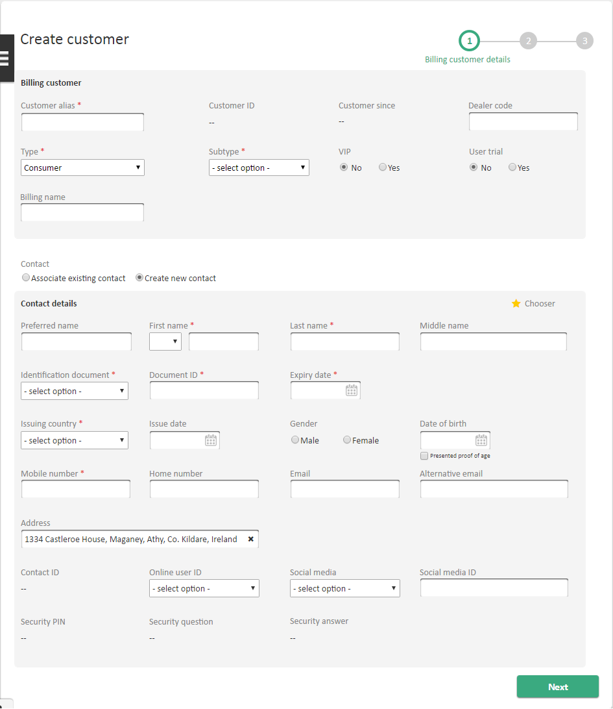

|  |  |
| --- | --- |
| Screen Description | |
| Display Name | Process name: Sales  Step name: Customer details |

|  |
| --- |
| Field Description |
| Please refer to *Customer details* screen of FEAT *#1: Customer Details* on [3]. |

##### New Billing profile details for new Customer step

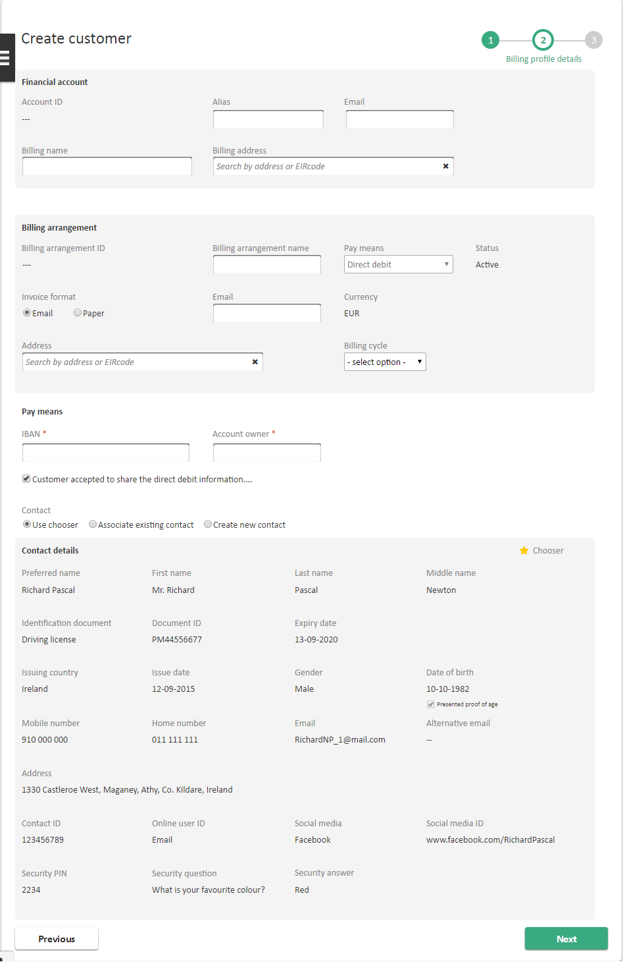

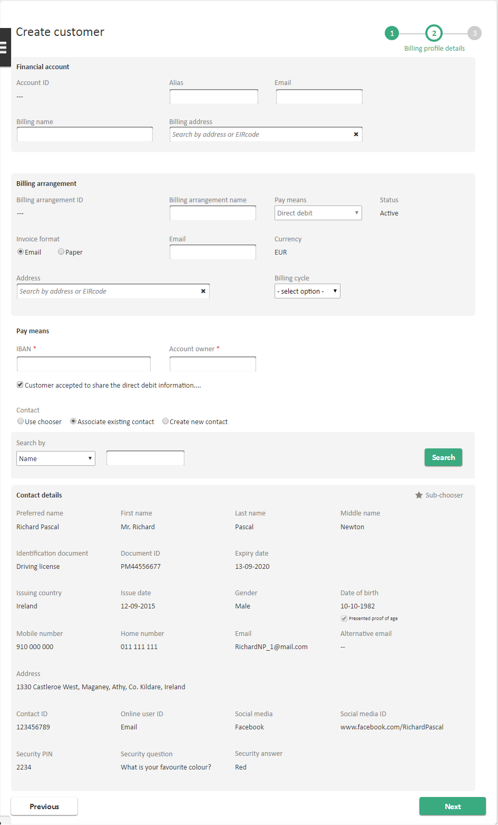

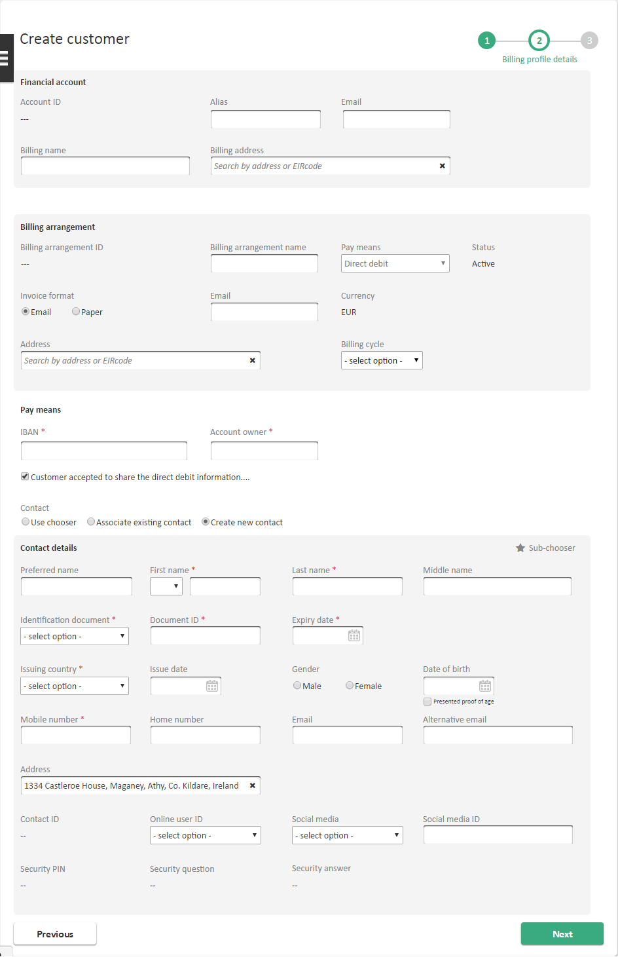

|  |  |
| --- | --- |
| Screen Description | |
| Display Name | Process name: Sales  Step name: New Billing profile details |

|  |
| --- |
| Field Description |
| Please refer to *Select existing billing arrangement* and *Select new billing arrangement* screen of FEAT *#2: Billing Details* on [3]. |

##### Create Customer and billing profile confirmation step

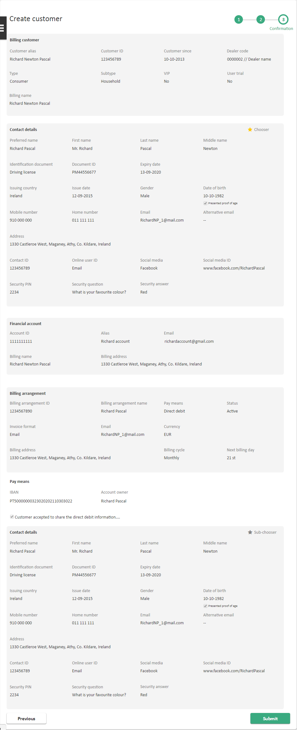

|  |  |
| --- | --- |
| Screen Description | |
| Display Name | Process name: Sales  Step name: Customer details |

|  |
| --- |
| Field Description |
| Please refer to *Customer details* screen of FEAT *#1: Customer Details* on [3]. |

#### Phase III – Basket Configuration

##### Check Stock and Delivery method

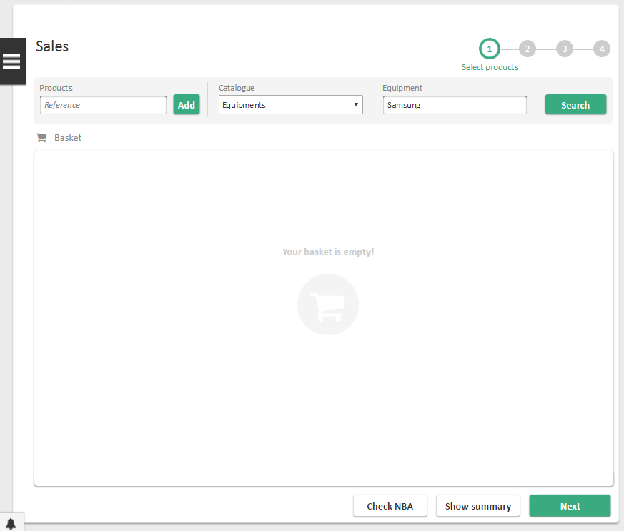

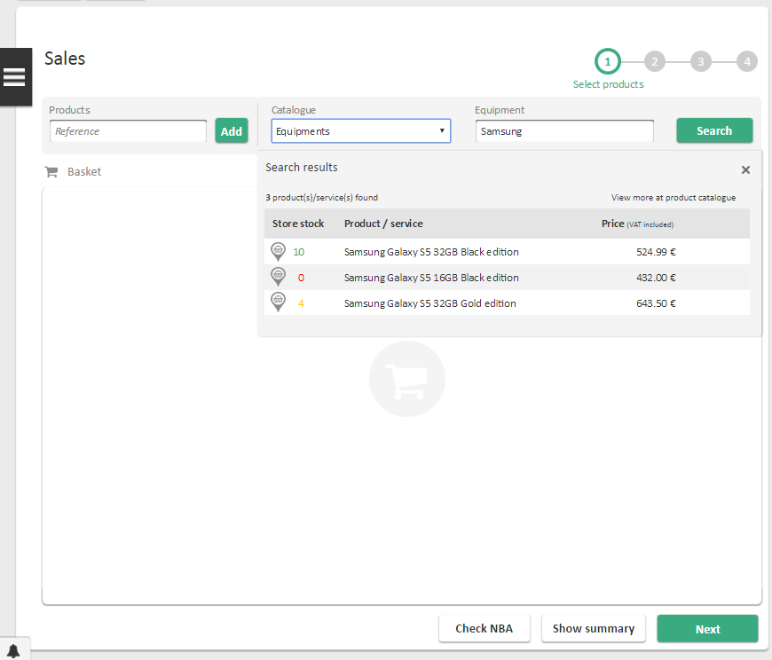

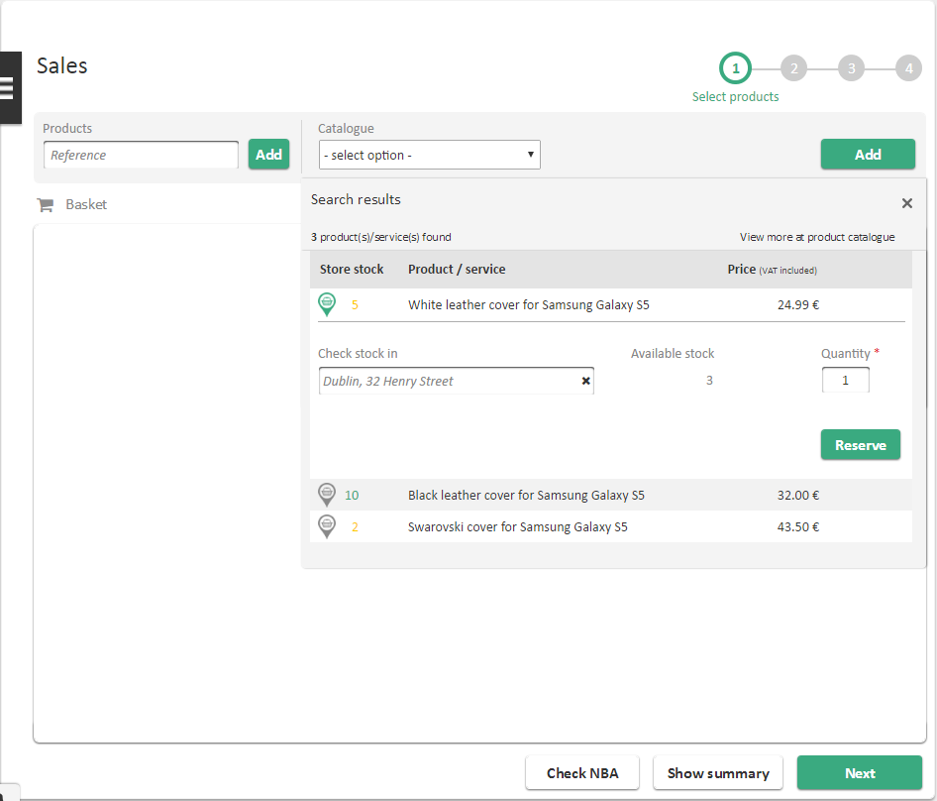

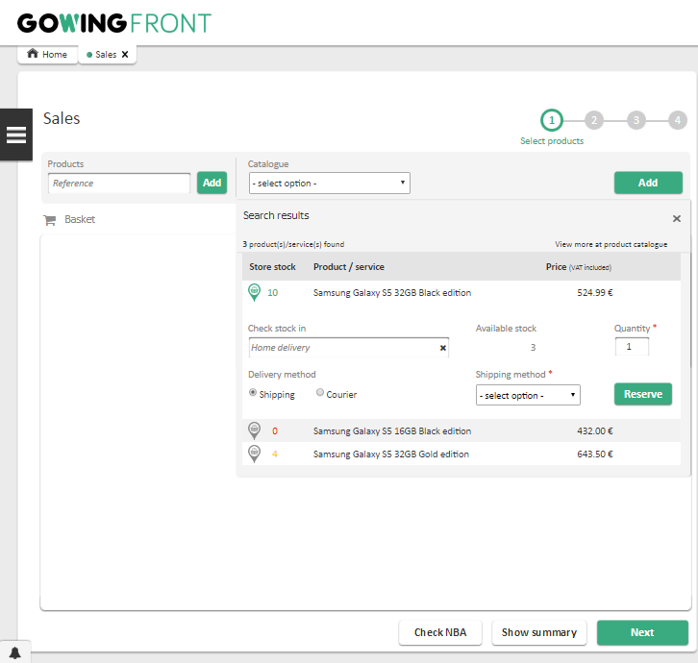

|  |  |
| --- | --- |
| Screen Description | |
| Display Name | Process name: Sales  Step name: Select products |

|  |  |  |  |  |
| --- | --- | --- | --- | --- |
| Field Description | | | | |
| Label | **Type** | **Description** | **Read Only** | **Mandatory** |
| Search Result area | | | | |
| View more at product catalogue | Link | Will redirect the user to the product catalogue process where a more detailed description about the selected product is displayed. | - | - |
| No. product(s)/service(s) found | Label | Number of products returned by the search. | - | - |
| Store Stock | Label | Shows the current stock for the logged in store. | - | - |
| Product / service | Label | Name of the product/service searched. | - | - |
| Price | Button | Price with VAT of the selected product. | - | - |
| Check Stock Area | | | | |
| Check Stock in | Textbox | Search as you type field. Will show the stores available. If an equipment is already in the basket, reserved to a store, UFE will only display that previous selected store. | No | No |
| Delivery method | Dropdown | Visible when the selected stock is **Home Delivery**. Will allow the user to select **Shipping** or **Courier** as a delivery method. These values will come from UFE Catalogue. | No | Yes, if visible |
| Shipping method | Dropdown | Visible when the selected stock is **Home Delivery**. Values will come from UFE Catalogue. | No | Yes, if visible |
| Available stock | Textbox | When a store is selected, the available stock of the searched item will be visible. | Yes | - |
| Quantity | Textbox | Insert how much of the respective product will be reserved. Max number is the same as the available stock. | No | Yes |
| Reserve | Button | Will reserve the product in the selected store. | - | - |







##### Offer component

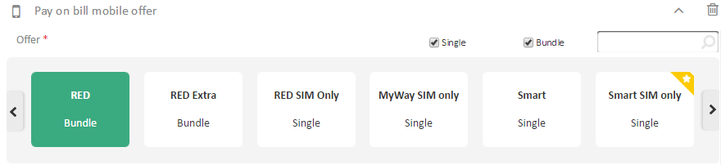

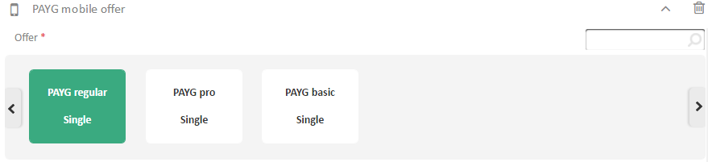

|  |  |
| --- | --- |
| Screen Description | |
| Display Name | Process name: Sales  Offer component |

|  |  |  |  |  |
| --- | --- | --- | --- | --- |
| Field Description | | | | |
| Label | **Type** | **Description** | **Read Only** | **Mandatory** |
| Type Offer | Label | Can be “Mobile offer” or “Fixed and Convergent offer”, depending on the item that was added to the basket. | - | - |
| Expand/Collapse offer | Icon | Will expand or collapse the offer | - | - |
| Trash icon | Icon | Removes the item from the basket | - | - |
| Sub type | Checkbox list | Filters the offers on the **Offer** carrousel by its type.  Possible values, all pre-selected by default:   * Single * Bundle | No | No |
| Search box | Textbox | Filters the offers on the **Offer** carrousel by its name. If there is no offer corresponding the search criteria, UFE will display the label in the carrousel area “No offers found with search criteria”. | No | No |
| Offer | Carrousel | List of available offers, including single and bundle offers.  On each carrousel item, the following information is displayed:   * Offer name * Single or Bundle offer indication, only for mobile offers * Service types (TV, Broadband and/or Landline) under the offer, only for fixed and convergent offers. | No | Yes |
| Offer components and products – Depending on the content of the offer, the corresponding components and products are displayed in the offer element in the basket. For each product/offer detail, please see the corresponding screen specification:   * Equipment’s component * Fixed (TV, Broadband or Landline) component * Mobile equipment component | | | | |

##### Manage component´s

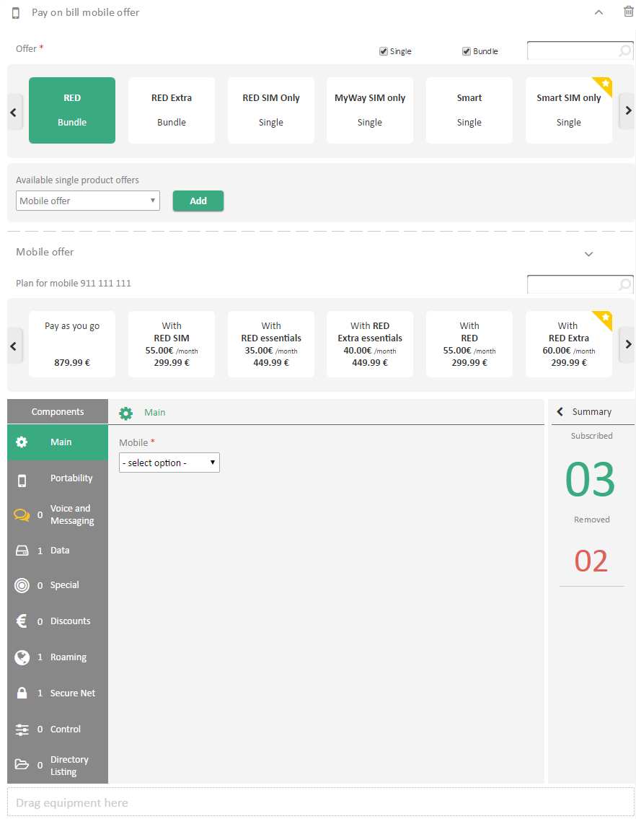

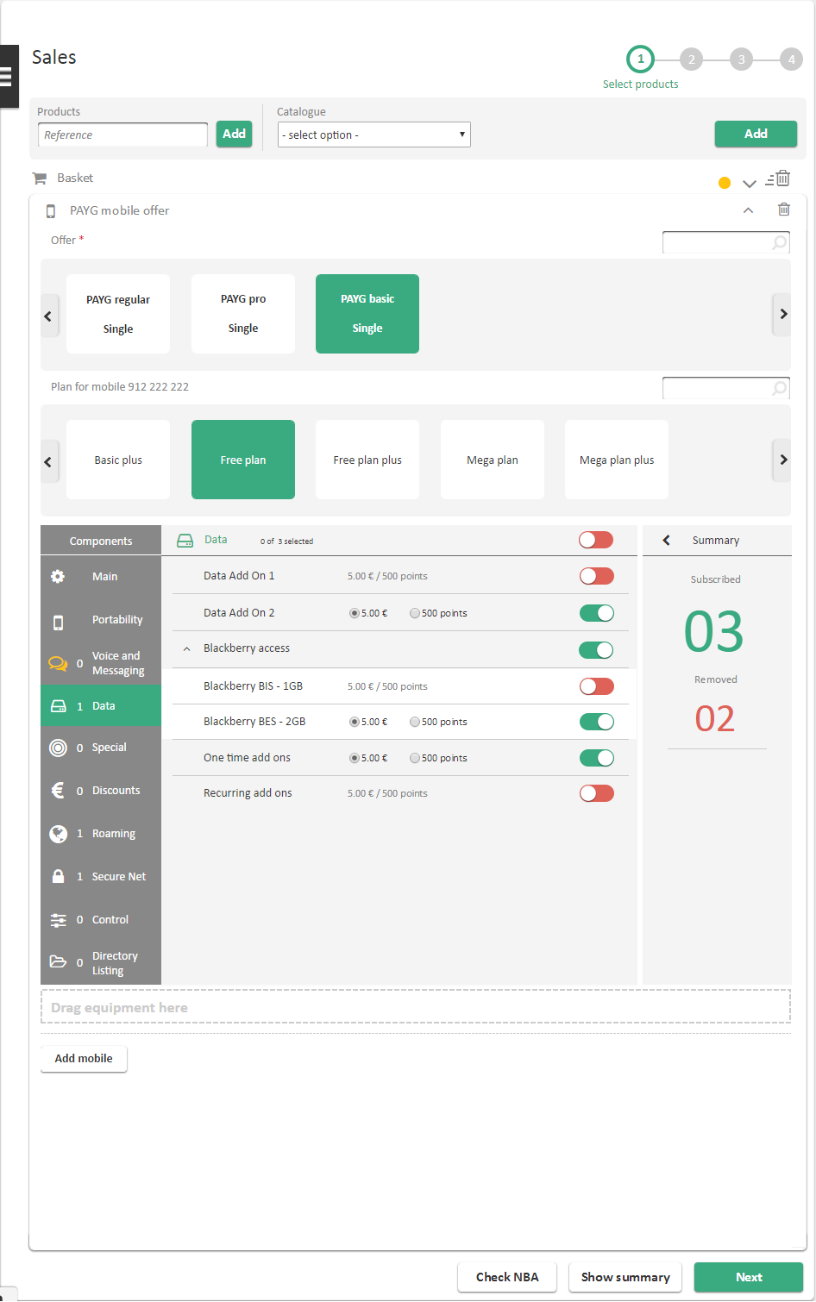

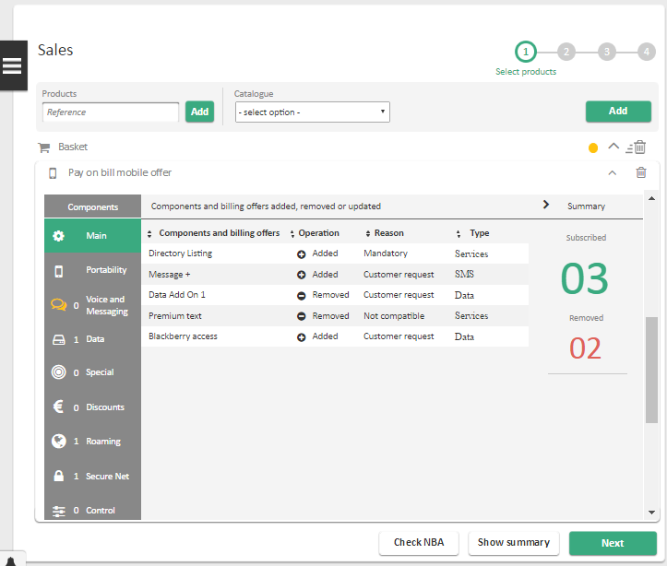

|  |  |
| --- | --- |
| Screen Description | |
| Display Name | Process name: Sales  Manage component´s |

|  |  |  |  |  |  |  |  |  |  |  |  |  |  |
| --- | --- | --- | --- | --- | --- | --- | --- | --- | --- | --- | --- | --- | --- |
| Field Description | | | | | | | | | | | | | |
| Label | | | | | | **Type** | | **Description** | | **Read Only** | | **Mandatory** | |
| Available single product offer + Add | | | | | | Dropdown + Button | | When an offer has a single product offer with cardinality bigger than one, UFE will display this area.  In the dropdown, the single product offers will be displayed and the user may add it to the basket by pressing the Add button.  Once a single product offer reach his maximum cardinality, it will disappear from the dropdown. Once all have been added, the area will disappear.  In the event of adding a single product offer being incompatible with one or more offers already in the basket, UFE will show the **component management confirmation** screen (described in the respective below section). If the user press yes, UFE will remove from the basket the single product offer and will add the new selected one. If the user press no, UFE will **not** remove the single product offer from the basket and will **not** add the new selected one. | | No | | No | |
| Single product offer | | | | | | Area | | Name of the single product offer area | | - | | - | |
| Plan | | | | | | Carrousel | | List of billing offers available on the Plan component under the Mobile offer. Each carrousel item displays the following information:   * Billing offer name * Billing offer price.   The price displayed is the base price with VAT presented in MEC, and previously loaded to UFE through UFE Catalogue component (for further details on this component, please see [2]). | | No | | Depends on the attribute definition. | |
| Components *- Allows the configuration of all components under the offer.* | | | | | | | | | | | | | |
| Main | | | | | - | | Allows the configuration of the following components under the offer:   * Main * SIM   This component is treated as a hybrid component, meaning that it will merge what comes from UFE Catalogue (Main and SIM) and will follow the below description for each field. | | - | | - | |
| Phone number | | | | Label + Refresh icon | | MSISDN of the mobile subscription.  On a new subscription (new number option), the Refresh icon is available to allow the user to change the pre-selected MSISDN.  On an existing subscription (existing number option), applicable when accepting a campaign or in a Pre2Pos scenario, the refresh icon is not visible. When **porting in**, the field Phone number will be disabled. When **upgrading** the field will be read only and pre-populated with the MSISDN of the mobile number.  Refresh icon may be used to refresh the list of available MSISDN (for new subscriptions). Only 10 MSISDNs will be loaded each time. | | Yes / No, depending on the scenario | | Yes | |
| SIM card number | | | | Textbox | | Allows the scan of the SIM card number and corresponds to the SKU attribute of the SIM component under the mobile offer.  Only available at shops. | | No | | Yes | |
| SIM card type | | | | Label / Dropdown | | Indicates the type of the SIM card and corresponds to the SIM Type attribute of the SIM component under the mobile offer.  When the process is running at the shop, this is a Label and is only visible after the SIM card number being provided.  When the process is running at the call centre, this is a dropdown always visible and the available values are configurable through Reference Data UFE_RD_17. | | Yes / No | | Yes | |
| *Other Main or SIM attributes* | | | | Textbox / Dropdown | | Any other visible and editable attributes of the Main or SIM components under the mobile offer are displayed here. If the attribute has an available list of values, UFE represents it as a dropdown. Otherwise, UFE represents it as a Textbox. | | No | | Depends on the attribute definition. | |
| Portability | | | | | - | | Allows the user to configure the port in request.  This component is loaded only if the mobile offer has the Number Portability under it.  All visible and editable attributes of the Number Portability component under the mobile offer are displayed here. If the attribute has an available list of values, UFE represents it as a dropdown. Otherwise, UFE represents it as a Textbox. | | - | | - | |
| Insurance *– This component is only visible and configurable if an Equipment was added to the offer and the offer has the Insurance component under it.* | | | | | | | | | | | | |
| *Other components* – All remaining components under the mobile offer are treated on screen the same way, as described on the next lines. | | | | | | | | | | | | |
| *Activate / Deactivate* | | | | Toggle | | Defines if the component must be activated or not.  If the component is mandatory under the mobile offer, the toggle is activated and disabled.  If the component is optional but should be activated by default, the toggle is activated and enabled, allowing the user to deactivate the component. | | Depends on the component definition. | | Yes | |
| *Price / Cherry points options* | | | | Toggle | | If an add-on has more than one billing offer (price and cherry point), UFE will merge them and show this toggle button in order for the user to select the desired option. | | - | | Yes | |
| *Component attributes* | | | | Textbox / Dropdown | | Any visible and editable attributes of the component are displayed here. If the attribute has an available list of values, UFE represents it as a dropdown. Otherwise, UFE represents it as a Textbox. In case of a cardinality of an attribute being more than 1, UFE will display a button for the user to be able to add more than one instance of this attribute. | | No | | Depends on the attribute definition. | |
| *Add more component* | | | | Button | | In case a component can be added multiple times (e.g STB component) and uniquely configured, UFE will show this button for the user to be able to add more than one instance of this component. If the cardinality is only 1, this button will **not be visible.** | | No | | No | |
| *Component billing offers* – List of billing offers under the component, if any. | | | | | | | | | | | |
| *Billing offer name* | | Label | | Billing offer name | | - | | - | |
| *Billing offer price* | | Label | | Billing offer base price.  This is the base price with VAT presented on MEC, and previously loaded to UFE through UFE Catalogue component (for full details on this UFE component, please see [2]). | | - | | - | |
| *Activate / Deactivate* | | Toggle | | Allows the choice of the billing offer. | | No | | No | |
| Sub components *– List of the sub components under the component, if any (e.g. Outgoing Calls component under the Voice and Messaging component). Attributes and billing offers under the sub components have the same specification as the corresponding element in the component itself.* | | | | | | | | | | | |
| Summary *– Summary of the configuration made on the components.* | | | | | | | | | | | | | |
| Summary | | | | | Button | | Show the summary of the subscribed, removed and updated | | - | | - | |
| Components and billing offers | | Column | | Name of the components, sub components or billing offers. | | - | | - | |
| Operation | | Column | | If was added, removed or updated. | | - | | - | |
| Reason | | Column | | Reason of the operation. | | - | | - | |
| Type | | Column | | Type of the components, sub components or billing offers. | | - | | - | |
| Subscribed components and billing offers | | | | | Label | | Corresponds to the number of added components, sub components and billing offers. This includes mandatory and optional elements. Changes at attribute level aren´t counted. | | - | | - | |
| Removed components and billing offers | | | | | Label | | On a campaign scenario, this corresponds to the number of removed components, sub components and billing offers. Changes at attribute level aren´t counted. | | - | | - | |
| *Drag equipment here* *– Allows the user to choose an equipment to associate to the mobile product. Only available if the mobile offer/product has the Device component under it.*  *For the chosen equipment details (Device Component), please see below Mobile equipment component description.* | | | | | | | | | | | | | |

##### Mobile equipment component

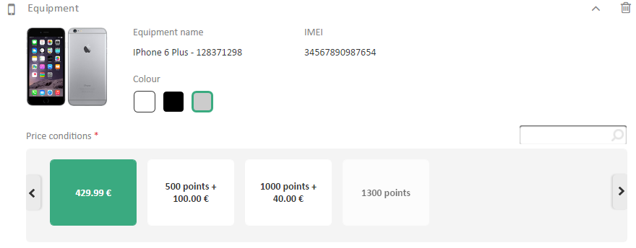

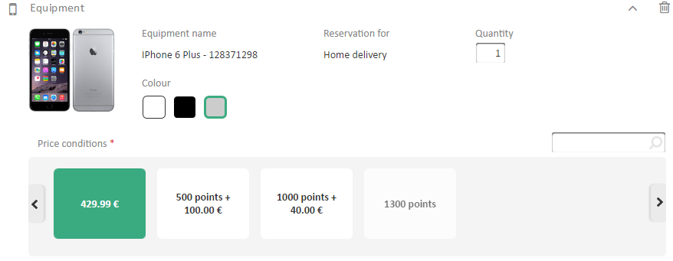

**Step 1: add a mobile offer to the basket**

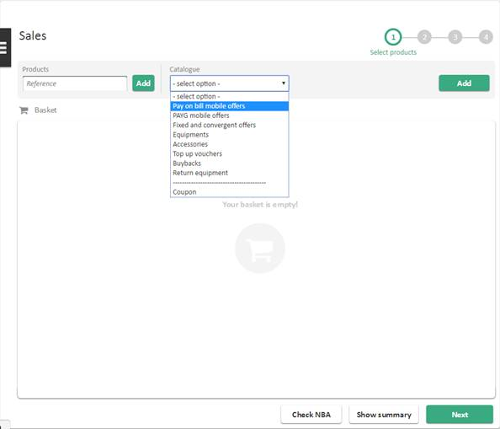

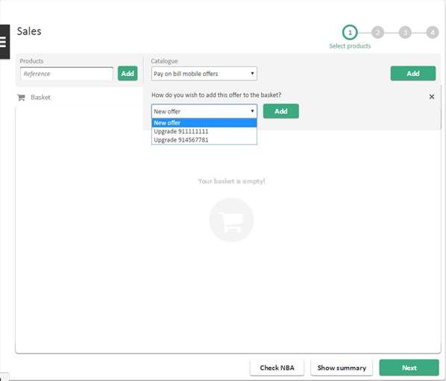

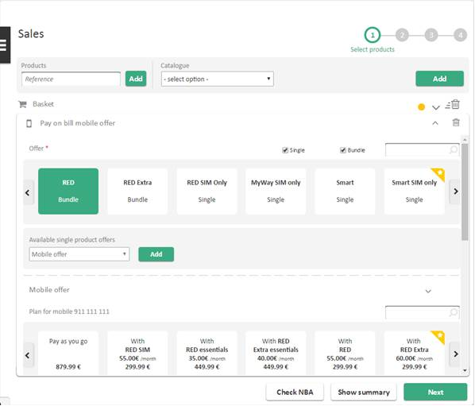

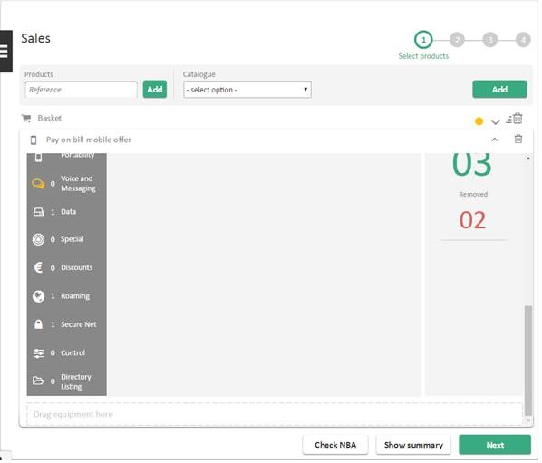

**Step 2: Add equipment to the basket**

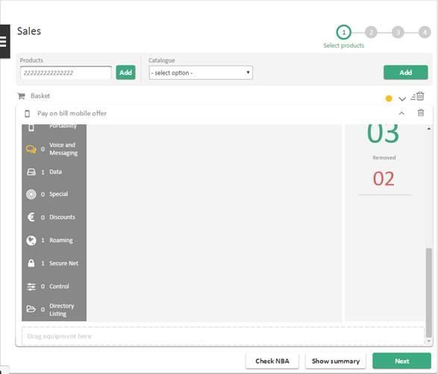

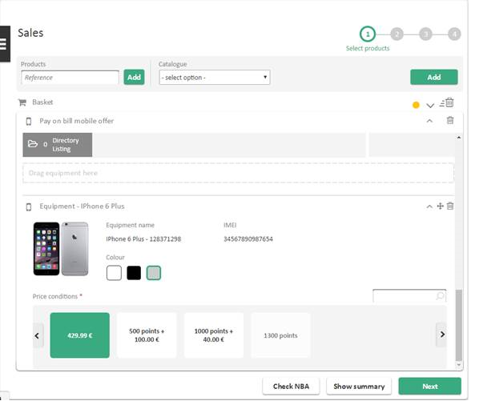

**Step 3: Drag the equipment to the mobile offer “Drag equipment here” area**

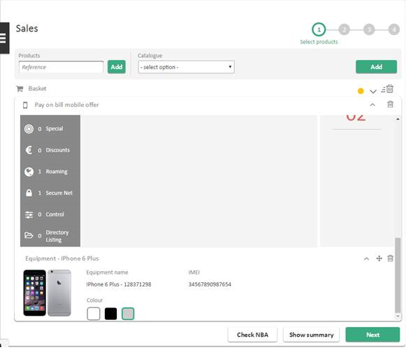

|  |  |
| --- | --- |
| Screen Description | |
| Display Name | Process name: Sales  Mobile equipment component |

|  |  |  |  |  |
| --- | --- | --- | --- | --- |
| Field Description | | | | |
| Label | **Type** | **Description** | **Read Only** | **Mandatory** |
| Quantity | Textbox | Quantity of the respective mobile equipment | Yes, if equipment was picked in store | - |
| Move icon | Icon | Allows the user to drag and drop the mobile equipment to associate it to a mobile offer. | - | - |
| Minimize/Expand | Icon | Minimize or expand component | - | - |
| Trash icon | Icon | Removes the item from the offer/basket. | - | - |
| Image | Image | Mobile equipment image. | - | - |
| Equipment name | Label | Mobile equipment name. | - | - |
| Price Conditions | Carrousel | Mobile equipment baseline price with VAT and respective loyalty points conditions.  This carrousel will be hidden when drag and dropping into an offer and if any price was selected, it will be discarded. | - | - |
| Reservation for | Label | Mobile equipment reservation destination. Will only appear if the equipment is **not** being handled in current **Store** or is being handled in call centre**.**  If it is home delivery, the value set will be “Home Delivery”.  If it is store delivery, the value set will be the name of the selected store in the screen *“Check Stock and Delivery method”.* | - | - |
| IMEI | Textbox | Mobile equipment IMEI. Will only appear if the equipment is being handled in **current** **Store**. Allows the user to insert the IMEI manually. | No | Yes |
| Colour | Label | Mobile equipment colour. When choosing another colour, UFE will refresh the price conditions. | - | - |
| Storage | Label | Mobile equipment storage. | - | - |

##### Accessory component

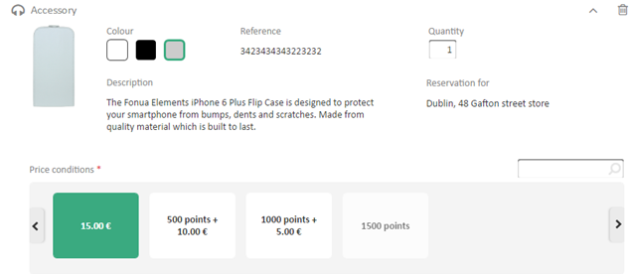

|  |  |
| --- | --- |
| Screen Description | |
| Display Name | Process name: Sales  Accessory component |

|  |  |  |  |  |
| --- | --- | --- | --- | --- |
| Field Description | | | | |
| Label | **Type** | **Description** | **Read Only** | **Mandatory** |
| Quantity | Textbox | Quantity of the respective accessory. Only numerical may be inputted. | Yes, if equipment was picked in store | - |
| Minimize/Expand | Icon | Minimize or expand component | - | - |
| Trash icon | Icon | Removes the item from the offer/basket. | - | - |
| Image | Image | Accessory image. | - | - |
| Price Conditions | Carrousel | Accessories with VAT and respective loyalty points conditions. | - | - |
| Reference | Label | Accessory reference | - | - |
| Colour | Label | Accessory colour. When choosing another colour, UFE will refresh the price conditions. | - | - |
| Reservation | Label | Reservation address. This label is **visible** when item is to be delivered at another store or for home delivery. | - | - |
| Description | Label | Accessory description | - | - |



##### Top up vouchers component

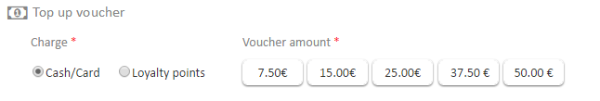

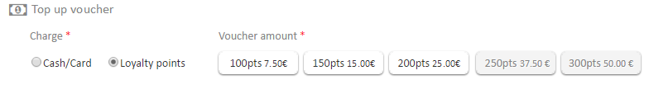

|  |  |
| --- | --- |
| Screen Description | |
| Display Name | Process name: Sales  Top up vouchers component |

|  |  |  |  |  |
| --- | --- | --- | --- | --- |
| Field Description | | | | |
| Label | **Type** | **Description** | **Read Only** | **Mandatory** |
| Expand/Collapse offer | Icon | Will expand or collapse the offer | - | - |
| *Trash icon* | Icon | Removes the item from the basket | - | - |
| Charge | Radio buttons | Will allow to switch between buying the voucher with Cash/Card or Loyalty points. | No | Yes |
| Voucher amount | List of selectable items | Voucher amount. Will vary with the selected Charge. | No | Yes |

##### Buyback component

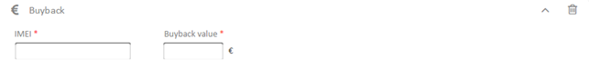

|  |  |
| --- | --- |
| Screen Description | |
| Display Name | Process name: Sales  Buyback component |

|  |  |  |  |  |
| --- | --- | --- | --- | --- |
| Field Description | | | | |
| Label | **Type** | **Description** | **Read Only** | **Mandatory** |
| Expand/Collapse offer | Icon | Will expand or collapse the offer | - | - |
| *Trash icon* | Icon | Removes the item from the basket | - | - |
| IMEI | Textbox | Allows the user to insert the IMEI manually of the buyback equipment. | No | Yes |
| Buyback value | Textbox | Value of the buyback equipment, obtaining manually by the user on Fónua system.  Must be a monetary value. | No | Yes |

##### Apply coupon component



|  |  |
| --- | --- |
| Screen Description | |
| Display Name | Process name: Sales  Apply coupon component |

|  |  |  |  |  |
| --- | --- | --- | --- | --- |
| Field Description | | | | |
| Label | **Type** | **Description** | **Read Only** | **Mandatory** |
| Coupon ID | Textbox | Coupon ID scanned or manually inserted to be applied to the basket. | No | - |
| Apply | Button | Will apply the coupon to the basket | - | - |

##### Request Quotation component

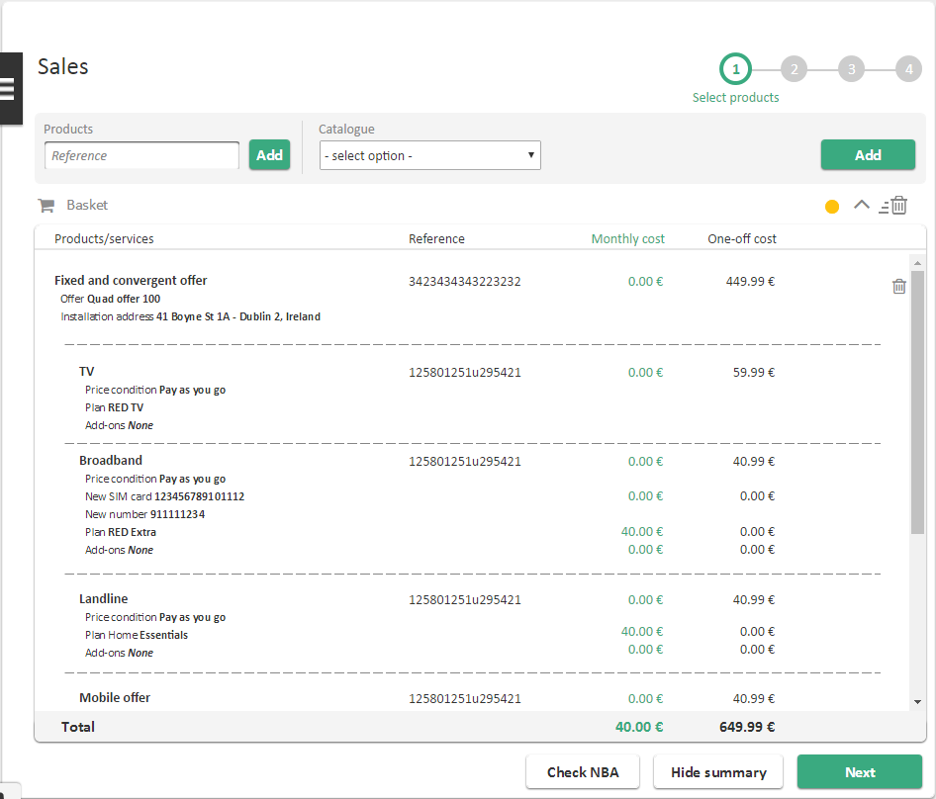

|  |  |
| --- | --- |
| Screen Description | |
| Display Name | Process name: Sales  Request quotation component |

|  |  |  |  |  |
| --- | --- | --- | --- | --- |
| Field Description | | | | |
| Label | **Type** | **Description** | **Read Only** | **Mandatory** |
| Quantity | Label | Column that displays the quantity of the products in the basket. | - | - |
| Products | Label | Column that displays the products in the basket. | - | - |
| Reference | Label | Column that displays the reference of the products in the basket. | - | - |
| Monthly Cost | Label | Column that displays the monthly cost of the product. If not applicable, the default value will be 0. | - | - |
| One-off cost | Label | Column that displays the one-off cost of the product. If not applicable, the default value will be 0. | - | - |

##### Component management confirmation

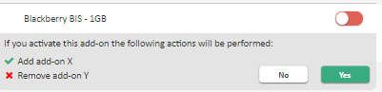

|  |  |
| --- | --- |
| Screen Description | |
| Display Name | Process name: Sales  Component management confirmation |

|  |  |  |  |  |
| --- | --- | --- | --- | --- |
| Field Description | | | | |
| Label | **Type** | **Description** | **Read Only** | **Mandatory** |
| Information | Label | Information to the user about the activation or deactivation | - | - |
| Affected Add-ons/ Components/ Single Product Offers | Label | Affected add-ons or components or single product offers that will be added or removed if action is accepted | - | - |
| No | Button | Will cancel the confirmation of the activation or deactivation | - | - |
| Yes | Button | Will accept the confirmation of the activation or deactivation | - | - |

##### Collapsed Basket View

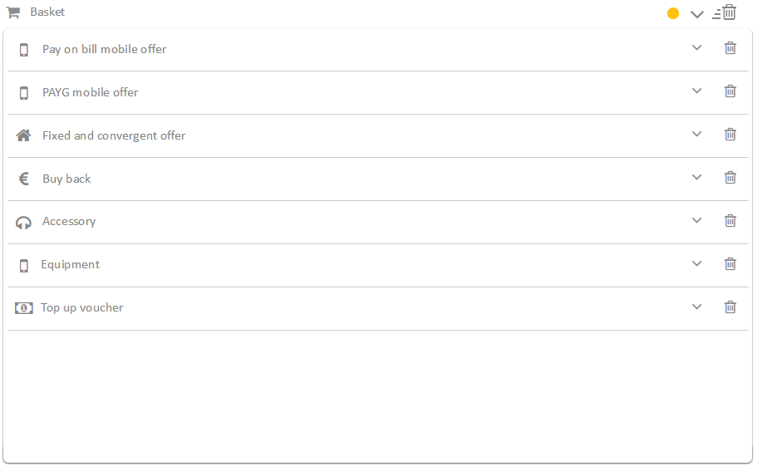

|  |  |
| --- | --- |
| Screen Description | |
| Display Name | Process name: Sales  Collapsed Basket |

|  |
| --- |
| Field Description |
| Collapsed view of the basket |

##### Process closure popup

**Generic popup when closing a process**

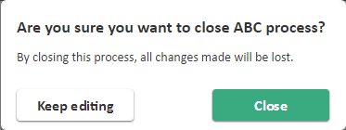

**Popup when closing a process and an order was created**

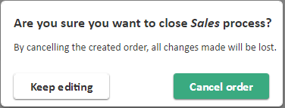

|  |  |
| --- | --- |
| Screen Description | |
| Display Name | Process name: Sales  Process closure popup |

|  |  |  |  |  |
| --- | --- | --- | --- | --- |
| Field Description | | | | |
| Label | **Type** | **Description** | **Read Only** | **Mandatory** |
| Keep editing | Button | Will keep the user in the process, no changes are made in this scenario. | - | - |
| Close | Button | Will close the process and all changes will be lost. | - | - |
| Cancel order | Button | Will cancel the order and all changes will be lost. | - | - |

#### Phase IV – Billing profile details

##### New/Choose Billing profile details step

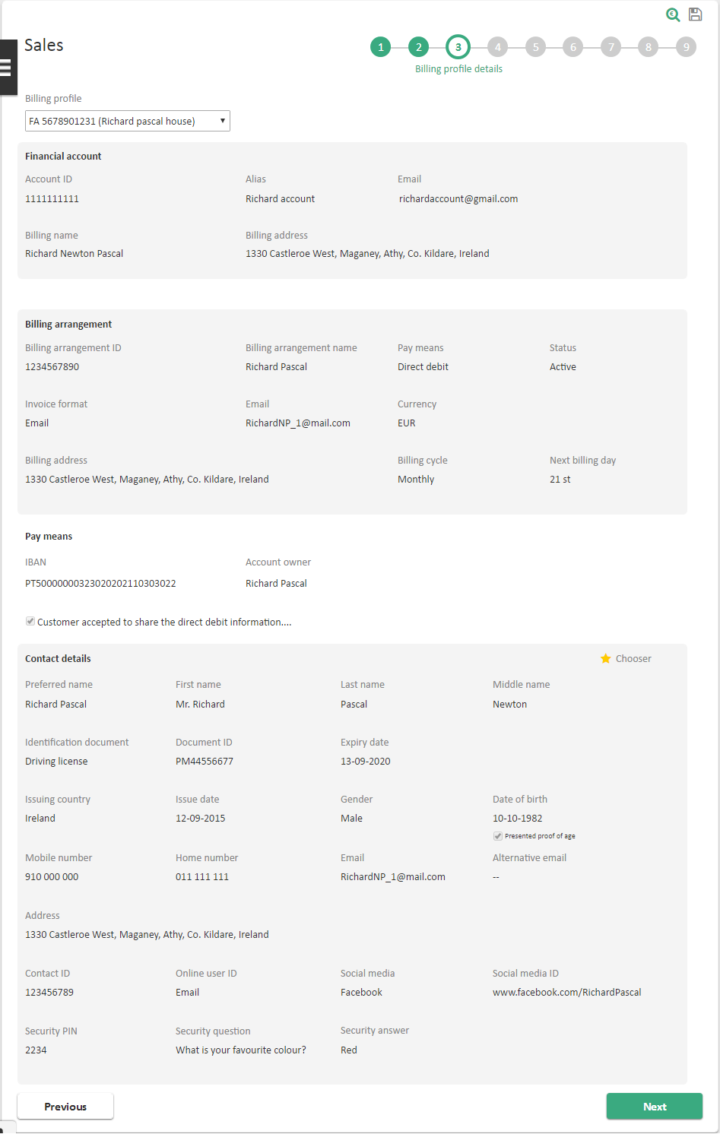

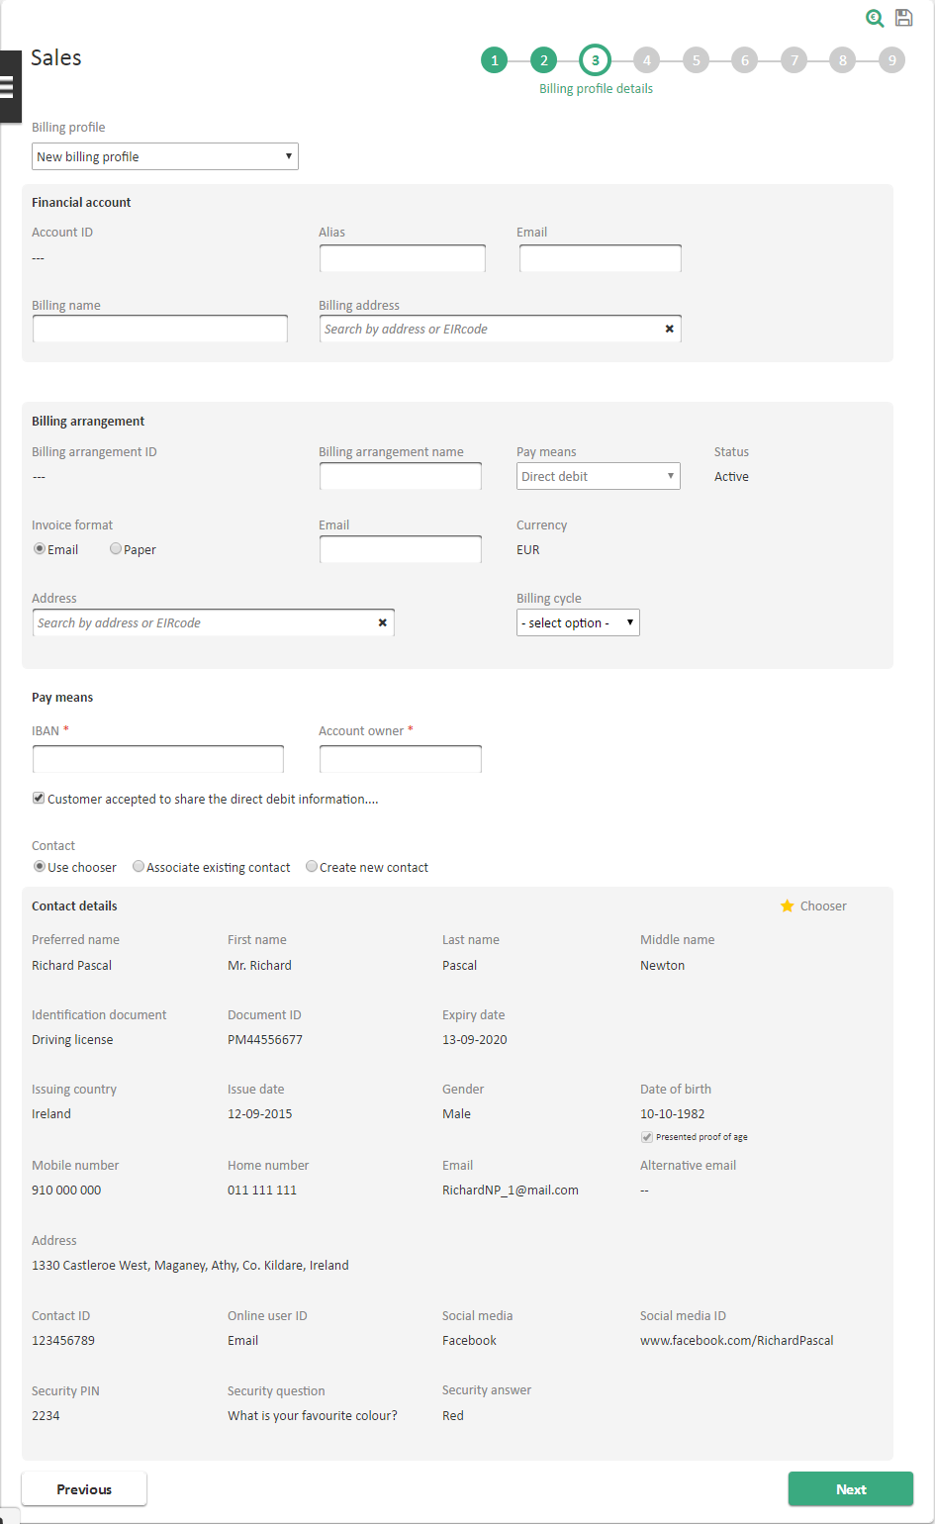

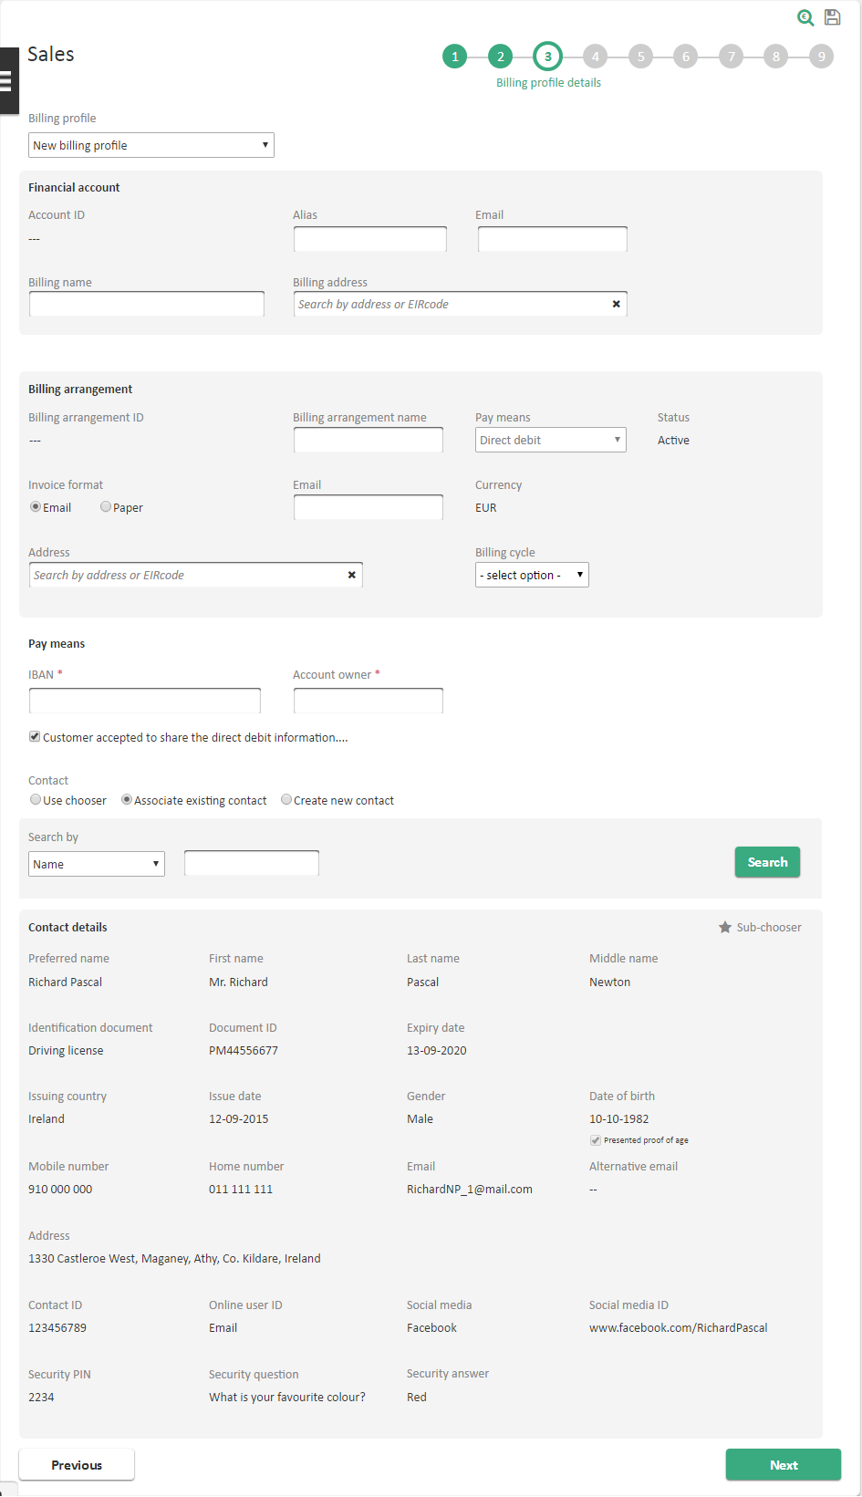

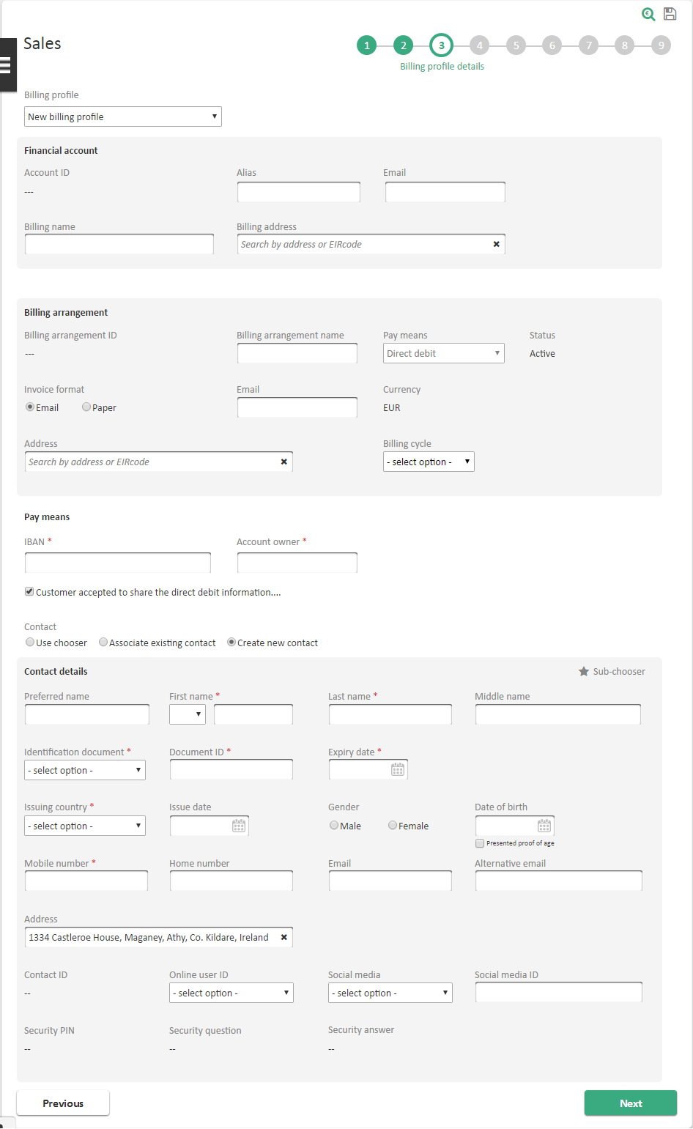

|  |  |
| --- | --- |
| Screen Description | |
| Display Name | Process name: Sales  Step name: Billing profile details |

|  |
| --- |
| Field Description |
| Please refer to *Select existing billing arrangement* and *Select new billing arrangement* screen of FEAT *#2: Billing Details* on [3]. |

##### Credit vetting override button

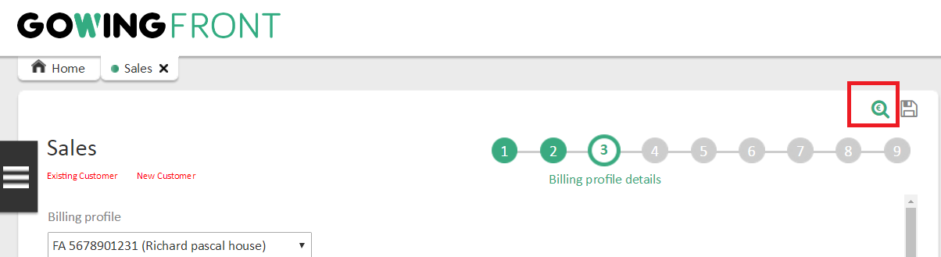

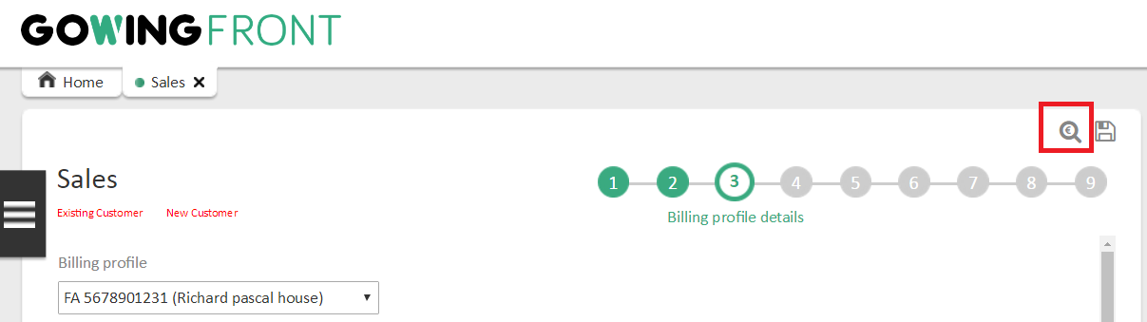

|  |  |
| --- | --- |
| Screen Description | |
| Display Name | Process name: Sales  Credit vetting override button |

|  |
| --- |
| Field Description |
| Special user roles can enable/disable credit vetting override by toggling the respective button in the upper right corner of the process. |

##### Credit vetting get referral results button

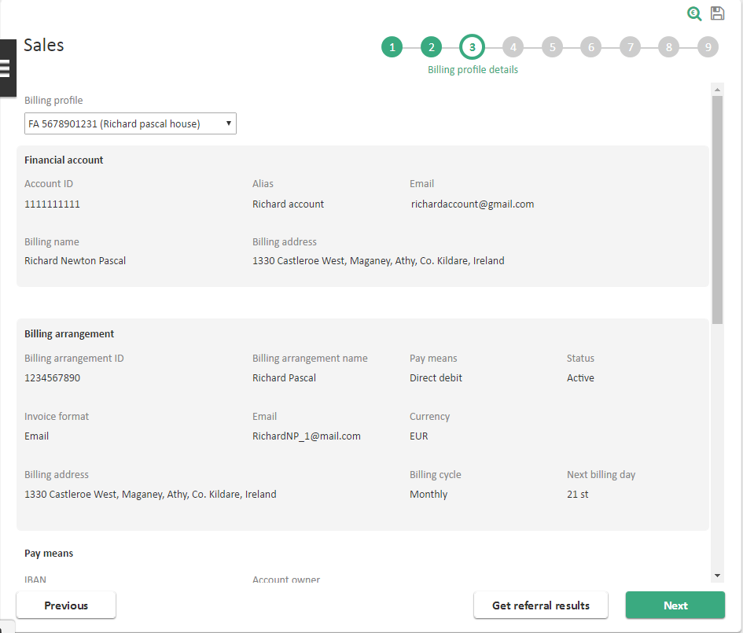

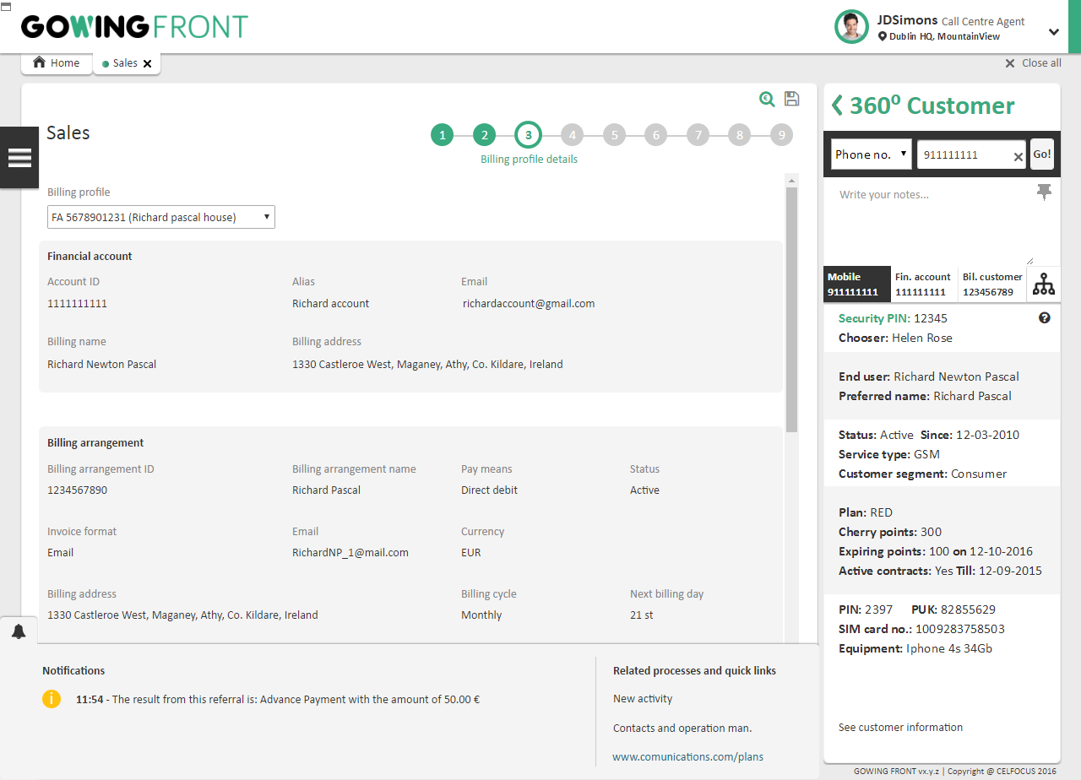

|  |  |
| --- | --- |
| Screen Description | |
| Display Name | Process name: Sales  Credit vetting get referral results button |

|  |
| --- |
| Field Description |
| If the credit vetting check result is Referral, UFE will show the “Get Referral Results” button. This button will fetch the result of the referral. |

##### Credit vetting workaround popup

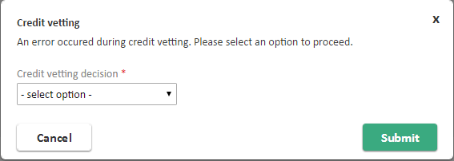

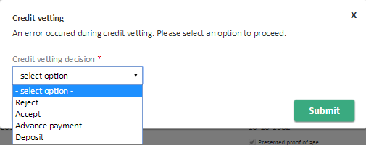

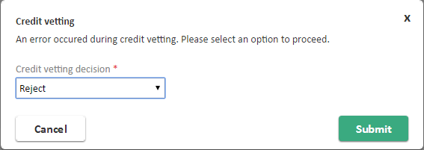

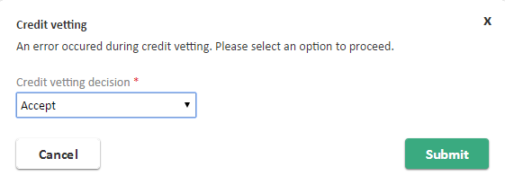

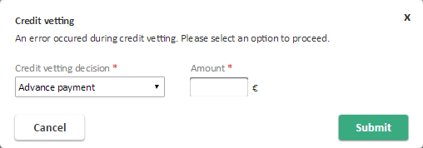

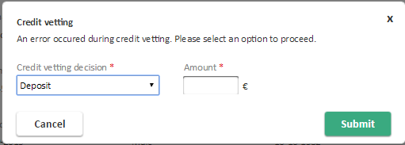

|  |  |
| --- | --- |
| Screen Description | |
| Display Name | Process name: Sales  Credit vetting workaround popup |

|  |  |  |  |  |
| --- | --- | --- | --- | --- |
| Field Description | | | | |
| Label | **Type** | **Description** | **Read Only** | **Mandatory** |
| Credit vetting decision | Dropdown list | Values in this combobox will be as follow:   * Accept – Order will be retrieved and accepted * Reject – Order will be retrieved and cancelled. * Advanced Payment / Deposit – Order will be retrieved and the following field must be filled:   + Amount | No | Yes |
| Amount | Textbox | Amount obtained by manual process. Only visible if selected decision is “Advanced Payment” or “Deposit”. Only numerical may be inputted. | No | Yes |

#### Phase V – Delivery

##### Home Delivery details step

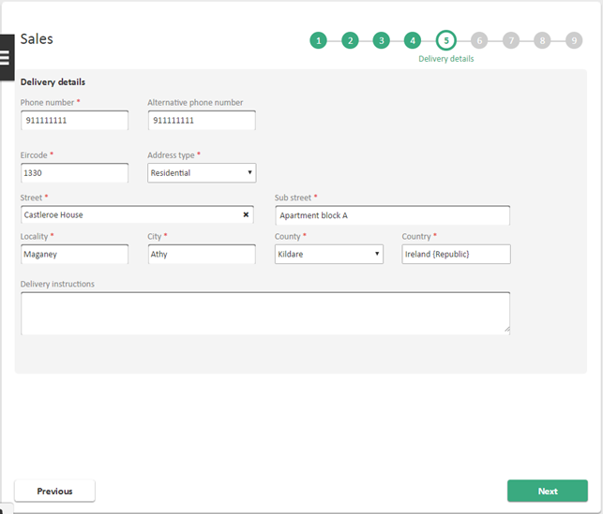

|  |  |
| --- | --- |
| Screen Description | |
| Display Name | Process name: Sales  Step name: Delivery details |

|  |  |  |  |  |  |
| --- | --- | --- | --- | --- | --- |
| Field Description | | | | | |
| Label | **Type** | | **Description** | **Read Only** | **Mandatory** |
| Input area | | | | | |
| Street | Textbox | Street shipping address.  **This field is restricted to 30 chars long.** | | No | Yes |
| Sub Street | Textbox | Sub Street shipping address.  **This field is restricted to 30 chars long.** | | No | Yes |
| Locality | Textbox | Locality shipping address. | | No | Yes |
| City | Textbox | City shipping address. | | No | Yes |
| County | Dropdown | County shipping address. | | No | Yes |
| Country | Textbox | Country shipping address. Locked to value Ireland. | | Yes | Yes |
| Eircode | Textbox | Eircode shipping address. | | No | Yes |
| Address type | Dropdown | Indicates if the delivery address is the residential or business.  Available values:   * Residential * Business | | No | Yes |
| Phone Number | Textbox | Mandatory phone number of the person who will receive the delivery. | | No | Yes |
| Alternative Phone Number | Textbox | Optional phone number of the person who will receive the delivery. | | No | No |
| Delivery Instructions | Input text | Free text, the user may input any shipping instructions. **This field is restricted to 30 chars long.** | | No | No |
| Actions area | | | | | |
| Previous | Button | | Go back to the previous step. | - | - |
| Next | Button | | Sends user to the next step. | - | - |

##### Store Delivery details step

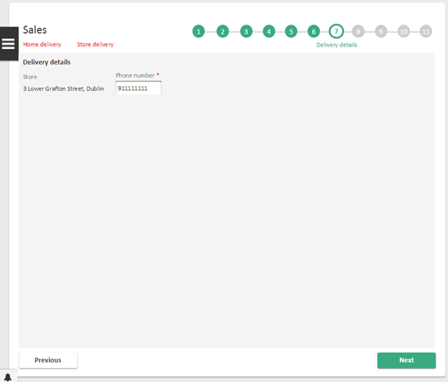

|  |  |
| --- | --- |
| Screen Description | |
| Display Name | Process name: Sales  Step name: Delivery details |

|  |  |  |  |  |
| --- | --- | --- | --- | --- |
| Field Description | | | | |
| Label | **Type** | **Description** | **Read Only** | **Mandatory** |
| Input area | | | | |
| Store | Textbox | Address and name of the store that the products will be picked up at. | Yes | Yes |
| Phone number | Input text | Contact number of the Customer. | No | Yes |
| Actions area | | | | |
| Previous | Button | Go back to the previous step. | - | - |
| Next | Button | Sends user to the next step. | - | - |

#### Phase VI – Confirmation

##### Confirmation step for new customer

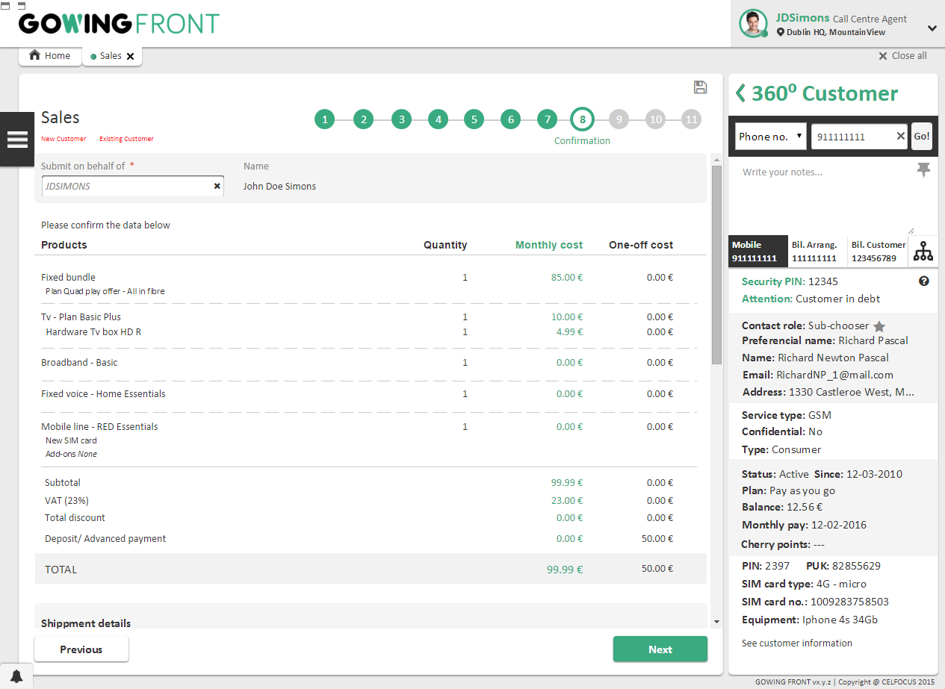

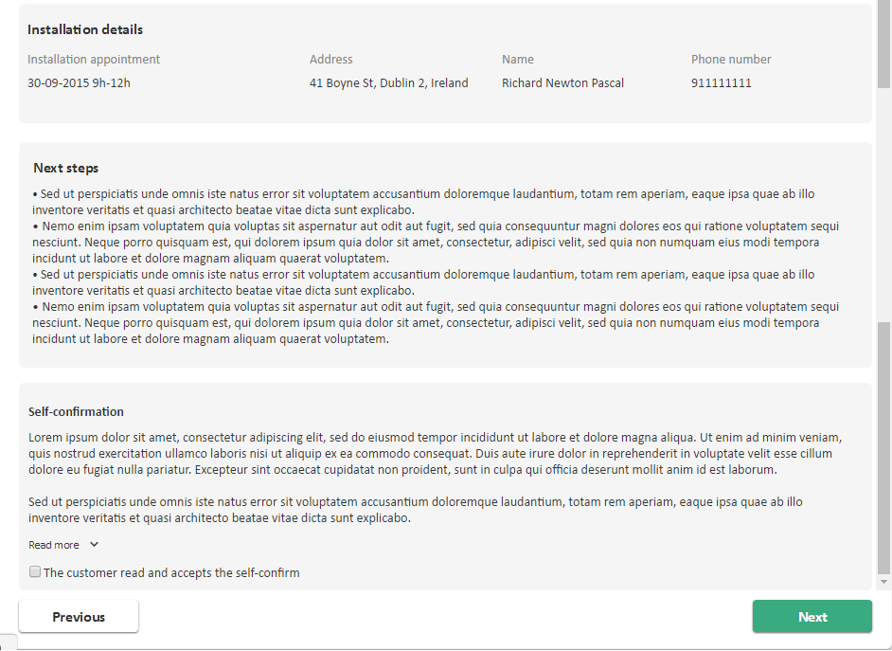

|  |  |
| --- | --- |
| Screen Description | |
| Display Name | Process name: Sales  Step name: Confirmation |

|  |  |  |  |  |
| --- | --- | --- | --- | --- |
| Field Description | | | | |
| Label | **Type** | **Description** | **Read Only** | **Mandatory** |
| Basket area | | | | |
| On behalf | Picklist | By default, UFE will submit/save the Order on behalf of the user in session. User must input the username here. | No | Yes |
| Name | Label | Name of the user that will be on behalf. Only appears after the username has been entered in the field before. | Yes | - |
| Products | Label | Represents each product, component and billing offer under the basket.  On a campaign scenario, where some component or billing offer must be removed, UFE shows that indication for the corresponding line. | - | - |
| Quantity | Label | Quantity of the product. | - | - |
| Monthly cost | Label | Corresponds to the recurring charges returned by the Quotation system.  Only available for billing offers with recurring charges. | - | - |
| One-off cost | Label | Corresponds to the one-time charges returned by the Quotation system.  Only available for billing offers and products with one-off cost. | - | - |
| Delivery area *– Only visible if the Activity 19 from BS#1 and Activty 21 from BS#2 was performed.* | | | | |
| Address | Label | Corresponds to the delivery address.  Only visible when the chosen Type of delivery was Delivery address. | - | - |
| Store | Label | Corresponds to the store where the customer will pick up the order.  Only visible when the chosen Type of delivery was Store. | - | - |
| Store address | Label | Address of the chosen store.  Only visible when the chosen Type of delivery was Store. | - | - |
| Installation area *– Only visible if the Activity 20 from BS#2 was performed.* | | | | |
| Installation appointment | Label | Chosen slot for the technician visit | - | - |
| Address | Label | Installation address, captured on the Serviceability process. | - | - |
| Name | Label | Contact name for the installation of the fixed service. | - | - |
| Phone number | Label | Contact phone number for the installation of the fixed service. | - | - |
| Next Steps area – *Will inform the user of the next steps to be made* | | | | |
| Self-Confirm area | | | | |
| Self-Confirm text | Label | Self-Confirm for customer acceptance.  This text is configurable on Reference Data UFE_RD149. | - | - |
| The customer read and accepts the Self-Confirm | Checkbox | Indicates if the customer accepts the Self-Confirm for the offers that are being subscribed. | No | Yes |
| Actions area | | | | |
| Previous | Button | Go back to the previous step. | - | - |
| Next | Button | Sends user to the next step. | - | - |

##### Confirmation step for existing customer



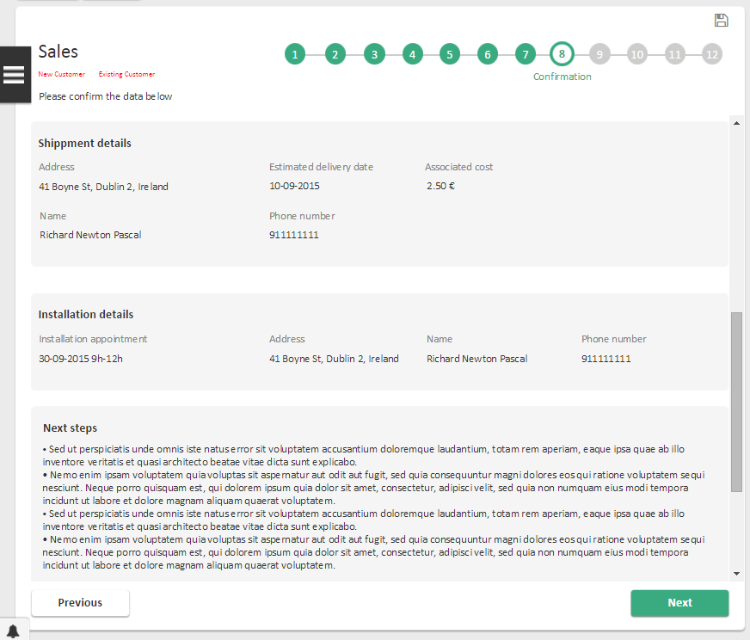

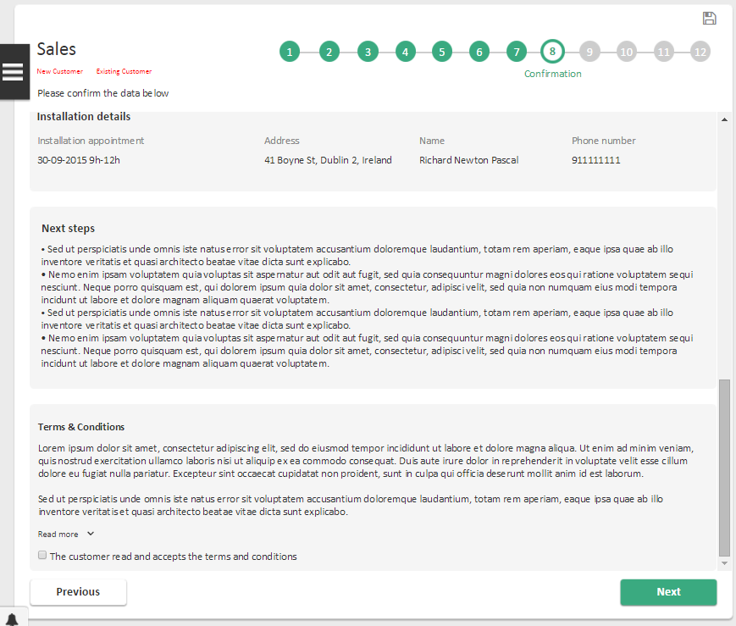

|  |  |
| --- | --- |
| Screen Description | |
| Display Name | Process name: Sales  Step name: Confirmation |

|  |  |  |  |  |
| --- | --- | --- | --- | --- |
| Field Description | | | | |
| Label | **Type** | **Description** | **Read Only** | **Mandatory** |
| Basket area | | | | |
| On behalf | Picklist | By default, UFE will submit/save the Order on behalf of the user in session | No | Yes |
| Name | Label | Name of the user that will be on behalf | Yes | - |
| Products | Label | Represents each product, component and billing offer under the basket.  On a campaign scenario, where some component or billing offer must be removed, UFE shows that indication for the corresponding line. | - | - |
| Quantity | Label | Quantity of the product. | - | - |
| Monthly cost | Label | Corresponds to the recurring charges returned by the Quotation system.  Only available for billing offers with recurring charges. | - | - |
| One-off cost | Label | Corresponds to the one-time charges returned by the Quotation system.  Only available for billing offers and products with one-off cost. | - | - |
| Delivery area *– Only visible if the Activity 20 was performed.* | | | | |
| Address | Label | Corresponds to the delivery address.  Only visible when the chosen Type of delivery was Delivery address. | - | - |
| Store | Label | Corresponds to the store where the customer will pick up the order.  Only visible when the chosen Type of delivery was Store. | - | - |
| Store address | Label | Address of the chosen store.  Only visible when the chosen Type of delivery was Store. | - | - |
| Installation area *– Only visible if the Activity 19 was performed.* | | | | |
| Installation appointment | Label | Chosen slot for the technician visit | - | - |
| Address | Label | Installation address, captured on the Serviceability process. | - | - |
| Name | Label | Contact name for the installation of the fixed service. | - | - |
| Phone number | Label | Contact phone number for the installation of the fixed service. | - | - |
| Next Steps area – *Will inform the user of the next steps to be made* | | | | |
| Self-Confirm area | | | | |
| Self-Confirm text | Label | Self-Confirm for customer acceptance.  This text is configurable on Reference Data UFE_RD149. | - | - |
| The customer read and accepts the Self-Confirm | Checkbox | Indicates if the customer accepts the Self-Confirm for the offers that are being subscribed. | No | Yes |
| Actions area | | | | |
| Previous | Button | Go back to the previous step. | - | - |
| Next | Button | Sends user to the next step. | - | - |







#### Phase VII – Contracts and documentation

##### Documentation step

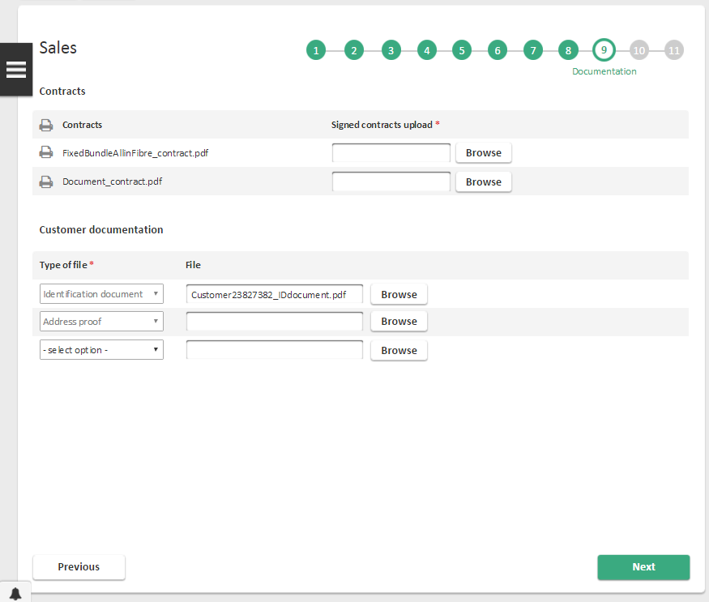

|  |  |
| --- | --- |
| Screen Description | |
| Display Name | Process name: Sales  Step name: Documentation |

|  |  |  |  |  |
| --- | --- | --- | --- | --- |
| Field Description | | | | |
| Label | **Type** | **Description** | **Read Only** | **Mandatory** |
| Contracts area *– only available if there is, at least, on contract.* | | | | |
| Contracts | Download file | Generated contract. | - | - |
| Signed contract upload | Upload file | Contract file signed by the customer. | No | Yes |
| Customer documentation area *– only available if a billing customer and/or a billing profile is being created in the process.* | | | | |
| Type of file | Dropdown | Type of the uploaded file.  Available values are configurable through Reference Data UFE_RD132. | No | Yes |
| File | Upload file | Customer document file. | No | Yes |
| Actions area | | | | |
| Next | Button | Sends user to the next step. | - | - |

#### Phase VIII – Payment

##### Payment step in Store

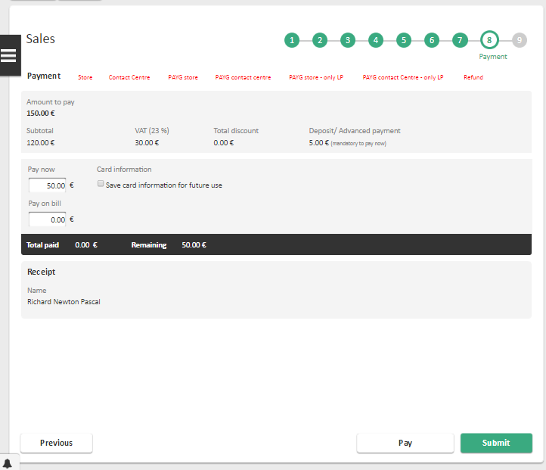

|  |  |
| --- | --- |
| Screen Description | |
| Display Name | Process name: Sales  Step name: Payment |

|  |
| --- |
| Field Description |
| Please refer to *Payment step* screen of *BS #1: Pay at Store* on [5]. |

##### Payment step in Store with Loyalty Points

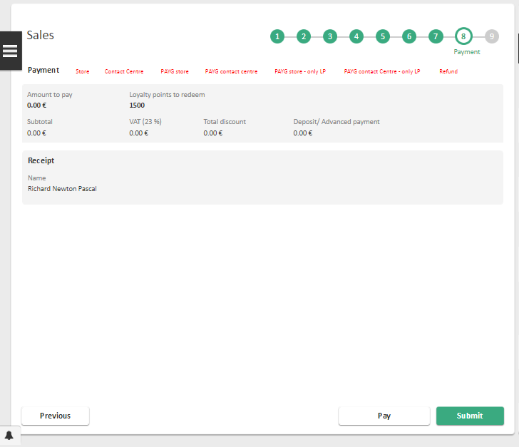

|  |  |
| --- | --- |
| Screen Description | |
| Display Name | Process name: Sales  Step name: Payment |

|  |
| --- |
| Field Description |
| Please refer to *Payment step* screen of *BS #1: Pay at Store* on [5]. |

##### Payment step in Store - PAYG

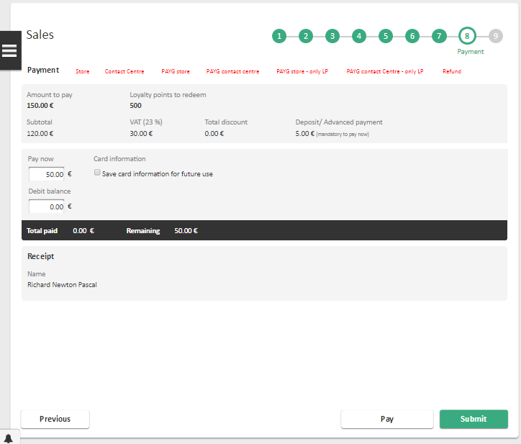

|  |  |
| --- | --- |
| Screen Description | |
| Display Name | Process name: Sales  Step name: Payment |

|  |
| --- |
| Field Description |
| Please refer to *Payment step* screen of *BS #1: Pay at Store* on [5]. |

##### Payment step in Contact Centre

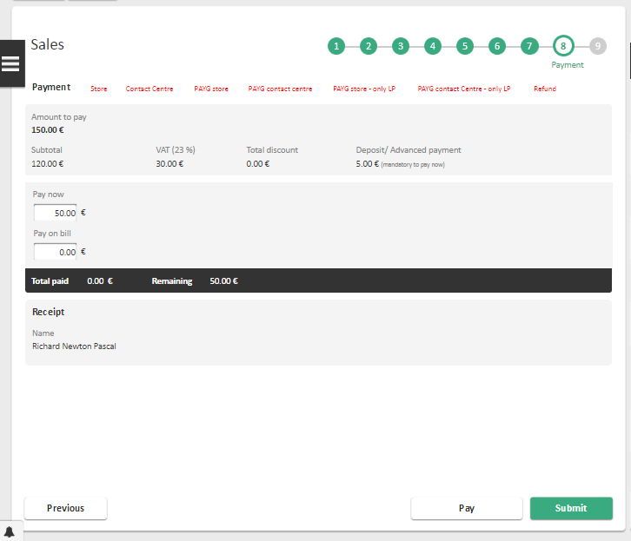

|  |  |
| --- | --- |
| Screen Description | |
| Display Name | Process name: Sales  Step name: Payment |

|  |
| --- |
| Field Description |
| Please refer to *Payment step* screen of *BS #2: Pay at Call Centre* on [5]. |

##### Payment step in Contact Centre with Loyalty Points

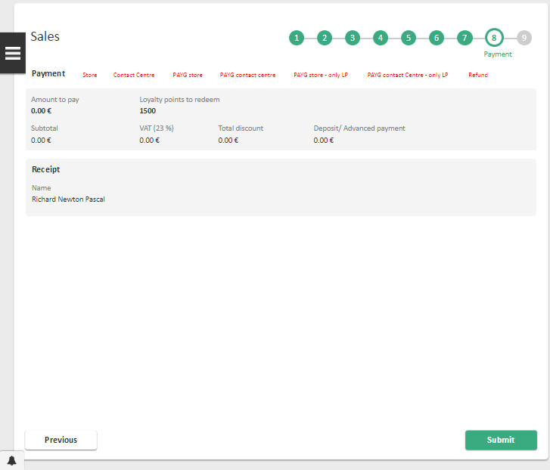

|  |  |
| --- | --- |
| Screen Description | |
| Display Name | Process name: Sales  Step name: Payment |

|  |
| --- |
| Field Description |
| Please refer to *Payment step* screen of *BS #2: Pay at Call Centre* on [5]. |

##### Payment step in Contact Centre - PAYG

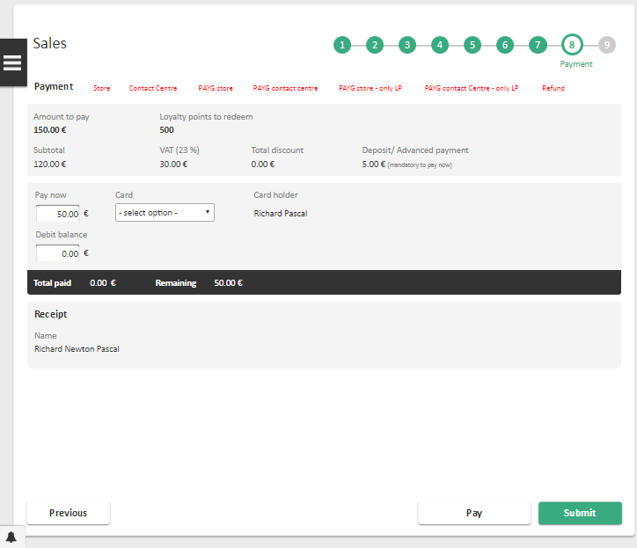

|  |  |
| --- | --- |
| Screen Description | |
| Display Name | Process name: Sales  Step name: Payment |

|  |
| --- |
| Field Description |
| Please refer to *Payment step* screen of *BS #2: Pay at Call Centre* on [5]. |

#### Phase IX – Finalization







##### Interaction step

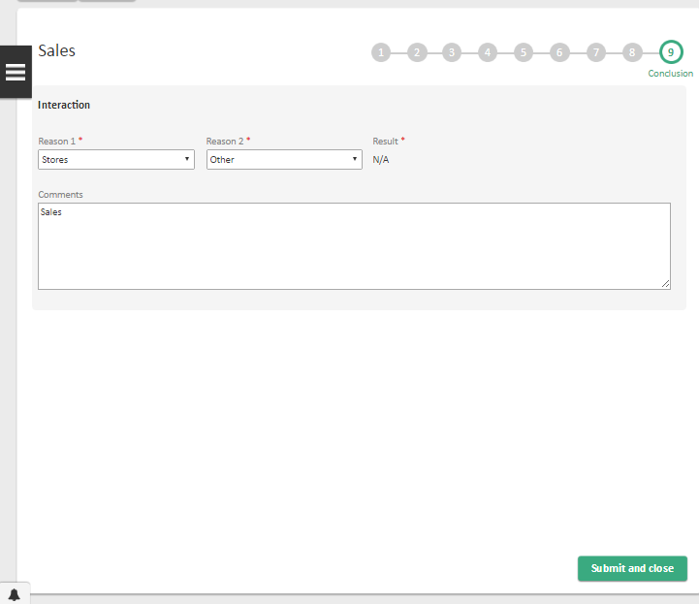

|  |  |
| --- | --- |
| Screen Description | |
| Display Name | Process name: Sales  Step name: Conclusion |

|  |
| --- |
| Field Description |
| Please refer to *Process interaction* screen description of *FEAT #1: Create interaction topic in process* on [4]. |

### BS #2: Subscribe a fixed or convergent offer

#### Phase I – Type of offer selection

Please refer to *Type of offer selection* screen specification on *BS #1: Subscribe a mobile offer*.

#### Phase II – Serviceability

Please refer to *036_VFIE_UFE_HLD_Serviceability HLD* [7]for all details concerning the serviceability process and respective screens.

#### Phase III – Create Customer and billing profile

Please refer to *Create Customer and billing profile step* screen specification on *BS #1: Subscribe a mobile offer*.

#### Phase IV – Basket Configuration

##### Fixed (TV, Broadband or Landline) component

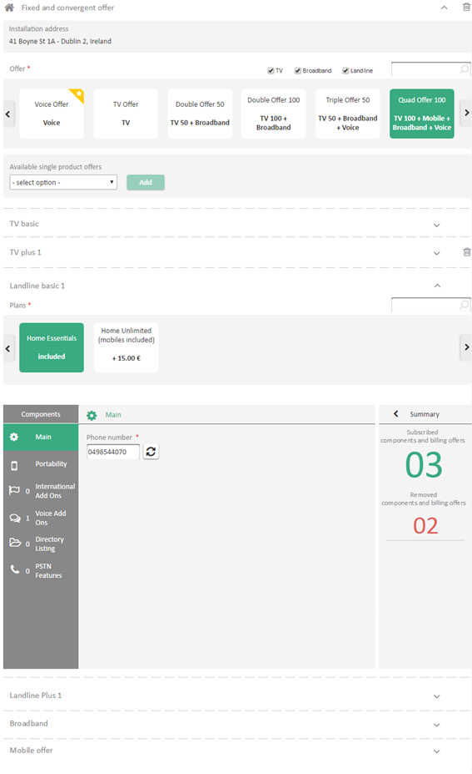

|  |  |
| --- | --- |
| Screen Description | |
| Display Name | Process name: Sales  Fixed (TV, Broadband or Landline) component |

|  |  |  |  |  |  |  |  |  |
| --- | --- | --- | --- | --- | --- | --- | --- | --- |
| Field Description | | | | | | | | |
| Label | | | | | **Type** | **Description** | **Read Only** | **Mandatory** |
| Installation address | | | | | Label | Installation address which the basket will be directed to.  Corresponds to the address provided on the Serviceability process. | Yes | - |
| Offer | | | | | Carrousel | List of offers available on the TV Plan / Broadband Plan / Landline Plan component. | No | Yes |
| Sub type | | | | | Checkbox list | Filters the offers on the **Offer** carrousel by its type.  Possible values, all pre-selected by default:   * TV * Broadband * Landline   By disabling one of these values, any offer that contains the selected value will not appear, even if paired with another option. | No | No |
| Search box | | | | | Textbox | Filters the offers on the **Offer** carrousel by its name. If there is no offer corresponding the search criteria, UFE will display the label in the carrousel area “No offers found with search criteria”. | No | No |
| Available single product offer + Add | | | | | Dropdown + Button | When an offer has a single product offer with cardinality bigger than one, UFE will display this area.  In the dropdown, the single product offers will be displayed and the user may add it to the basket by pressing the Add button.  Once a single product offer reach his maximum cardinality, it will disappear from the dropdown. Once all have been added, the area will disappear.  In the event of adding a single product offer being incompatible with one or more offers already in the basket, UFE will show the **component management confirmation** screen (described in the respective below section). If the user press yes, UFE will remove from the basket the single product offer and will add the new selected one. If the user press no, UFE will **not** remove the single product offer from the basket and will **not** add the new selected one. | No | No |
| Single product offer | | | | | Area | Name of the single product offer area | - | - |
| Trash icon | | | | | Icon | If the minimum cardinality of the single product offer is bigger than 0, this icon will not appear. When available, it will remove this single product offer from the basket. | - | - |
| Components *- Allows the configuration of all components under the offer.* | | | | | | | | |
| Plan | | | | Carrousel | List of billing offers available on the TV Plan / Broadband Plan / Landline Plan component under the fixed offer. Each carrousel item displays the following information:   * Billing offer name * Billing offer price.   The price displayed is the base price with VAT presented in MEC, and previously loaded to UFE through UFE Catalogue component (for further details on this component, please see [2]). | No | Depends on the attribute definition. |
| Main | | | | - | Allows the configuration of the following components under the offer:   * Main   This component will follow the below description for each field. | - | - |
| Phone number / Temporary phone number | | | Label + Edit icon+ Refresh icon | If the portability component is activated, the label is “Temporary phone number”. Otherwise, the label is “Phone number”.  In case of VOIP, the user may select from a pool of numbers, the desired one. In any other case (Non-VOIP) this field will be disabled.  Refresh icon may be used to refresh the list of available phone numbers. | Yes | Yes |
| *Other Main attributes* | | | Textbox / Dropdown | Any other visible and editable attributes of the Main component under the fixed offer are displayed here. If the attribute has an available list of values, UFE represents it as a dropdown. Otherwise, UFE represents it as a Textbox. | No | Depends on the attribute definition. |
| Portability | | | | - | Allows the user to configure the port in request.  This component is loaded only if the fixed offer has the Fixed Number Portability under it.  All visible and editable attributes of the Fixed Number Portability component under the fixed offer are displayed here. If the attribute has an available list of values, UFE represents it as a dropdown. Otherwise, UFE represents it as a Textbox. | - | - |
| STB | | | | - | UFE will get from UFE Catalogue the structure of the STB component.  As “Main STB” is mandatory, UFE will add automatically this component to basket (If customer wants to give a name to this STB, the user will fill “STB Name” attribute with the name provided by customer).  If the customer wants another or more STBs, UFE will add a new component (Zapper or OTT) for each STB, until reaching the maximum allowed for each STB type (4 for Zapper and 5 for OTT) | - | - |
| *Other components* – All remaining components under the fixed offer are treated on screen the same way, as described on the next lines. | | | | | | | |
| *Activate / Deactivate* | | | Toggle | Defines if the component must be activated or not.  If the component is mandatory under the fixed offer, the toggle is activated and disabled.  If the component is optional but should be activated by default, the toggle is activated and enabled, allowing the user to deactivate the component. | Depends on the component definition. | Yes |
| *Component attributes* | | | Textbox / Dropdown / Checkbox | Any visible and editable attributes of the component are displayed here. If the attribute has an available list of values, UFE represents it as a dropdown. If the attribute is a Yes/No attribute, UFE represents it as a checkbox. Otherwise, UFE represents it as a Textbox. In case of a cardinality of an attribute being more than 1, UFE will display a button for the user to be able to add more than one instance of this attribute. | No | Depends on the attribute definition. |
| *Add more component* | | | Button | In case a component can be added multiple times (e.g STB component) and uniquely configured, UFE will show this button for the user to be able to add more than one instance of this component. If the cardinality is only 1, this button will **not be visible.** | No | No |
| *Component billing offers* – List of billing offers under the component, if any. | | | | | | |
| *Billing offer name* | Label | Billing offer name | - | - |
| *Billing offer price* | Label | Billing offer base price.  This is the base price with VAT presented on MEC, and previously loaded to UFE through UFE Catalogue component (for full details on this UFE component, please see [2]). | - | - |
| *Activate / Deactivate* | Toggle | Allows the choice of the billing offer. | No | No |
| Sub components *– List of the sub components under the component, if any (e.g. Outgoing Calls component under the Voice and Messaging component). Attributes and billing offers under the sub components have the same specification as the corresponding element in the component itself.* | | | | | | |
| Summary *– Summary of the configuration made on the components.* | | | | | | | | |
| Summary | | | | Button | Show the summary of the subscribed, removed and updated | - | - |
| Components and billing offers | | Column | Name of the components and billing offers. | - | - |
| Operation | | Column | If was added, removed or updated. | - | - |
| Reason | | Column | Reason of the operation. | - | - |
| Type | | Column | Type of the add-on | - | - |
| Subscribed components and billing offers | | | | Label | Corresponds to the number of added components, sub components and billing offers. This includes mandatory and optional elements. Changes at attribute level aren´t counted. | - | - |
| Removed components and billing offers | | | | Label | On a campaign scenario, this corresponds to the number of removed components, sub components and billing offers. Changes at attribute level aren´t counted. | - | - |
| Check NBA | | | | Button | Allows the user to check if there are NBA campaigns suitable to the customer. | - | - |
| Summary | | | | Button | Shows the user the summary of all items in the basket along with their real prices. These prices are obtained through a call to quotation. | - | - |

#### Phase V – Shared Equipment

##### Shared equipment component

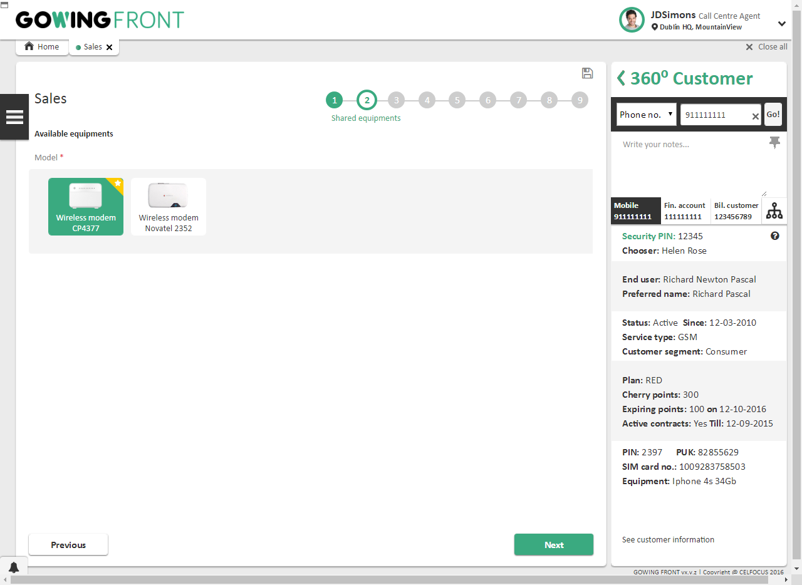

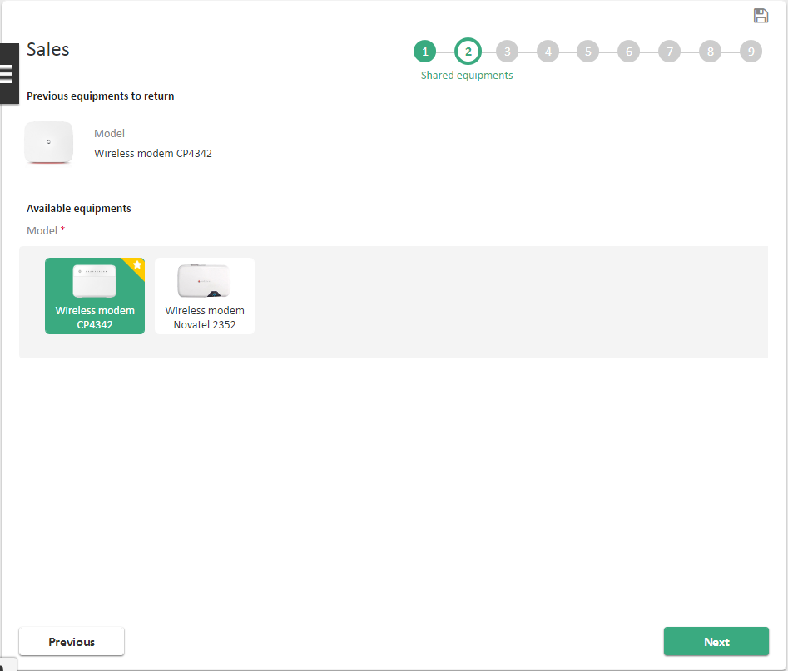

|  |  |
| --- | --- |
| Screen Description | |
| Display Name | Process name: Sales  Shared equipment component |

|  |  |  |  |  |
| --- | --- | --- | --- | --- |
| Field Description | | | | |
| Label | **Type** | **Description** | **Read Only** | **Mandatory** |
| Previous equipment’s to return | Label | In the scenarios of upgrade, where a Customer may have to return his shared equipment’s, this area will be **visible** and will indicate the information about the equipment to be returned. | Yes | - |
| Available Equipment’s / Model | Carrousel | Recommended shared equipment´s are shown here. The user may choose any from the recommended list. | No | Yes |

#### Phase VI – Billing profile details

Please refer to B*illing profile details step* screen specification on *BS #1: Subscribe a mobile offer*.

#### Phase VII – Installation

##### Installation details step

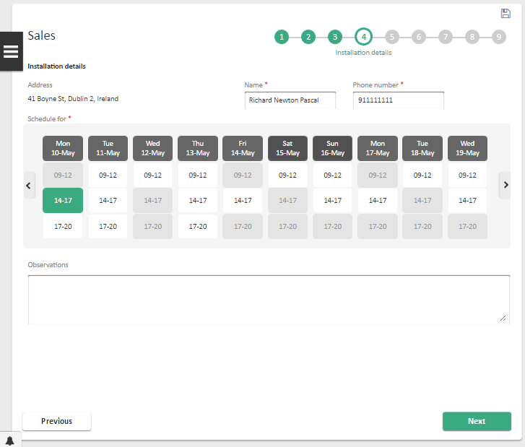

|  |  |
| --- | --- |
| Screen Description | |
| Display Name | Process name: Sales  Step name: SIRO Installation details step |

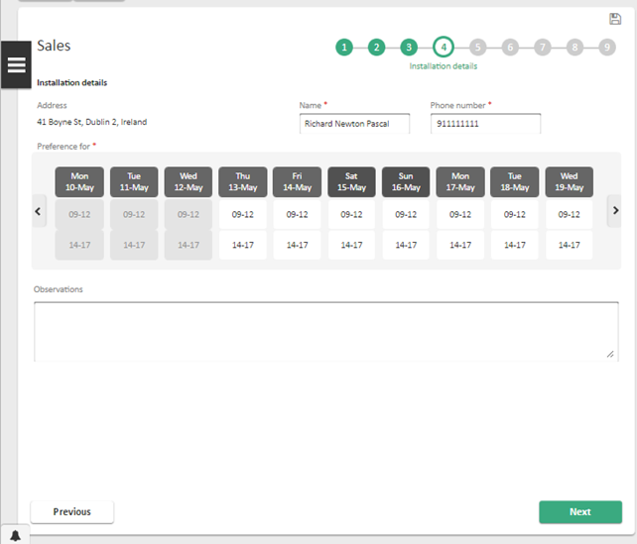

|  |  |
| --- | --- |
| Screen Description | |
| Display Name | Process name: Sales  Step name: BT & Eircom Installation details step |

|  |  |  |  |  |
| --- | --- | --- | --- | --- |
| Field Description | | | | |
| Label | **Type** | **Description** | **Read Only** | **Mandatory** |
| Input area | | | | |
| Address | Label | Installation address, captured on the Serviceability process. | - | - |
| Name | Textbox | Contact name for the installation of the fixed service. | No | No |
| Phone number | Textbox | Contact phone number for the installation of the fixed service. | No | No |
| Installation appointment | Calendar | List of available slots for the technician visit, only applicable if the chosen provider is SIRO.  For non-SIRO, UFE will schedule with +3 days, on a pre-defined slots for AM or PM. | No | Yes |
| Observations | Text area | Notes to be sent to the provider. | No | No |
| Actions area | | | | |
| Previous | Button | Go back to the previous step. | - | - |
| Next | Button | Sends user to the next step. | - | - |

#### Phase VIII – Delivery

Please refer to *Delivery step* screen specification on *BS #1: Subscribe a mobile offer*.

#### Phase IX – Confirmation

Please refer to *Confirmation step* screen specification on *BS #1: Subscribe a mobile offer*.

#### Phase X – Contracts and documentation

Please refer to *Contracts and documentation step* screen specification on *BS #1: Subscribe a mobile offer*.

#### Phase XI – Payment

Please refer to *Payment step* screen specification on *BS #1: Subscribe a mobile offer*.

#### Phase XII – Conclusion

Please refer to *Conclusion step* screen specification on *BS #1: Subscribe a mobile offer*.

### BS #3: Buy an equipment

#### Phase I – Products selection

***Select type of offer step***

Please refer to *Select type of offer step* screen specification on *BS #1: Subscribe a mobile offer*.

### BS #4: Buy an accessory

#### Phase I – Products selection

##### Select type of offer step

Please refer to *Select type of offer step* screen specification on *BS #1: Subscribe a mobile offer*.

### BS #5: Buy a top up voucher

#### Phase I – Products selection

##### Select type of offer step

Please refer to *Select type of offer step* screen specification on *BS #1: Subscribe a mobile offer*.

### BS #6: Buy back an equipment

#### Phase I – Products selection

##### Select type of offer step

Please refer to *Select type of offer step* screen specification on *BS #1: Subscribe a mobile offer*.

### BS #7: Subscribe a Retention or Upgrade campaign

#### Phase I – Products/Offers selection

##### Select type of offer step

Please refer to *Select type of offer step* screen specification on *BS #1: Subscribe a mobile offer*.

### FEAT #1: Save process

Refer to the previous business scenarios for screen specifications.

### FEAT #2: Recover process

Refer to the previous business scenarios for screen specifications.

## Integration Specification

**Note:** Operations Inputs and Outputs can only be described after target systems provide this information.

**Note:** Onlyoperations Inputs and Outputs with relevance in the current business scenario will be detailed in this section.

### BS #1: Subscribe a mobile offer

|  |  |  |  |  |  |
| --- | --- | --- | --- | --- | --- |
| Step # | Integration | System | Description | Sync/  Async | Depends On |
| 1a | Get Eligible Products List | OMS | Will retrieve eligible target offer | Sync | - |
| 1c | Get Loyalty Points | CherryPoints | Get Loyalty points of a given subscription. | Sync | - |
| 1e | Validate pending orders | OMS | Get orders for respective customer. Used to validate existence of pending orders. | Sync | - |
| 3b | Create Billing Customer and Billing profile | CRM | Create a new billing customer and a new billing profile associated to this customer | Sync | - |
| 4c  6b | Reserve phone number | ASRM | Reserve phone number to a given customer (ex: when buying a new phone and SIM) | Sync | - |
| 4b  6a  6b | Search available phone numbers | ASRM | Get available mobile phone numbers | Sync | - |
| 6b | Release reserved phone number | ASRM | Will release a previously reserved phone number | Sync | - |
| 7a | Get asset details | ORSIM | Get inventory information for a given (SIM card serial number→ product) | Sync | - |
| 7b  10h | Reserve asset | ORSIM | Reserve asset on inventory | Sync | - |
| 7c | Cancel asset reservation | ORSIM | Cancel a previous asset reservation on the inventory | Sync | - |
| 8a | Check Port Contact | ADM | Returns which operator the number belongs | Sync | - |
| 8b | Send SMS | ANM | Sends an SMS with a provided content to a target number. | Sync | - |
| 10b  10f | Get stock availability | ORSIM | Get the stock of a given product | Sync | - |
| 10f | Product Reservation | ORSIM | Will reserve the correspondent product | Sync | - |
| 12a | Get available campaigns | MCCM | Get list of available campaigns | Sync | - |
| 12c  12d | Accept-reject-postpone campaign | MCCM | Accept, reject or postpone a given campaign | Sync | - |
| 15b | Validate coupon | MCCM | Validate coupon and get coupon details | Sync | - |
| 15b | Apply coupon information | MCCM | Send information about coupon was applied | Sync | - |
| 4e  16a  16b  16c | Cancel Product Reservation | ORSIM | Cancels the product reservation | Sync | - |
| 16c | Cancel sales order | OMS | Cancel Order for a customer sale | Sync | - |
| 17a | Quote Orderable items | Quotation (internal call) | Request orderable items quotation | Sync | - |
| 18a | Create billing profile | CRM | Creates a billing profile (financial account, billing arrangement and pay mean) under a given billing customer | Sync | - |
| 18b | Check credit vetting | PowerCurve | Checks credit vetting for a given customer and a given basket content | Sync | - |
| Get credit vetting referral | PowerCurve | Get the referral result to display to the agent | Sync | - |
| 19d | Validate address | CRM | Validate address with given parameters | Sync | - |
| 20a | Create voucher | VM | Create a new top up voucher | - | - |
| 20d | Generate contract | OSB | Contract Generation | ASync | - |
| 20e | Create Sales Order | OMS | Create Order for a customer sale | Sync | - |
| 21b | Communicate Contract Sending | ANM | Triggers the contract sending to a customer address | Sync | - |
| 22a | Query generated contract | DMaaS | Obtain the generated document for the provided ID | Sync | - |
| 22b | Upload document | DMaaS | Upload relevant documents to the existent document management system, e.g. contracts, customer identification, invoice, receipt | Sync | - |
| 23 | Redeem loyalty points | CherryPoints | Redeem points | Sync | - |
| 24a | Submit sales order | OMS | Submit Order for a customer sale | Sync | - |
| 24c | Rollback loyalty points deduction | CherryPoints | Rollback the loyalty points deduction. | Sync | - |

### BS #2: Subscribe a fixed or convergent offer

|  |  |  |  |  |  |
| --- | --- | --- | --- | --- | --- |
| Step # | Integration | System | Description | Sync/  Async | Depends On |
| 1c | Get Loyalty Points | CherryPoints | Get Loyalty points of a given subscription. | Sync | - |
| 1e | Validate pending orders | OMS | Get orders for respective customer. Used to validate existence of pending orders. | Sync | - |
| 3b | Create Billing Customer and Billing profile | CRM | Create a new billing customer and a new billing profile associated to this customer | Sync | - |
| 4b  4e  4f | Search available phone numbers | ASRM | Get available phone numbers | Sync | - |
| 4c | Reserve phone number | ASRM | Reserve phone number to a given customer (ex: when buying a new phone and SIM) | Sync | - |
| 4d  4e  4f | Release reserved phone number | ASRM | Will release a previously reserved phone number | Sync | - |
| 6a | Check Port Contact | ADM | Returns which operator the number belongs | Sync | - |
| 6a | Check Port Contact | ADM | Returns which operator the number belongs | Sync | - |
| 7c  15a | Feasibility Check | OSB | Will return the feasibility status for a given address with a given offer and provider. Will reuse the QA QA response with the WLR PSTN Features settings | Sync | - |
| 13b | Validate coupon | MCCM | Validate coupon and get coupon details | Sync | - |
| 13b | Get Payment voucher details | MCCM | Send information about coupon was applied | Sync | - |
| 4g  14a  14b  14c | Cancel Product Reservation | ORSIM | Cancels the product reservation | Sync | - |
| 14c | Cancel sales order | OMS | Cancel Order for a customer sale | Sync | - |
| 15b | Fetch Feasibility Status | OSB | Will return the feasibility status for a given address (NLE/LE scenario) | Sync | - |
| 16a | Create Sales Order | OMS | Create Order for a customer sale | Sync | - |
| 17a  17c | Get Recommended shared equipment’s | OMS | Get the recommended shared equipment´s for a given offer | Sync | - |
| 18a | Quote Orderable items | Quotation | Request orderable items quotation | Sync | - |
| 19a | Create billing profile | CRM | Creates a billing profile (financial account, billing arrangement and pay mean) under a given billing customer | Sync | - |
| 19b | Check credit vetting | PowerCurve | Checks credit vetting for a given customer and a given basket content | Sync | - |
| Get credit vetting referral | PowerCurve | Get the referral result to display to the agent | Sync | - |
| 20a | Get available SIRO schedule slots | SIRO | Get available schedule slots for SIRO to perform a fixed installation | Sync | - |
| 20b | Reserve schedule slot | SIRO | Reserve selected schedule slot to perform a fixed installation | Sync | - |
| 21d | Validate address | CRM | Validate address with given parameters | Sync | - |
| 22a | Create voucher | VM | Create a new top up voucher | - | - |
| 22b | Create Sales Order | OMS | Create Order for a customer sale | Sync | - |
| 22d | Generate contract | OSB | Contract Generation | ASync | - |
| 23b | Communicate Contract Sending | ANM | Triggers the contract sending to a customer address | Sync | - |
| 24a | Query generated contract | DMaaS | Obtain the generated document for the provided ID | Sync | - |
| 24b | Upload document | DMaaS | Upload relevant documents to the existent document management system, e.g. contracts, customer identification, invoice, receipt | Sync | - |
| 25 | Redeem loyalty points | CherryPoints | Redeem points | Sync | - |
| 26a | Submit sales order | OMS | Submit Order for a customer sale | Sync | - |
| 26c | Rollback loyalty points deduction | CherryPoints | Rollback the loyalty points deduction. | Sync | - |

### BS #3: Buy an equipment

|  |  |  |  |  |  |
| --- | --- | --- | --- | --- | --- |
| Step # | Integration | System | Description | Sync/  Async | Depends On |
| 1b  1h  1f  2a | Get stock availability | ORSIM | Get the stock of a given product | Sync | - |
| 1e | Get loyalty points | CherryPoints | Get available loyalty points | Sync | - |
| 1h | Product Reservation | ORSIM | Will reserve the correspondent product | Sync | - |

### BS #4: Buy an accessory

|  |  |  |  |  |  |
| --- | --- | --- | --- | --- | --- |
| Step # | Integration | System | Description | Sync/  Async | Depends On |
| 1b  1h  1e  2a | Get stock availability | ORSIM | Get the stock of a given product | Sync | - |
| 1d | Get loyalty points | CherryPoints | Get available loyalty points | Sync | - |
| 1g | Product Reservation | ORSIM | Will reserve the correspondent product | Sync | - |



### BS #5: Buy a top up voucher

|  |  |  |  |  |  |
| --- | --- | --- | --- | --- | --- |
| Step # | Integration | System | Description | Sync/  Async | Depends On |
| 1b | Get loyalty points | CherryPoints | Get available loyalty points | Sync | - |

### BS #6: Buyback an equipment

|  |  |  |  |  |  |
| --- | --- | --- | --- | --- | --- |
| Step # | Integration | System | Description | Sync/  Async | Depends On |
| - | - | - | - | - | - |



### BS #7: Subscribe a Retention or Upgrade campaign

|  |  |  |  |  |  |
| --- | --- | --- | --- | --- | --- |
| Step # | Integration | System | Description | Sync/  Async | Depends On |
| 1a | Analyse and produce summary | OMS | This API will perform analysis for a given full blown campaign or a regular Replace offer scenario and provide results of analysis | Sync | - |

### FEAT #1: Save process

|  |  |  |  |  |  |
| --- | --- | --- | --- | --- | --- |
| Step # | Integration | System | Description | Sync/  Async | Depends On |
| 1b | Validate pending orders | OMS | Validate if there's any pending order for a given context or entity | Sync | - |
| Create Sales Order | OMS | Create Order for a customer sale | Sync | - |
| Update Sales Order | OMS | Update Order for a customer sale | Sync | - |

### FEAT #2: Recover process

|  |  |  |  |  |  |
| --- | --- | --- | --- | --- | --- |
| Step # | Integration | System | Description | Sync/  Async | Depends On |
| 1a | Validate pending orders | OMS | Validate if there's any pending order for a given context or entity, based on status = INITIAL | Sync | - |
| 2a | Get available campaigns | MCCM | Retrieves available campaigns | Sync | - |
|  |  |  |  |  |  |
|  |  |  |  |  |  |
| 2e | Get Sales Orders | OMS | Get orders from OMS in order to retrieve the orderable items | Sync | - |
| 2f | Update Sales Order | OMS | Used to update a sales order | Sync | - |

# Security Constraints

## User Profiling

|  |  |  |  |
| --- | --- | --- | --- |
| Object | BS / FEAT # | Activity # | Type of Permission |
| Sales process access | All | - | Process access |
| Override credit vetting permission | BS#1 | 18 | Credit Vetting Override |

## Data Audit

|  |  |  |
| --- | --- | --- |
| BS/ FEAT# | Activity # | Step # |
| BS #1 | Activity 1 | 1a |
| BS #1 | Activity 1 | 1e |
| BS #1 | Activity 3 | 3b |
| BS #1 | Activity 4 | 4b |
| BS #1 | Activity 4 | 4c |
| BS #1 | Activity 6 | 6a |
| BS #1 | Activity 6 | 6b |
| BS #1 | Activity 7 | 7a |
| BS #1 | Activity 7 | 7b |
| BS #1 | Activity 7 | 7c |
| BS #1 | Activity 8 | 8a |
| BS #1 | Activity 8 | 8b |
| BS #1 | Activity 10 | 10b |
| BS #1 | Activity 10 | 10e |
| BS #1 | Activity 10 | 10h |
| BS #1 | Activity 12 | 12a |
| BS #1 | Activity 12 | 12c |
| BS #1 | Activity 12 | 12d |
| BS #1 | Activity 15 | 15b |
| BS #1 | Activity 16 | 16a |
| BS #1 | Activity 16 | 16b |
| BS #1 | Activity 17 | 17a |
| BS #1 | Activity 18 | 18a |
| BS #1 | Activity 18 | 18e |
| BS #1 | Activity 19 | 19d |
| BS #1 | Activity 20 | 20a |
| BS #1 | Activity 20 | 20b |
| BS #1 | Activity 21 | 21b |
| BS #1 | Activity 22 | 22a |
| BS #1 | Activity 22 | 22b |
| BS #1 | Activity 23 | 23 |
| BS #1 | Activity 24 | 24a |
| BS #2 | Activity 1 | 1e |
| BS #2 | Activity 3 | 3b |
| BS #2 | Activity 4 | 4b |
| BS #2 | Activity 4 | 4c |
| BS #2 | Activity 4 | 4e |
| BS #2 | Activity 6 | 6a |
| BS #2 | Activity 7 | 7c |
| BS #2 | Activity 14 | 14b |
| BS #2 | Activity 15 | 15a |
| BS #2 | Activity 15 | 15b |
| BS #2 | Activity 16 | 16a |
| BS #2 | Activity 16 | 16b |
| BS #2 | Activity 17 | 17a |
| BS #2 | Activity 18 | 18a |
| BS #2 | Activity 19 | 19a |
| BS #2 | Activity 20 | 20a |
| BS #2 | Activity 20 | 20e |
| BS #2 | Activity 21 | 21a |
| BS #2 | Activity 21 | 21b |
| BS #2 | Activity 21 | 21c |
| BS #2 | Activity 22 | 22d |
| BS #2 | Activity 23 | 23a |
| BS #2 | Activity 23 | 23b |
| BS #2 | Activity 23 | 23d |
| BS #2 | Activity 24 | 24b |
| BS #2 | Activity 25 | 25a |
| BS #2 | Activity 25 | 25b |
| BS #2 | Activity 26 | 26 |
| BS #2 | Activity 27 | 27a |
| BS #3 | Activity 1 | 1b |
| BS #3 | Activity 1 | 1e |
| BS #3 | Activity 1 | 1h |
| BS #3 | Activity 2 | 2a |
| BS #4 | Activity 1 | 1b |
| BS #4 | Activity 1 | 1e |
| BS #4 | Activity 1 | 1h |
| BS #4 | Activity 2 | 2a |
| BS #7 | Activity 1 | 1a |
| FEAT #1 | Activity 1 | 1b |
| FEAT #1 | Activity 1 | 1c |
| FEAT #2 | Activity 1 | 1a |
| FEAT #2 | Activity 2 | 2d |

# Reference Data

The content of this chapter will be referred to the UFE Reference Data Matrix [1].

# Messages

## Error messages

|  |  |  |  |
| --- | --- | --- | --- |
| Message # | Message | BS /  FEAT # | Activity # / Screen |
| EM_SAL_1 | It was not possible to get the available MSISDNs. Please try again. | BS #1 | Activity 4 |
| EM_SAL_2 | It was not possible to reserve the specified MSISDN. Please try again. | BS #1 | Activity 4 |
| EM_SAL_3 | The chosen MSISDN is not available. Please choose/search for another MSISDN. | BS #1 | Activity 6 |
| EM_SAL_4 | It was not possible to get the SIM card details. Please try again. | BS #1 | Activity 7 |
| EM_SAL_5 | The provided SIM card is not available. Please provide another one. | BS #1 | Activity 7 |
| EM_SAL_6 | It was not possible to reserve the SIM card. Please try again. | BS #1 | Activity 7 |
| EM_SAL_7 | The provided port-in number is already a VFIE number. | BS #1 | Activity 8 |
| EM_SAL_8 | It was not possible to validate the port-in number. Please try again. | BS #1  BS #7 | Activity 8  Activity 1 |
| EM_SAL_9 | The port-in number does not belong to the provided donor operator. Please correct the data. | BS #1 | Activity 8 |
| EM_SAL_10 | It was not possible to get the product details. Please try again. | BS #1 | Activity 10 |
| EM_SAL_11 | It was not possible to calculate the basket final value. Please try again. | BS #1 | Activity 17 |
| EM_SAL_12 | It was not possible to check credit vetting. Please try again. | BS #1 | Activity 19 |
| EM_SAL_13 | The credit vetting was rejected. Please inform the customer. | BS #1 | Activity 19 |
| EM_SAL_14 | It was not possible to generate the contracts. Please try again. | BS #1 | Activity 23 |
| EM_SAL_15 | It was not possible to create the customer and the billing profile. The order was not submitted. | BS #1 | Activity 3 |
| EM_SAL_16 | It was not possible to create the billing profile. The order was not submitted. | BS #1 | Activity 18 |
| EM_SAL_17 | It was not possible to upload the signed documents. Please try again. | BS #1 | Activity 23 |
| EM_SAL_18 | It was not possible to submit the final order. Please try again. | BS #1  BS #2 | Activity 24  Activity 26 |
| EM_SAL_19 | It was not possible to get the available fixed phone number. Please try again. | BS #2 | Activity 4 |
| EM_SAL_20 | It was not possible to reserve an available fixed phone number. Please try again. | BS #2 | Activity 4 |
| EM_SAL_21 | An error occurred while cancelling the order. Please try again | BS #1  BS #2 | Activity 16  Activity 14 |
| EM_SAL_22 | It was not possible to get the available slots for the technician visit. Please try again. | BS #1 | Activity 19 |
| EM_SAL_23 | It was not possible to reserve the chosen slot. Please try again. | BS #1 | Activity 19 |
| EM_SAL_24 | It was not possible to get the accessory details. Please try again. | BS #4 | Activity 1 |
| EM_SAL_25 | An error occurred while checking the feasibility. Please press the next button to try again. | BS #2 | Activity 15 |
| EM_SAL_26 | It was not possible to get the top up voucher from the catalogue. Please try again. | BS #6 | Activity 1 |
| EM_SAL_27 | It was not possible to get the buyback from the catalogue. Please try again. | BS #6 | Activity 1 |
| EM_SAL_28 | Please contextualize a customer in order to proceed or go to POS. | BS #3  BS #4 | Activity 1 |
| EM_SAL_30 | The product was not found in the catalogue. | BS #1 | Activity 10 |
| EM_SAL_31 | It was not possible to get the available stores. Please try again. | BS #1 | Activity 10 |
| EM_SAL_32 | It was not possible to check the available stock on the chosen store. | BS #1 | Activity 10 |
| EM_SAL_34 | It was not possible to generate the top up voucher ID. Please try again. | BS #1 | Activity 21 |
| EM_SAL_35 | An error occurred while sending SMS. Please try again. | BS #1 | Activity 8 |
| EM_SAL_36 | An error occurred sending the coupon confirmation. Please try again. | BS #1  BS #2 | Activity 24  Activity 26 |
| EM_SAL_37 | An equipment in the basket has already a delivery method defined. All other equipment’s need to be delivered in the same way. | BS #1 | Activity 10 |
| EM_SAL_38 | The chosen offer is not available anymore. | FEAT #2 | Activity 1 |
| EM_SAL_39 | Using a campaign and a coupon in the same basket is not possible. | BS #1  BS #2 | Activity 15  Activity 13 |
| EM_SAL_40 | An error occurred when trying to save the basket. Please try again manually. | BS #1  BS #2 | Activity 21 |
| EM_SAL_41 | The request for contract generation failed. Please try again | BS #1 | Activity 20  Activity 22 |
| EM_SAL_43 | An error occurred while validating the coupon. Please try again. | BS #1 | Activity 15 |
| EM_SAL_44 | An error occurred while reserving the products. Please try again. | BS #1 | Activity 10 |
| EM_SAL_45 | An error occurred while getting the shared equipment. Please try again. | BS #2 | Activity 16 |
| EM_SAL_46 | An error occurred while download the contract. The process cannot continue until the contract is returned. You may save the basket and try again later. | BS #1 | Activity 23 |
| EM_SAL_47 | An error occurred while getting the price of the equipment. Please try again. | BS #1 | Activity 10 |
| EM_SAL_48 | Address not found in CRM, please provide an existing address | BS#1 | Activity 20 |
| EM_SAL_49 | An error occurred while calling the service to send the contracts to the Customer address. Please try again | BS#1 | Activity 22 |
| EM_SAL_50 | The chosen fixed voice number is not available. Please choose/search for another fixed voice number. | BS #2 | Activity 4 |
| EM_SAL_51 | An error occurred while taking over the order. Please try again. | FEAT#2 | Activity 2 |
| EM_SAL_52 | There are pending orders on the provider side. The process cannot continue. | BS#2 | Activity 15 |
| EM_SAL_53 | An error occurred while checking the line status. Please try again. | BS#2 | Activity 15 |
| EM_SAL_54 | An error occurred while cancelling the reservations made. Please try again | BS#1 | Activity 16 |
| EM_SAL_55 | The Customer is in collections. The Customer must first be out of collections in order to be able to access this process. | BS #1 | Activity 1 |
| EM_SAL_56 | An error occurred while releasing the reserved phone number. Please try again. | BS #1 | Activity 6 |
| EM_SAL_58 | The telephone number (CLI) given by the Customer is not the same returned by feasibility check {number}. Please validate. | BS #2 | Activity 15 |
| EM_SAL_59 | An error occurred while getting the WLR PSTN Features. Please try again. | BS #2 | Activity 6 |
| EM_SAL_60 | The customer has pending orders in ordering side. The process cannot continue | BS #1  BS #2 | Activity 1 |
| EM_SAL_61 | An error occurred while creating an order. Please try again. | BS #1  BS #2 | Activity 20  Activity 22 |
| EM_SAL_62 | The code given by the Customer does not match the one generated. Please confirm again. | BS #1 | Activity 8 |
| EM_SAL_63 | A validation port-in code is necessary for the portability to be made. Please go to the Portability component and proceed accordingly. | BS #1 | Activity 8 |
| EM_SAL_64 | An error occurred while doing the rollback of the loyalty point deduction. Please retry by submitting the previous action. | BS #1  BS #2 | Activity 24  Activity 27 |
| EM_SAL_65 | An error occurred while getting the loyalty points. Please try again. | BS #1  BS #2  BS #3  BS #4  BS #5 | Activity 1 |

## Success messages

|  |  |  |  |
| --- | --- | --- | --- |
| Message # | Message | BS /  FEAT # | Activity # / Screen |
| SM_SAL_1 | The credit vetting is approved. | BS #1 | Activity 18 |
| SM_SAL_2 | The billing customer and billing profile was successfully created. | BS #1 | Activity 3 |
| SM_SAL_3 | The billing profile was successfully created. | BS #1 | Activity 18 |
| SM_SAL_4 | The documents %document type% were successfully uploaded. | BS #1 | Activity 23 |
| SM_SAL_5 | The order was successfully submitted. | BS #1 | Activity 25 |
| SM_SAL_9 | Loyalty points were successfully credited. Please retry the last action to deduce them again. | BS #1  BS #2 | Activity 24  Activity 27 |
| SM_SAL_10 | Contracts will be sent to the Customer address defined in the primary contact. | BS #1  BS #2 | Activity 21  Activity 23 |

## Warning messages

|  |  |  |  |  |
| --- | --- | --- | --- | --- |
| Message # | Message | BS /  FEAT # | Activity # / Screen | |
| WM_SAL_1 | There are no available offers. | BS #1 | Activity 1 | |
| WM_SAL_2 | It was not possible to cancel the reservation of the previous SIM card. | BS #1 | Activity 7 | |
| WM_SAL_3 | The customer needs to do an advanced payment of %amount% in order to perform the subscription(s) activation(s). Please inform the customer. The payment will be handled later in the process. | BS #1 | Activity 18 | |
| WM_SAL_4 | The customer needs to do a deposit of %amount% in order to perform the subscription(s) activation(s). Please inform the customer. The payment will be handled later in the process. | BS #1 | Activity 18 | |
| WM_SAL_5 | The credit vetting is referral with the ID: {referralID}. Please press the “Get Referral Results” button to obtain the result. | BS #1  BS #2 | Activity 18  Activity 20 | |
| WM_SAL_6 | There are no available slots for the technician visit. | BS #2 | Activity 21 | |
| WM_SAL_7 | UFE cannot apply the correction automatically due to a problem in identifying which product is causing the incompatibility. Please proceed manually with the corrections. | BS #1 | Activity 9  Activity 13 | |
| BS #2 | Activity 7 | |
| WM_SAL_8 | There are no results for your search. | BS #1 | Activity 10 | |
| WM_SAL_10 | The result from this referral is: {creditVettingReferralMessage} | BS #1  BS #2 | Activity 18  Activity 20 | |
| WM_SAL_11 | The following products are no longer in stock and were removed from the current basket: {productsName] | FEAT #2 | Activity 2 | |
| WM_SAL_12 | The basket can only contain one fixed or convergent offer. For multiple fixed or convergent activations, please follow the entire process for each one, independently. | BS #2 | Activity 1 | |
| WM_SAL_13 | Please confirm with the user if he wishes to make a buyback. | BS #6 | Activity 1 | |
| WM_SAL_14 | Please insert the code received by the customer in the port in code area. | BS #1 | Activity 8 | |
| WM_SAL_15 | There are not enough loyalty points for this product. | BS #1  BS #2  BS #3  BS #4  BS #5 | Activity 1 | |
| WM_SAL_16 | UFE detected an unconformity in the selected offer. The respective changes {Added: [addedProducts], Removed: [removedProducts]} have been made. Please verify before continuing. | BS #1 | Activity 13 | |
| WM_SAL_18 | The coupon has already been used. Please check if the coupon number is correct or input another coupon number. | BS #1 | Activity 15 | |
| WM_SAL_19 | The product {name} went out of stock during the sales process. Please remove this product from the basket in order to continue. | BS #1 | Activity 10 | |
| WM_SAL_20 | Feasibility is not yet ready. Please inform the customer that he will be later contacted to schedule the technician visit if necessary. | BS #2 | Activity 15 | |
| WM_SAL_21 | There are no other items in the basket. | FEAT #2 | Activity 2 | |
| WM_SAL_22 | The basket has an invalid associated campaign. The campaign line item was removed but other items may remain. Please review them accordingly. | FEAT #2 | Activity 2 | |
| WM_SAL_23 | The following products have a different base price from the time when the basket was saved: {productsName] | FEAT #2 | Activity 2 | |
| WM_SAL_24 | Please inform the user that he must collect the order in the selected store with the ID: {Basket ID} | BS #1 | Activity 23 | |
| WM_SAL_25 | Credit Vetting is now active. The customer will be subjected to a credit vetting analysis. | BS #1 | Activity 18 | |
| WM_SAL_26 | Credit Vetting is now inactive. The customer will not be subjected to a credit vetting analysis. | BS #1 | Activity 18 | |
| WM_SAL_27 | Line Enquiry result is: {insituNonInsituResponse} and {lineActive/lineInactive}. Please press “Next” to proceed if desired. | BS #2 | Activity 16 | |
| WM_SAL_28 | Not all contracts have been selected to be uploaded. Please correct this to continue. | BS #1  BS #2 | Activity 22  Activity 25 | |

# Technical Design

## Introduction

### Purpose

This chapter provides a high level description of Unified Frontend Processes, from a technical point of view, and is intended to target both Vodafone Ireland and Celfocus teams:

* **Vodafone’s Business/Technical Teams:** To use as a technical overview of each process.
* **Celfocus Development:** To use as a basis for implementation.
* **Celfocus Quality Management:** To clarify implementation.

The reader is assumed to have basic knowledge of Vodafone services and features. Knowledge and understanding of Unified Modelling Language (UML) artifacts is also required.

### Conventions

Defines and describes any standards or typographical conventions that were followed when writing this specification, including text styles, highlighting and significant notations.

#### Artifact Identification

Artifacts, like *Sequence Diagrams* will be uniquely identifiable within the context of this application. Their ID will have the below defined structure.

##### Sequence Diagram

Sequence Diagrams will provide a simplified graphical representation of workflows that focuses on detailing the sequence of activities and the participating objects that exist in each process.

**Format:** AD.*<feature ID/acronym>*.*<sequential number>*

*e.g.*, AD.IF.001 would correspond to the first Sequence Diagram of the *Invoice Format* feature.

### Structure

This chapter is organized into the following sections:

* **Introduction**, which introduces this document to its readers.
* **Technical Overview**, which specifies the system behaviour detailing each process workflow. This section will be specified based in sequence diagrams and subsequent descriptions.

## Technical Overview

### Description

In the Sales process, the agents are allowed to assist the customers on acquiring products and activate offers. They are able to provide the customer with varied information regarding the products and available offers. The agents will also be able to retrieve contact and billing information from the customer, and perform tasks such as pre-orders, reservation of equipment or other related tasks.

### System Interfaces

The table below presents the backend systems that are part of this process, its description and Interface ID according to the IML file (Interface Master List). The description provided is specific for this process, even though the system could serve a much wider scope.

|  |  |  |
| --- | --- | --- |
| Name | Description | Interface ID |
| UFEBasket Interface | UFE will create an internal payment order with the details of the basket (including top-up). POS will pull the basket information via this interface to make the payment and print the receipt with the basket details. | IF099.08 |
| Manage CherryPoints (CherryPoints) | Query / consume loyalty points, View cherry points balance and opt in/out of cherry points | IF192.01 |
| Customer Management activities (CRM) | Search, address Validation , New Customer, update Customer, Case, Interaction, List Notifications | IF192.02 |
| Port-IN (Porting snap shot) | Validate if the number was already ported in | IF192.03 |
| Store/ Stock Inventory management (ORSIM) | Stock Availability, Reservation, Validate serial number | IF192.07 |
| Credit Vetting (OSB) | Check Credit Vetting - first leg (see IF226.04 + IF226.05 on IML) | IF192.09 |
| Appointment Scheduling (SIRO Gateway) | Retrieve available slots (according to SIRO) to be reserved by UFE on installations | IF192.12 |
| Campaign, NBA, Best Price Plan and Retention Information (MCCM) | Campaign, NBA, Best Price Plan and Retention Information | IF192.16 |
| Create/Cancel Voucher (VM) | Create new top up voucher | IF192.23 |
| OL resource Management (ASRM) | Resource Number Management and allocation from OL | IF192.27 |
| Manage Products and Orders Online (OMS) | Get Product information for Query/Update By Online Systems  Negotiate Product for from OL application including add-ons, Bundles, Offers, campaign;  Manage OrderAction from Online application (including create, cancel);  Generate Contract PDF from OL application | IF192.28 |
| Manage coupon (MCCM) | Coupon management | IF192.30 |
| Upload Customer Documents (DMaaS) | Save uploaded documents | IF192.35 |
| UFE Notifications (ANM) | Send customer notification (email) with contract details | IF192.41 |

### Service Calls

This section lists service calls (when particularly relevant to the process flow) with the corresponding expected input and output parameters. The Interface and Service Id’s included reflect what was included on the IML and Service Definition Tracker.

**Note**: Additionally to the following services, consider also the service calls for the referenced documents on annex.

|  |  |  |
| --- | --- | --- |
|  | |  |
| Service | Search available phone numbers | |
| Relevant Input Notes | N/A | |
| Relevant Output Notes | The response returns a list of available MSISDNs | |
| Interface Id | IF192.27 | |
| Service Id | 584 | |
| CSM Service | LogicalResourceInventoryItem | |
| CSM Operation | GetLogicalResourceInventoryItemList | |

|  |  |  |
| --- | --- | --- |
|  | |  |
| Service | Reserve phone number | |
| Relevant Input Notes | The request is made against a phone number and the contextualized costumer | |
| Relevant Output Notes | The response returns the reservation status | |
| Interface Id | IF192.27 | |
| Service Id | 583 | |
| CSM Service | LogicalResourceInventoryItem | |
| CSM Operation | UpdateLogicalresourceInventoryItem | |

|  |  |  |
| --- | --- | --- |
|  | |  |
| Service | Analyse and produce summary | |
| Relevant Input Notes | The request is made against the existing offer and the selected offer | |
| Relevant Output Notes | The response returns the necessary actions to be submitted in the final orders | |
| Interface Id | IF192.28 | |
| Service Id | 714 | |
| CSM Service | CompareOffer | |
| CSM Operation | Compare | |



|  |  |  |
| --- | --- | --- |
|  | |  |
| Service | Validate coupon | |
| Relevant Input Notes | The request is made against the typed coupon ID | |
| Relevant Output Notes | The response returns the coupon status and its details | |
| Interface Id | IF192.30 | |
| Service Id | 547 | |
| CSM Service | PaymentVoucher | |
| CSM Operation | GetPaymentVoucherList | |

|  |  |  |
| --- | --- | --- |
|  | |  |
| Service | Create voucher | |
| Relevant Input Notes | The request sends a voucher value and type | |
| Relevant Output Notes | The response should return the status and amount of voucher | |
| Interface Id | IF192.23 | |
| Service Id | 547 | |
| CSM Service | PaymentVoucher | |
| CSM Operation | GetPaymentVoucherList | |

|  |  |  |
| --- | --- | --- |
|  | |  |
| Service | Get asset details | |
| Relevant Input Notes | The request is made against a given asset | |
| Relevant Output Notes | The response returns the inventory information for the given asset | |
| Interface Id | IF192.07 | |
| Service Id | TBD | |
| CSM Service | PhysicalResourceInventoryItem | |
| CSM Operation | GetPhysicalResourceInventoryItemList | |

|  |  |  |
| --- | --- | --- |
|  | |  |
| Service | Reserve asset | |
| Relevant Input Notes | The request is made against a given asset and the contextualized costumer | |
| Relevant Output Notes | The response returns the status of the request and the reservation identifier | |
| Interface Id | IF192.07 | |
| Service Id | 499 | |
| CSM Service | ProductStockReservation | |
| CSM Operation | CreateProductStockReservation | |







|  |  |  |
| --- | --- | --- |
|  | |  |
| Service | Get stock availability | |
| Relevant Input Notes | The request is made against a given item identifier and store | |
| Relevant Output Notes | The response returns the stock availability | |
| Interface Id | IF192.07 | |
| Service Id | 501 | |
| CSM Service | ProductStock | |
| CSM Operation | GetProductStockList | |



|  |  |  |
| --- | --- | --- |
|  | |  |
| Service | Get available campaigns | |
| Relevant Input Notes | The request is made against the contextualized billing customer, campaign type and user role | |
| Relevant Output Notes | The response returns the available campaigns for the provided search parameters, with the Campaign name, description and Components to add | |
| Interface Id | IF192.16 | |
| Service Id | 579 | |
| CSM Service | CustomerMarketingProduct | |
| CSM Operation | GetCustomerMarketingProductList | |



|  |  |  |
| --- | --- | --- |
|  | |  |
| Service | Check credit vetting / Get credit vetting referral | |
| Relevant Input Notes | The request should be made for a given customer and operation | |
| Relevant Output Notes | The response returns a status about the credit vetting for the customer  When a “ACCEPTED-WITH-CONDITIONS” status is returned, the service also returns a type of condition (Deposit / Advance payment) and the corresponding MEC Id and amount. | |
| Interface Id | IF192.09 | |
| Service Id | 370 | |
| CSM Service | CustomerCreditRating | |
| CSM Operation | CheckCustomerCreditRating | |

|  |  |  |
| --- | --- | --- |
|  | |  |
| Service | Get available SIRO schedule slots | |
| Relevant Input Notes | N/A | |
| Relevant Output Notes | The response should return the status of the request and a reservation identifier | |
| Interface Id | IF192.12 | |
| Service Id | 672 | |
| CSM Service | WorkforceAppointmentSlot | |
| CSM Operation | GetWorkforceAppointmentSlotList | |

|  |  |  |
| --- | --- | --- |
|  | |  |
| Service | Reserve schedule slot | |
| Relevant Input Notes | The request should be made against a slot with the provided reservation identifier | |
| Relevant Output Notes | The response should return the status of the request | |
| Interface Id | IF192.12 | |
| Service Id | 673 | |
| CSM Service | CustomerAppointment | |
| CSM Operation | CreateCustomerAppointment | |







|  |  |  |
| --- | --- | --- |
|  | |  |
| Service | Create sales order | |
| Relevant Input Notes | The request should be made for the given order and contextualized customer | |
| Relevant Output Notes | The response should return the status of the order and its identifier | |
| Interface Id | IF192.28 | |
| Service Id | 429 | |
| CSM Service | SalesOrder | |
| CSM Operation | CreateSalesOrder | |

|  |  |  |
| --- | --- | --- |
|  | |  |
| Service | Get Recommended shared equipment’s | |
| Relevant Input Notes | The request should be made for the given offer | |
| Relevant Output Notes | The response should return the list of possible shared equipment | |
| Interface Id | IF192.28 | |
| Service Id | 715 | |
| CSM Service | RecommendCustomerEquipment | |
| CSM Operation | RecommendCustomerEquipment | |

|  |  |  |
| --- | --- | --- |
|  | |  |
| Service | Redeem loyalty points | |
| Relevant Input Notes | The request sends the loyalty points quantity to be redeemed | |
| Relevant Output Notes | The response should return the operation status | |
| Interface Id | IF192.01 | |
| Service Id | 366 | |
| CSM Service | LoyaltyAccountAdjustment | |
| CSM Operation | CreateLoyaltyAccountAdjustment | |

|  |  |  |
| --- | --- | --- |
|  | |  |
| Service | Generate contract | |
| Relevant Input Notes | The request should be made for the given document IDs, customer data and sale details | |
| Relevant Output Notes | The service will return the document ID and the request status. | |
| Interface Id | IF192.28 | |
| Service Id | 574 | |
| CSM Service | CustomerAgreement | |
| CSM Operation | CreateCustomerAgreement | |

|  |  |  |
| --- | --- | --- |
|  | |  |
| Service | Query generated contract | |
| Relevant Input Notes | This request should be made for the given contract and document ID | |
| Relevant Output Notes | The response should return a draft of the contract for signature | |
| Interface Id | IF192.35 | |
| Service Id | 581 | |
| CSM Service | Document | |
| CSM Operation | GetDocumentList | |

|  |  |  |
| --- | --- | --- |
|  | |  |
| Service | Upload document | |
| Relevant Input Notes | The content is sent in base64 and document ID | |
| Relevant Output Notes | The response returns the upload status and a unique file identifier in the system | |
| Interface Id | IF192.35 | |
| Service Id | 582 | |
| CSM Service | Document | |
| CSM Operation | CreateDocument | |

|  |  |  |
| --- | --- | --- |
|  | |  |
| Service | Create Billing Customer and Billing profile | |
| Relevant Input Notes | The request is made against the costumer data | |
| Relevant Output Notes | The response returns the status of the request and the billing customer/profile identifier | |
| Interface Id | IF192.02 | |
| Service Id | 524 | |
| CSM Service | CustomerAccount | |
| CSM Operation | CreateCustomerAccount | |

|  |  |  |
| --- | --- | --- |
|  | |  |
| Service | Create billing profile | |
| Relevant Input Notes | The request is made against a given billing customer identifier | |
| Relevant Output Notes | The response returns the status of the request and the billing profile identifier | |
| Interface Id | IF192.02 | |
| Service Id | 300 | |
| CSM Service | CustomerAccount | |
| CSM Operation | UpdateCustomerAccount | |

|  |  |  |
| --- | --- | --- |
|  | |  |
| Service | Submit sales order | |
| Relevant Input Notes | The request should be made for the given order and contextualized customer | |
| Relevant Output Notes | The response should return the status of the order and its identifier | |
| Interface Id | IF192.28 | |
| Service Id | 599 | |
| CSM Service | SalesOrder | |
| CSM Operation | UpdateSalesOrder | |

|  |  |  |
| --- | --- | --- |
|  | |  |
| Service | Get loyalty points | |
| Relevant Input Notes | The current customer context should be passed as parameter | |
| Relevant Output Notes | The response returns a status about pending orders | |
| Interface Id | IF192.01 | |
| Service Id | 390 | |
| CSM Service | LoyaltyAccount | |
| CSM Operation | GetLoyaltyAccountList | |

|  |  |  |
| --- | --- | --- |
|  | |  |
| Service | Validate pending orders | |
| Relevant Input Notes | The current customer context should be passed as parameter | |
| Relevant Output Notes | The response returns a status about pending orders | |
| Interface Id | IF192.28 | |
| Service Id | 389 | |
| CSM Service | SalesOrder | |
| CSM Operation | GetSalesOrderList | |

|  |  |  |
| --- | --- | --- |
|  | |  |
| Service | Communicate Contract Sending | |
| Relevant Input Notes | The current customer context and contract ID should be passed as parameter | |
| Relevant Output Notes | The response returns a status about the request | |
| Interface Id | IF192.41 | |
| Service Id | 543 | |
| CSM Service | Communication | |
| CSM Operation | SendCommunicationList | |







|  |  |  |
| --- | --- | --- |
|  | |  |
| Service | Fetch Feasibility Status (Check LE result) | |
| Relevant Input Notes | The request is made for against the provided address | |
| Relevant Output Notes | The response returns the feasibility status for a given address (NLE/LE scenario), see Activity 15 » Feasibility Check | |
| Interface Id | IF192.28 | |
| Service Id | 815 | |
| CSM Service | ServiceFeasibility | |
| CSM Operation | GetServiceFeasibilityList | |

|  |  |  |
| --- | --- | --- |
|  | |  |
| Service | Feasibility Check | |
| Relevant Input Notes | The request is made for a given address with a given offer and provider. Will reuse the QA response with the WLR PSTN Features settings | |
| Relevant Output Notes | The response returns the feasibility status for a given address with a given offer and provider (see Activity 15 » Feasibility Check) | |
| Interface Id | IF192.09 | |
| Service Id | 707 | |
| CSM Service | CheckServiceFeasibility | |
| CSM Operation | CheckServiceFeasibility | |

|  |  |  |
| --- | --- | --- |
|  | |  |
| Service | Cancel asset reservation | |
| Relevant Input Notes | The request is made against a given reservation identifier and the contextualized costumer | |
| Relevant Output Notes | The response returns the status of the request | |
| Interface Id | IF192.07 | |
| Service Id | 718 | |
| CSM Service | ProductStockReservation | |
| CSM Operation | UpdateProductStockReservation | |

|  |  |  |
| --- | --- | --- |
|  | |  |
| Service | Release reserved phone number | |
| Relevant Input Notes | The request is made against a phone number and the contextualized costumer | |
| Relevant Output Notes | The response returns the reservation status | |
| Interface Id | IF192.27 | |
| Service Id | 583 | |
| CSM Service | LogicalResourceInventoryItem | |
| CSM Operation | UpdateLogicalresourceInventoryItem | |







|  |  |  |
| --- | --- | --- |
|  | |  |
| Service | Accept-reject-postpone campaign | |
| Relevant Input Notes | The request is made against a specified campaign and, if the result is a rejection, the reject reason | |
| Relevant Output Notes | The response returns the customer Loyalty Points | |
| Interface Id | IF192.16 | |
| Service Id | 717 | |
| CSM Service | CustomerMarketingProduct | |
| CSM Operation | UpdateCustomerMarketingProduct | |

|  |  |  |
| --- | --- | --- |
|  | |  |
| Service | Cancel Product Reservation | |
| Relevant Input Notes | The request is made against a given stock reservation ID and the contextualized costumer | |
| Relevant Output Notes | The response returns the status of the request | |
| Interface Id | IF192.07 | |
| Service Id | 718 | |
| CSM Service | ProductStockReservation | |
| CSM Operation | UpdateProductStockReservation | |

|  |  |  |
| --- | --- | --- |
|  | |  |
| Service | Quote Orderable items | |
| Relevant Input Notes | The request is made against all orderable items on the basket | |
| Relevant Output Notes | The response returns the updated values on prices and costs | |
| Interface Id | IF192.28 | |
| Service Id | 587 | |
| CSM Service | SalesQuote | |
| CSM Operation | CreateSalesQuote | |







|  |  |  |
| --- | --- | --- |
|  | |  |
| Service | Product Reservation | |
| Relevant Input Notes | The request is made against a given product and the contextualized costumer | |
| Relevant Output Notes | The response returns the status of the request and the reservation identifier | |
| Interface Id | IF192.07 | |
| Service Id | 499 | |
| CSM Service | ProductStockReservation | |
| CSM Operation | CreateProductStockReservation | |

|  |  |  |
| --- | --- | --- |
|  | |  |
| Service | Update Sales Order | |
| Relevant Input Notes | The request should be made for the given order and contextualized customer | |
| Relevant Output Notes | The response should return the status of the order and its identifier | |
| Interface Id | IF192.28 | |
| Service Id | 599 | |
| CSM Service | SalesOrder | |
| CSM Operation | UpdateSalesOrder | |

|  |  |  |
| --- | --- | --- |
|  | |  |
| Service | Validate address | |
| Relevant Input Notes | The request should be made for the given address and contextualized customer | |
| Relevant Output Notes | The response should return the address status | |
| Interface Id | IF192.02 | |
| Service Id | 585 | |
| CSM Service | PostalAddress | |
| CSM Operation | GetPostalAddressList | |

|  |  |  |
| --- | --- | --- |
|  | |  |
| Service | Get eligible products list | |
| Relevant Input Notes | The request should be made for the given offer and sales channel | |
| Relevant Output Notes | The response returns a list with the eligible offers | |
| Interface Id | IF192.28 | |
| Service Id | 425 | |
| CSM Service | EligibleProductOffering | |
| CSM Operation | GetEligibleProductOfferingList | |

|  |  |  |
| --- | --- | --- |
|  | |  |
| Service | Check Port Contact | |
| Relevant Input Notes | The request sends the provided MSISDN as input | |
| Relevant Output Notes | The response returns which operator the number belongs to | |
| Interface Id | IF192.03 | |
| Service Id | 531 | |
| CSM Service | ProcessPortContact | |
| CSM Operation | CheckPortContact | |



|  |  |  |
| --- | --- | --- |
|  | |  |
| Service | Send SMS | |
| Relevant Input Notes | The request sends the provided MSISDN as input | |
| Relevant Output Notes | The response returns which operator the number belongs to | |
| Interface Id | IF192.41 | |
| Service Id | 543 | |
| CSM Service | Communication | |
| CSM Operation | CreateCommunication | |



|  |  |  |
| --- | --- | --- |
|  | |  |
| Service | Apply coupon information | |
| Relevant Input Notes | The request should be made for the specified voucher | |
| Relevant Output Notes | The response returns the operation status | |
| Interface Id | IF192.16 | |
| Service Id | 717 | |
| CSM Service | CustomerMarketingProduct | |
| CSM Operation | UpdateCustomerMarketingProduct | |

|  |  |  |
| --- | --- | --- |
|  | |  |
| Service | Get Payment voucher details | |
| Relevant Input Notes | The request should be made for the specified voucher | |
| Relevant Output Notes | The response returns the voucher details | |
| Interface Id | IF192.16 | |
| Service Id | 579 | |
| CSM Service | CustomerMarketingProduct | |
| CSM Operation | GetCustomerMarketingProductList | |

|  |  |  |
| --- | --- | --- |
|  | |  |
| Service | Get Sales Orders | |
| Relevant Input Notes | The current customer context should be passed as parameter | |
| Relevant Output Notes | The response returns the orderable items | |
| Interface Id | IF192.28 | |
| Service Id | 389 | |
| CSM Service | SalesOrder | |
| CSM Operation | GetSalesOrderList | |

|  |  |  |
| --- | --- | --- |
|  | |  |
| Service | Cancel sales order | |
| Relevant Input Notes | The request should be made for the given order and contextualized customer | |
| Relevant Output Notes | The response should return the status of the order and its identifier | |
| Interface Id | IF192.28 | |
| Service Id | 429 | |
| CSM Service | SalesOrder | |
| CSM Operation | CreateSalesOrder | |



































































































































































### Reference Data

The following tables present the implementation values for the process reference data identified in chapter 4. When applicable, it also details the Business Parameters documented in the BPT Control Matrix.

Some parameters types are described as an example and can be extended to support additional values.

|  |  |  |  |
| --- | --- | --- | --- |
| Reference Data Domain | | | |
| Name | refdata.sales | | |
| Description | Reference Data for sales process | | |
| Parameters | | | |
| RF# / Name | UFE_RD132 | Document types | |
| Description | Available document types to be uploaded | | |
| Type | List of objects, keys: value (string), text (string – key value for translation in ‘i18n’ file) {  "value": “addressProof”,  “text”: “sales.comboboxes.documentTypes.addressProof"  },  {  "value": “taxpayerProof”,  “text”: " sales.comboboxes.documentTypes.taxpayerProof"  },  … | | |
| Json Path | combos/documentTypes/items | | |
| BPT Table / Entity |  | | |
| RF# / Name | UFE_RD148 | Components list | |
| Description | List of offer components that are not explicitly configurable by the user on the Sales process | | |
| Type | List of components: id (string), description (string)  {  "id": “C000001”,  "description": “Directory listing”  }  (**Note:** previous values are an example.) | | |
| Json Path | fixedconfigurable | | |
| BPT Table / Entity | N/A | | |
| RF# / Name | UFE_RD149 | Self-Confirm | |
| Description | Text to be read by the call centre user to the customer with the Self-Confirm. | | |
| Type | Terms string:  "Lorem ipsum dolor sit amet, consectetur adipiscing elit. Aenean euismod bibendum laoreet. Proin gravida dolor sit amet lacus accumsan et viverra justo commodo. Proin sodales pulvinar tempor. Cum sociis natoque penatibus et magnis dis parturient montes, nascetur ridiculus mus. Nam fermentum, nulla luctus pharetra vulputate, felis tellus mollis orci, sed rhoncus sapien nunc eget odio”  (**Note:** previous value are an example.) | | |
| Json Path | termsandconditions | | |
| BPT Table / Entity | N/A | | |
| RF# / Name | UFE_RD59 | Default Interaction | |
| Description | Default interaction for the process | | |
| Type | List of objects, keys: campaign (string), group (string), subject (string) {  "campaign": “Sales”,  "group": “Mobile Phone”,  "subject": “Loyalty”,  }  (**Note:** previous values are an example.) | | |
| Json Path | defaultInteraction | | |
| BPT Table / Entity | N/A | | |
| RF# / Name | UFE_RD133 | Default comment | |
| Description | Default comment presented in the wizard's final step | | |
| Type | text (string – key value for translation in ‘i18n’ file)  {  “sales.interaction.defaultComment” : “To be defined”  } | | |
| Json Path | defaultComment | | |
| BPT Table / Entity |  | | |
| RF# / Name | UFE_RD17 | SIM Card type | |
| Description | Available types of SIM Cards | | |
| Type | List of objects, keys: value (string), text (string – key value for translation in ‘i18n’ file) {  "value": “StandardFull”,  “text”: " mngSimCard.combos.cardtype.standardfull"  }  (**Note:** previous values are an example.) | | |
| Json Path | combos/reason/items | | |
| BPT Table / Entity |  | | |
| RF# / Name | UFE_RD164 | Takeover order | |
| Description | List of channel that do not authorize order takeover in UFE (i.e.: CRM) | | |
| Type | List of objects, keys: value (string), text (string – key value for translation in ‘i18n’ file) {[  “CRM”  ]}  (**Note:** previous values are an example.) | | |
| Json Path | internal/takeoverChannels | | |
| BPT Table / Entity |  | | |
| RF# / Name | UFE_RD169 | | Store list |
| Description | List of available stores | | |
| Type | List of objects, keys: value (string), text (string – key value for translation in ‘i18n’ file) {[  “store”: “St. Georgia Street Store”  ]}  (**Note:** previous values are an example.) | | |
| Json Path | combos/stores/items | | |
| BPT Table / Entity |  | | |











### Users Messages

The error, warning and information messages below represent all the messages that can be displayed to the user while interacting with the process. The Description and Context fields detail in which part / moment of the process a message can be triggered. As these messages are included in the Internationalization (i18n) file, the Json Path field corresponds to the path for each message in the i18n.js file. In addition, these messages correlate to the ones identified in chapter 5.

#### Error Messages

|  |  |
| --- | --- |
| Messages | |
| Message # | *EM_SAL_1* |
| Description | Message displayed if an error occurs while getting the available MSISDN |
| Context | Choosing offer to subscribe or another MSISDN |
| Json Path | sales.messages.error.ERROR_GETTING_AVAILABLE_MSISDN |
| Message (English) | It was not possible to get the available MSISDNs. Please try again. |
| Message # | *EM_SAL_2* |
| Description | Message displayed if an error occurs while reserving a MSISDN |
| Context | Choosing offer to subscribe |
| Json Path | sales.messages.error.ERROR_RESERVING_AVAILABLE_MSISDN |
| Message (English) | It was not possible to reserve the specified MSISDN. Please try again. |
| Message # | *EM_SAL_3* |
| Description | Message displayed when choosing a MSISDN which is not available |
| Context | Choosing another MSISDN |
| Json Path | sales.messages.error.ERROR_MSISDN_NOT_AVAILABLE |
| Message (English) | The chosen MSISDN is not available. Please choose/search for another MSISDN. |
| Message # | *EM_SAL_4* |
| Description | Message displayed if an error occurs while retrieving SIM card details |
| Context | Providing SIM card |
| Json Path | sales.messages.error.ERROR_GETTING_SIM_CARD_DETAILS |
| Message (English) | It was not possible to get the SIM card details. Please try again. |
| Message # | *EM_SAL_5* |
| Description | Message displayed if the provided SIM card is not available. |
| Context | Providing SIM card |
| Json Path | sales.messages.error.ERROR_SIM_CARD_NOT_AVAILABLE |
| Message (English) | The provided SIM card is not available. Please provide another one. |
| Message # | *EM_SAL_6* |
| Description | Message displayed if an error occurs while trying to reserve the selected available SIM card |
| Context | Providing SIM card |
| Json Path | sales.messages.error.ERROR_RESERVING_SIM_CARD |
| Message (English) | It was not possible to reserve the SIM card. Please try again. |
| Message # | *EM_SAL_7* |
| Description | Message displayed if trying to port-in a number that is already in VFIE network |
| Context | Choosing portability |
| Json Path | sales.messages.error.ERROR_PORTIN_NUMBER_ALREADY_VFIE |
| Message (English) | The provided port-in number is already a VFIE number. |
| Message # | *EM_SAL_8* |
| Description | Message displayed if an error occurs while validation of the port-in number |
| Context | Choosing portability |
| Json Path | sales.messages.error.ERROR_VALIDATING_PORTIN_NUMBER |
| Message (English) | It was not possible to validate the port-in number. Please try again. |
| Message # | *EM_SAL_9* |
| Description | Message displayed if port-in number belongs to a different donor operator than the identified one |
| Context | Choosing portability |
| Json Path | sales.messages.error.ERROR_PORTIN_NUMBER_NOT_FROM_PROVIDED_DONOR |
| Message (English) | The port-in number does not belong to the provided donor operator. Please correct the data. |
| Message # | *EM_SAL_10* |
| Description | Message displayed if an error occurs while getting the equipment details |
| Context | Adding/associating mobile equipment |
| Json Path | sales.messages.error.ERROR_GETTING_EQUIPMENT_DETAILS |
| Message (English) | It was not possible to get the product details. Please try again. |
| Message # | *EM_SAL_11* |
| Description | Message displayed if an error occurs while getting the basket final value |
| Context | Requesting basket quotation |
| Json Path | sales.messages.error.ERROR_CALCULATING_BASKET_FINAL_VALUE |
| Message (English) | It was not possible to calculate the basket final value. Please try again. |
| Message # | *EM_SAL_12* |
| Description | Message displayed if an error occurs while performing credit vetting |
| Context | Entering/Confirming billing profile details |
| Json Path | sales.messages.error.ERROR_CHECKING_CREDIT_VETTING |
| Message (English) | It was not possible to check credit vetting. Please try again. |
| Message # | *EM_SAL_13* |
| Description | Message displayed when credit vetting has been rejected |
| Context | Entering/Confirming billing profile details |
| Json Path | sales.messages.error.ERROR_REJECTED_CREDIT_VETTING |
| Message (English) | The credit vetting was rejected. Please inform the customer. |
| Message # | *EM_SAL_14* |
| Description | Message displayed if an error occurs while generating contracts |
| Context | Uploading documentation |
| Json Path | sales.messages.error.ERROR_GENERATING_CONTRACTS |
| Message (English) | It was not possible to generate the contracts. Please try again. |
| Message # | *EM_SAL_15* |
| Description | Message displayed if an error occurs while trying to create a customer and billing profile |
| Context | Creating billing customer |
| Json Path | sales.messages.error.ERROR_CREATING_CUSTOMER_AND_BP |
| Message (English) | It was not possible to create the customer and the billing profile. The order was not submitted. |
| Message # | *EM_SAL_16* |
| Description | Message displayed if an error occurs while trying to create a new billing profile |
| Context | Creating billing profile |
| Json Path | sales.messages.error.ERROR_CREATING_BILLING_PROFILE |
| Message (English) | It was not possible to create the billing profile. The order was not submitted. |
| Message # | *EM_SAL_17* |
| Description | Message displayed if an error occurs while trying to save uploaded documents |
| Context | Submitting a subscription |
| Json Path | sales.messages.error.ERROR_SAVING_UPLOADED_DOCUMENTS |
| Message (English) | It was not possible to upload the signed documents. Please try again. |
| Message # | *EM_SAL_18* |
| Description | Message displayed if an error occurs while trying to submit the final order |
| Context | Submitting a subscription |
| Json Path | sales.messages.error.ERROR_SUBMITTING_FINAL_ORDER |
| Message (English) | It was not possible to submit the final order. Please try again. |
| Message # | *EM_SAL_19* |
| Description | Message displayed if an error occurs while retrieving the available fixed phone number |
| Context | Choosing fixed or convergent offer |
| Json Path | sales.messages.error.ERROR_GETTING_FIXED_PHONE_NUMBER |
| Message (English) | It was not possible to get the available fixed phone number. Please try again. |
| Message # | *EM_SAL_20* |
| Description | Message displayed if an error occurs while attempting to reserve a fixed phone number. |
| Context | Choosing fixed or convergent offer |
| Json Path | sales.messages.error.ERROR_RESERVING_FIXED_PHONE_NUMBER |
| Message (English) | It was not possible to reserve an available fixed phone number. Please try again. |
| Message # | *EM_SAL_22* |
| Description | Message displayed if an error occurs while getting the available technician slots |
| Context | Choosing fixed or convergent offer |
| Json Path | sales.messages.error.ERROR_GETTING_AVAILABLE_TECH_VISIT_SLOTS |
| Message (English) | It was not possible to get the available slots for the technician visit. Please try again. |
| Message # | *EM_SAL_23* |
| Description | Message displayed if an error occurs while attempting to reserve the technician slot |
| Context | Choosing fixed or convergent offer |
| Json Path | sales.messages.error.ERROR_RESERVING_CHOSEN_SLOT |
| Message (English) | It was not possible to reserve the chosen slot. Please try again. |
| Message # | *EM_SAL_24* |
| Description | Message displayed if an error occurs while getting the accessory details |
| Context | Viewing accessory details |
| Json Path | sales.messages.error.ERROR_GETTING_ACCESSORY_DETAILS |
| Message (English) | It was not possible to get the accessory details. Please try again. |
| Message # | *EM_SAL_25* |
| Description | Message displayed if an error occurs while fetching feasibility status |
| Context | Scheduling installation |
| Json Path | sales.messages.error.ERROR_CHECKING_FEASIBILITY |
| Message (English) | An error occurred while checking the feasibility. Please press the next button to try again. |
| Message # | *EM_SAL_26* |
| Description | Message displayed if an error occurs while adding the top up voucher to the basket |
| Context | Adding top up voucher to basket |
| Json Path | sales.messages.error.ERROR_GETTING_TOPUP_VOUCHER_FROM_CATALOGUE |
| Message (English) | It was not possible to get the top up voucher from the catalogue. Please try again. |
| Message # | *EM_SAL_27* |
| Description | Message displayed when an error occurs while getting the buyback details from the catalogue |
| Context | Adding buyback to basket |
| Json Path | sales.messages.error.ERROR_GETTING_BUYBACK_FROM_CATALOGUE |
| Message (English) | It was not possible to get the buyback from the catalogue. Please try again. |
| Message # | *EM_SAL_28* |
| Description | Message displayed if the user tries to add a standalone with no contextualized customer |
| Context | Buying equipment / accessory |
| Json Path | sales.messages.error.ERROR_PROCEEDING_TO_POS |
| Message (English) | Please contextualize a customer in order to proceed or go to POS. |
| Message # | *EM_SAL_29* |
| Description | Message displayed if an error occurs while retrieving the NBA campaigns that match the customer choices |
| Context | Getting NBA campaigns |
| Json Path | sales.messages.error.ERROR_GETTING_AVAILABLE_NBA_CAMPAIGNS |
| Message (English) | It was not possible to get the available NBA campaigns suitable with the customer choices. |
| Message # | *EM_SAL_30* |
| Description | Message displayed if the equipment cannot be found on the catalogue. |
| Context | Adding/associating equipment to basket |
| Json Path | sales.messages.error.ERROR_EQUIPMENT_NOT_FOUND |
| Message (English) | The product was not found in the catalogue. |
| Message # | *EM_SAL_31* |
| Description | Message displayed if an error occurs while getting the available stores for Pick and Collect |
| Context | Providing shipping details |
| Json Path | sales.messages.error.ERROR_RETRIEVING_AVAILABLE_STORE_LIST |
| Message (English) | It was not possible to get the available stores. Please try again. |
| Message # | *EM_SAL_32* |
| Description | Message displayed if an error occurs while getting the available stock of the selected store |
| Context | Providing shipping details |
| Json Path | sales.messages.error.ERROR_CHECKING_AVAILABLE_STOCK |
| Message (English) | It was not possible to check the available stock on the chosen store. |
| Message # | *EM_SAL_33* |
| Description | Message displayed if an error occurs while informing campaign system regarding customer's decision for the campaign |
| Context | Sending customer's option for the campaign |
| Json Path | sales.messages.error.ERROR_INFORMING_CAMPAIGN_SYSTEM |
| Message (English) | It was not possible inform the campaign system regarding the customer decision. |
| Message # | *EM_SAL_34* |
| Description | Message displayed if an error occurs while generating voucher ID |
| Context | Getting voucher ID |
| Json Path | sales.messages.error.ERROR_GENERATING_TOPUP_VOUCHER |
| Message (English) | It was not possible to generate the top up voucher ID. Please try again. |
| Message # | *EM_SAL_35* |
| Description | Message displayed if an error occurs while sending SMS with port-in code |
| Context | Generating port-in code |
| Json Path | sales.messages.error.ERROR_SENDING_SMS |
| Message (English) | An error occurred while sending SMS. Please try again. |
| Message # | *EM_SAL_36* |
| Description | Message displayed if any error occurs trying to send the confirmation of the coupon |
| Context | Aplying coupon |
| Json Path | sales.messages.error.ERROR_SENDING_COUPON_INFORMATION |
| Message (English) | An error occurred sending the coupon confirmation. Please try again. |
| Message # | *EM_SAL_37* |
| Description | Message displayed If the user tries to add an equipment by reference scanning when one is already in the basket to be picked up in another store or to be delivered at home |
| Context | Subscribing mobile offer |
| Json Path | sales.messages.error.ERROR_BASKET_EQUIPMENT |
| Message (English) | An equipment in the basket has already a delivery method defined. All other equipment’s need to be delivered in the same way. |
| Message # | *EM_SAL_38* |
| Description | Message displayed if the previously selected offer is no longer available |
| Context | Recovering process |
| Json Path | sales.messages.error.ERROR_OFFER_NOT_AVAILABLE |
| Message (English) | The chosen offer is not available anymore. |
| Message # | *EM_SAL_40* |
| Description | Message displayed if an error occurs while saving the basket |
| Context | Leaving confirmation step |
| Json Path | sales.messages.error.ERROR_TRYING_TO_SAVE_BASKET |
| Message (English) | An error occurred when trying to save the basket. Please try again |
| Message # | *EM_SAL_41* |
| Description | Message displayed if an error occurs while trying to request the contract generation |
| Context | Leaving confirmation step |
| Json Path | sales.messages.error.ERROR_CONTRACT_GENERATION_REQUEST |
| Message (English) | The request for contract generation failed. Please try again |
| Message # | *EM_SAL_42* |
| Description | Message displayed if an error occurs while analysing the current offer and the selected offer |
| Context | Selecting offer on “Choose offer” screen |
| Json Path | sales.messages.error.ERROR_TRYING_TO_ANALYSE_OFFER |
| Message (English) | An error occurred when trying to analyse the current offer against the selected offer. Please try again. |
| Message # | *EM_SAL_43* |
| Description | Message displayed if an error occurs while trying to validate the coupon |
| Context | Applying coupon |
| Json Path | sales.messages.error.ERROR_VALIDATING_COUPON |
| Message (English) | An error occurred while validating the coupon. Please try again. |
| Message # | *EM_SAL_44* |
| Description | Message displayed if an error occurs while trying to reserve the selected products |
| Context | Associate an equipment step |
| Json Path | sales.messages.error.ERROR_RESERVING_PRODUCTS |
| Message (English) | An error occurred while reserving the products. Please try again. |
| Message # | *EM_SAL_45* |
| Description | Message displayed if an error occurs while getting the shared equipment´s from OMS |
| Context | Choosing offer |
| Json Path | sales.messages.error.ERROR_GETTING_SHARED_EQUIPMENT |
| Message (English) | An error occurred while getting the shared equipment. Please try again. |
| Message # | *EM_SAL_46* |
| Description | Message displayed if an error occurs and a contract cannot be downloaded |
| Context | Contract download and documentation upload |
| Json Path | sales.messages.error.ERROR_DOWLOADING_CONTRACT |
| Message (English) | An error occurred while download the contract. The process cannot continue until the contract is returned. You may save the basket and try again later. |
| Message # | *EM_SAL_47* |
| Description | Message displayed if an error occurs while getting the price of an equipment |
| Context | Associating an equipment |
| Json Path | sales.messages.error.ERROR_GETTINS_EQUIPMENT_PRICE |
| Message (English) | An error occurred while getting the price of the equipment. Please try again. |
| Message # | *EM_SAL_48* |
| Description | Message displayed if the address is not found on CRM system |
| Context | Validating delivery address |
| Json Path | sales.messages.error.ERROR_ADDRESS_NOT_FOUND |
| Message (English) | Address not found in CRM, please provide an existing address |
| Message # | *EM_SAL_49* |
| Description | Message displayed if an error occurs while calling the service from CSM to send the contracts to the Customer |
| Context | Self-Confirm step |
| Json Path | sales.messages.error.ERROR_CALLING_CONTRACTS_SERVICE |
| Message (English) | An error occurred while calling the service to send the contracts to the Customer address. Please try again |
| Message # | *EM_SAL_50* |
| Description | Message displayed if trying to reserve a fixed phone number that is not available |
| Context | Reserving fixed voice number |
| Json Path | sales.messages.error.ERROR_VOICE_NUMBER_NOT_AVAILABLE |
| Message (English) | The chosen fixed voice number is not available. Please choose/search for another fixed voice number. |
| Message # | *EM_SAL_51* |
| Description | Message displayed if an error occurs while taking over the order |
| Context | Loading process |
| Json Path | sales.messages.error.ERROR_TAKING_OVER_ORDER |
| Message (English) | An error occurred while taking over the order. Please try again. |
| Message # | *EM_SAL_52* |
| Description | Message displayed if there are pending orders on the provider side |
| Context | Feasibility check |
| Json Path | sales.messages.error.ERROR_CUSTOMER_HAS_PENDING_ORDERS |
| Message (English) | There are pending orders on the provider side. The process cannot continue. |
| Message # | *EM_SAL_53* |
| Description | Message displayed if an error occurs while checking the line status |
| Context | Feasibility check |
| Json Path | sales.messages.error.ERROR_CHECKING_LINE_STATUS |
| Message (English) | An error occurred while checking the line status. Please try again. |
| Message # | *EM_SAL_54* |
| Description | Message displayed if an error occurs while cancelling the reservations made |
| Context | Clearing basket |
| Json Path | sales.messages.error.ERROR_CANCELLING_RESERVATIONS |
| Message (English) | An error occurred while cancelling the reservations made. Please try again |
| Message # | *EM_SAL_55* |
| Description | Message displayed if the customer is in collections and is trying to upgrade from 3P to 4P, or to activate a new mobile line |
| Context | Choosing offer |
| Json Path | sales.messages.error.ERROR_CUSTOMER_IN_COLLECTIONS |
| Message (English) | The Customer is in collections. The Customer must first be out of collections in order to be able to access this process. |
| Message # | *EM_SAL_56* |
| Description | Message displayed if an error occurs while releasing the reserved MSISDN |
| Context | Releasing MSISDN |
| Json Path | sales.messages.error.ERROR_RELEASING_MSISDN |
| Message (English) | An error occurred while releasing the reserved phone number. Please try again. |
| Message # | *EM_SAL_58* |
| Description | Message displayed if the CLI given by the Customer is not the same returned by feasibility |
| Context | Wholesale line rental (WLR) |
| Json Path | sales.messages.error.ERROR_DIFFERENT_CLI_NUMBER |
| Message (English) | The telephone number (CLI) given by the Customer is not the same returned by feasibility check {number}. Please validate. |
| Message # | *EM_SAL_59* |
| Description | Message displayed if an error occurs while getting the WLR PSTN Features |
| Context | Ancillary Services – Catalogue |
| Json Path | sales.messages.error.ERROR_GETTING_WLR_PSTN |
| Message (English) | An error occurred while getting the WLR PSTN Features. Please try again. |
| Message # | *EM_SAL_60* |
| Description | Message displayed if the customer has pending orders on ordering |
| Context | Get Pending Orders |
| Json Path | sales.messages.error.ERROR_OMS_PENDING_ORDERS |
| Message (English) | The customer has pending orders in ordering side. The process cannot continue |
| Message # | *EM_SAL_61* |
| Description | Message displayed if an error occurs while creating an order |
| Context | Create Pending Orders |
| Json Path | sales.messages.error.ERROR_OMS_CREATING_ORDER |
| Message (English) | An error occurred while creating an order. Please try again. |
| Message # | *EM_SAL_62* |
| Description | Message displayed if the port-in code is not correct |
| Context | Generate port-in code |
| Json Path | sales.messages.error.ERROR_PORTIN_CODES_NO_MATCH |
| Message (English) | The code given by the Customer does not match the one generated. Please confirm again. |
| Message # | *EM_SAL_63* |
| Description | Message displayed if the portability component is enabled and the port-in code has not been inserted |
| Context | Generate port-in code |
| Json Path | sales.messages.error.ERROR_PORTIN_CODE_NOT_INSERTED |
| Message (English) | A validation port-in code is necessary for the portability to be made. Please go to the Portability component and proceed accordingly. |
| Message # | *EM_SAL_64* |
| Description | Message displayed if an error occurs while doing the rollback of the loyalty point deduction |
| Context | Order submission rollback |
| Json Path | sales.messages.error.ERROR_ROLLING_BACK_LOYALTY_POINTS |
| Message (English) | An error occurred while doing the rollback of the loyalty point deduction. Please retry by submitting the previous action. |
| Message # | *EM_SAL_65* |
| Description | Message displayed if an error occurs while obtaining the loyalty points |
| Context | Add fixed or convergent offer to the basket |
| Json Path | sales.messages.error.ERROR_GETTING_LOYALTY_POINTS |
| Message (English) | An error occurred while getting the loyalty points. Please try again. |

#### Warning Messages

|  |  |
| --- | --- |
| Messages | |
| Message # | *WM_SAL_1* |
| Description | Message displayed if there are no offers available. |
| Context | Adding mobile offer to basket |
| Json Path | sales.messages.warning.WARN_NO_AVAILABLE_OFFERS |
| Message (English) | There are no available offers. |
| Message # | *WM_SAL_2* |
| Description | Message displayed if an attempt to cancel a reservation of the previous SIM card has failed |
| Context | Subscribing mobile offer |
| Json Path | sales.messages.warning.WARN_IMPOSSIBLE_CANCELING_SIM_RESERVATION |
| Message (English) | It was not possible to cancel the reservation of the previous SIM card. |
| Message # | *WM_SAL_3* |
| Description | Message displayed if it is not possible to continue the transaction because the customer needs to do an advanced payment of a certain amount. |
| Context | Subscribing mobile offer |
| Json Path | sales.messages.warning.WARN_ADVANCED_PAYMENT_REQUIRED |
| Message (English) | The customer needs to do an advanced payment of %amount% in order to perform the subscription(s) activation(s). Please inform the customer. The payment will be handled later in the process. |
| Message # | *WM_SAL_4* |
| Description | Message displayed if it is not possible to continue the subscription because the customer needs to deposit a certain amount. |
| Context | Subscribing mobile offer |
| Json Path | sales.messages.warning.WARN_DEPOSIT_REQUIRED |
| Message (English) | The customer needs to do a deposit of %amount% in order to perform the subscription(s) activation(s). Please inform the customer. The payment will be handled later in the process. |
| Message # | *WM_SAL_5* |
| Description | Message displayed if the customer credit vetting is in referral |
| Context | Subscribing mobile offer |
| Json Path | sales.messages.warning.WARN_CREDIT_VETTING_REFERRAL |
| Message (English) | The credit vetting is referral with the ID: {referralID}. Please press the “Get Referral Results” button to obtain the result. |
| Message # | *WM_SAL_6* |
| Description | Message displayed if there are no slots available for the technician visit. |
| Context | Scheduling installation for fixed offer |
| Json Path | sales.messages.warning.WARN_NO_AVAILABLE_TECH_SLOTS |
| Message (English) | There are no available slots for the technician visit. |
| Message # | *WM_SAL_7* |
| Description | Message displayed if add-on management is not possible. |
| Context | Configuring offer components |
| Json Path | sales.messages.warning.WARN_ADDON_MANAGEMENT_NOT_POSSIBLE |
| Message (English) | UFE cannot apply the correction automatically due to a problem in identifying which product is causing the incompatibility. Please proceed manually with the corrections. |
| Message # | *WM_SAL_8* |
| Description | Message displayed if a search query returns no results. |
| Context | Selecting a mobile product to buy/associate |
| Json Path | sales.messages.warning.WARN_NO_SEARCH_RESULTS |
| Message (English) | There are no results for your search. |
| Message # | *WM_SAL_9* |
| Description | Message displayed if the customer choices do not match with any of the available NBA campaigns. |
| Context | Searching NBA campaigns suitable for the costumer |
| Json Path | sales.messages.warning.WARN_NO_SUITABLE_NBA_CAMPAIGNS |
| Message (English) | There are no available NBA campaigns suitable with the customer choices. |
| Message # | *WM_SAL_10* |
| Description | Message displayed to show the referral result to the user |
| Context | Check credit vetting |
| Json Path | sales.messages.warning.WARN_REFERRAL_RESULT |
| Message (English) | The result from this referral is: {creditVettingReferralMessage} |
| Message # | *WM_SAL_12* |
| Description | Message displayed if the basket already contain one fixed or convergent offer |
| Context | Validate basket content |
| Json Path | sales.messages.warning.WARN_ONLY_ONE_FIXED_CONVERGENT_ALLOWED |
| Message (English) | The basket can only contain one fixed or convergent offer. For multiple fixed or convergent activations, please follow the entire process for each one, independently. |
| Message # | *WM_SAL_13* |
| Description | Message displayed if the user needs to confirm if customer wants to add a buyback equipment |
| Context | Adding buyback to the basket |
| Json Path | sales.messages.warning.WARN_CONFIRMS_BUYBACK |
| Message (English) | Please confirm with the user if he wishes to make a buyback. |
| Message # | *WM_SAL_14* |
| Description | Message displayed if the customer desires to port in the mobile phone number, so the user needs to insert the port in code sent to the customer by SMS |
| Context | Choosing portability |
| Json Path | sales.messages.warning.WARN_INSERT_CUSTOMER_PORTIN_CODE |
| Message (English) | Please insert the code received by the customer in the port in code area. |
| Message # | *WM_SAL_15* |
| Description | Message displayed if the customer does not have enough loyalty points for a product |
| Context | Adding equipment to basket |
| Json Path | sales.messages.warning.WARN_NOT_ENOUGH_LOYALTY_POINTS |
| Message (English) | There are not enough loyalty points for this product. |
| Message # | *WM_SAL_16* |
| Description | Message displayed if any unconformity was detected and the user chose to apply the corrections, UFE automatically select the mandatory billing offers and deselect the incompatible billing offers |
| Context | Validating offer configuration |
| Json Path | sales.messages.warning.WARN_UNCONFORMITY_DETECTED |
| Message (English) | UFE detected an unconformity in the selected offer. The respective changes {Added: [addedProducts], Removed: [removedProducts]} have been made. Please verify before continuing. |
| Message # | *WM_SAL_17* |
| Description | Message displayed if a selected NBA campaign cannot be applied because there are mandatory components in the selected plan incompatible with the NBA campaign |
| Context | Searching for NBA campaigns |
| Json Path | sales.messages.warning.WARN_NBA_CAMPAIGN_CANNOT_BE_APPLIED |
| Message (English) | The selected NBA campaign cannot be applied because there are mandatory components in the selected plan incompatible with the NBA campaign. |
| Message # | *WM_SAL_18* |
| Description | Message displayed if the coupon has already been applied |
| Context | Applying coupon |
| Json Path | sales.messages.warning.WARN_COUPON_ALREADY_USED |
| Message (English) | The coupon has already been used. Please check if the coupon number is correct or input another coupon number. |
| Message # | WM_SAL_19 |
| Description | Message displayed if a product went out of stock during the process |
| Context | Associate an equipment step |
| Json Path | sales.messages.warning.WARN_EQUIPMENT_OUT_OF_STOCK |
| Message (English) | The product {name} went out of stock during the sales process. Please remove this product from the basket in order to continue. |
| Message # | *WM_SAL_20* |
| Description | Message displayed if an error occurs while checking feasibility |
| Context | Installation step |
| Json Path | sales.messages.warning.WARN_FEASIBILITY_NOT_READY |
| Message (English) | Feasibility is not yet ready. Please inform the customer that he will be later contacted to schedule the technician visit if necessary. |
| Message # | *WM_SAL_21* |
| Description | Message displayed if the basket is empty. |
| Context | Attempting to proceed with actions using basket items. |
| Json Path | sales.messages.warning.WARN_EMPTY_BASKET |
| Message (English) | There are no other items in the basket. |
| Message # | *WM_SAL_24* |
| Description | Message displayed if user must collect an order in the a store |
| Context |  |
| Json Path | sales.messages.warning.WARN_INFORM_USER_COLLECT |
| Message (English) | Please inform the user that he must collect the order in the selected store with the ID: {Basket ID} |
| Message # | *WM_SAL_25* |
| Description | Message displayed after the credit vetting has been activated |
| Context | After activating a customer’s credit vetting |
| Json Path | sales.messages.warning.WARN_CREDIT_VETTING_TO_ANALISE |
| Message (English) | Credit Vetting is now active. The customer will be subjected to a credit vetting analysis. |
| Message # | *WM_SAL_26* |
| Description | Message displayed after the credit vetting has been deactivated |
| Context | After deactivating a customer’s credit vetting |
| Json Path | sales.messages.warning.WARN_CREDIT_VETTING_NO_ANALISIS |
| Message (English) | Credit Vetting is now inactive. The customer will not be subjected to a credit vetting analysis. |
| Message # | *WM_SAL_27* |
| Description | Message displayed after the line enquiry (NLE/LE) response |
| Context | After Line Enquiry response |
| Json Path | sales.messages.warning.WARN_CREDIT_NLE_LE_ANALISIS |
| Message (English) | Line Enquiry result is: {insituNonInsituResponse} and {lineActive/lineInactive}. Please press “Next” to proceed if desired. |
| Message # | *WM_SAL_28* |
| Description | Message displayed if not all contracts have been selected to be uploaded |
| Context | Save uploaded documents |
| Json Path | sales.messages.warning.WARN_NOT_ALL_CONTRACTS_SELECTED |
| Message (English) | Not all contracts have been selected to be uploaded. Please correct this to continue. |

#### Success Messages

|  |  |
| --- | --- |
| Messages | |
| Message # | *SM_SAL_1* |
| Description | Message displayed when the credit vetting has been approved. |
| Context | Entering/Confirming billing profile details |
| Json Path | sales.messages.success.CREDIT_VETTING_APPROVED |
| Message (English) | The credit vetting is approved. |
| Message # | *SM_SAL_2* |
| Description | Message displayed when the billing customer and profile have been created. |
| Context | Creating billing customer |
| Json Path | sales.messages.success.BILLING_CUSTOMER_CREATED |
| Message (English) | The billing customer and billing profile was successfully created. |
| Message # | *SM_SAL_3* |
| Description | Message displayed when the billing profile has been created. |
| Context | Creating billing profile |
| Json Path | sales.messages.success.BILLING_PROFILE_CREATED |
| Message (English) | The billing profile was successfully created. |
| Message # | *SM_SAL_4* |
| Description | Message displayed when the document has been saved. |
| Context | Saving uploaded documents when subscribing offer |
| Json Path | sales.messages.success.DOCUMENT_SAVED |
| Message (English) | The document %document type% was successfully saved. |
| Message # | *SM_SAL_5* |
| Description | Message displayed when the order has been submitted. |
| Context | Submitting order to OMS |
| Json Path | sales.messages.success.ORDER_SUBMITTED |
| Message (English) | The order was successfully submitted. |
| Message # | *SM_SAL_6* |
| Description | Message displayed when the user rejects the campaign |
| Context | Campaigns step |
| Json Path | sales.messages.success.CAMPAIGN_REJECTED |
| Message (English) | The campaign was successfully rejected. |
| Message # | *SM_SAL_7* |
| Description | Message displayed when the user postpones the campaign |
| Context | Campaigns step |
| Json Path | sales.messages.success.CAMPAIGN_POSTPONED |
| Message (English) | The campaign was successfully postponed. |
| Message # | *SM_SAL_8* |
| Description | Message displayed when the user accepts the campaign |
| Context | Campaigns step |
| Json Path | sales.messages.success.CAMPAIGN_ACCEPTED |
| Message (English) | The campaign was successfully accepted. |
| Message # | *SM_SAL_9* |
| Description | Message displayed when the loyalty points are credited in case of error |
| Context | Loyalty points credit |
| Json Path | sales.messages.success.LOYALTY_CREDITED |
| Message (English) | Loyalty points were successfully credited. Please retry the last action to deduce them again. |
| Message # | *SM_SAL_10* |
| Description | Message displayed when the contracts are successfully sent |
| Context | Self-Confirm step |
| Json Path | sales.messages.success.CALLING_CONTRACTS_SERVICE |
| Message (English) | Contracts will be sent to the Customer address defined in the primary contact. |

# Open Items

|  |  |  |  |  |  |
| --- | --- | --- | --- | --- | --- |
| OI # | Title | Description | Created By / Date | Clarification | Closed By / Date |
| 863 | Sure signal | Sure signal should be modeled as equipment and not as service, need to come up with solution how we will allow the customer to add a line | Byrne, Elizabeth, Vodafone Ireland | August 10 - Reassigned to Shachar to update HLS accordingly. shachar 10/8 HLS updated. current assumption is that the MSISDNs connected to the device are managed outside of BSS. Can you please let me know what this means? There is a requirement that the customer can add/remove MSISDN on CRM/UFE and the portalshachar 9/9:  there should be an additional self service tool as VFNL has to configure the associated MSISDNs. if required CRM can offer a lunching context for this tool but it will not be part of the product model if any other behaviour is required it should be a potential BR | - |
| 978 | Deposit | Describe how the deposit, staggered deposit and advance Payment will be handled in BSS | Marrinan, Brid, Vodafone Ireland | Credit Vetting solution is under analysis in terms of integration points output and impacted application, once full solution is agreed HLS will be updated. | - |
| 1126 | ER Products | Describe how Event Rating Products - provisioned by other companies (e.g. Sky sport package) will be handled | Marrinan, Brid, Vodafone Ireland | Assigned to Lior D. | - |
| 1185 | Buy back device | Describe how the credits for buy back devices will be done in call centre - can the mass credit file be used for it ? | Kapustin, Nella, Amdocs | [Eli Hay 7/7/2015] In order to answer this issue I need to understand if the buy back value should include or exclude tax, Does the buy back reduces only the amount to pay or is it considered as discount of the device price. | - |
| 1198 | Coupons | Which ID will be used to validate the Coupon - Customer ID or Subscriber ID | Marrinan, Brid, Vodafone Ireland | [11/25 Carlos] A generic solution has been pre designed and coupon consomptions could be managed at different ID levels. This will need to confirmed and reviewed during the design based on the business use cases and OMS and channel capacities. | - |
| 1947 | CPM | Clarify which information should be captured at CPM and in which entities should we capture this? Vodafone to clarify | Coelho, Luís, CelFocus |  | - |
| 1955 | Screenshots for Evaluation | Vodafone to validate and comment the screenshoots provided in terms of fields required, fields not required, other inputs (Padriac to check with Sean) | Silva, Paulo, | 12/8 - meeting CommOps & Consumer Monday 17/8 to discuss 29/9 - meeting to work trrough fields per screen [BMK] - Hi Paulo, the answer to this AI is dependant on the BPT sessions, the business needs to choose which fields will be visible in UFE.  20151016 Paulo: Brian if this is still under analysis by Vpodafone pending on BPT, the action itself stills stands on Vodafone side. If not with your, assign it for the person responsible to provide us this feedback./';  28082015 - assigning to Avril as this AI is dependant in BPT 28102015 - AM reassigning to originator - can you send me full details of what is required here so I can assess if this is BPT or not e.g. screenshots etc?   20151028 - Hi Avril, in attach you can find a template with the Fields per Entity to be mapped. My colleague Luis Biscaia had a meeting with Padraic and Brian to clarify this template and expected output. Please validate if the this fields are corrected or more should be added/deleted/modify. (Updated Due Date from 28/10 to 15/11) | - |
| 2845 | SIM Change | The ICCID needs to be available to manually enter for anonymous purchases, but if we know about the order then this will be prepopulated. A check needs to be done to make sure this SIM has not been activated against another handset already, this is done in OMS (TBC) Could you confirm OMS will do this check and update the process with these information? | Kennedy, Greg, Vodafone Ireland | Marius - Verification is done in OMS, SIM is verified in ASRM to make sure has not already been assigned to another subscriber. Tom, please add this also in the BP.  Cristiano 5/10/2010 Could you confirm that OSB will provide also the details(ICCID) if we know about the order? TOM - Sim Change flow has been updated with this validation CM 12/10/2015 Could you please answer to the BR above? Is OSB able to provide ICCID if we know about the order made by the customer? TOM 24/10 - Yuri, can you answer the above and assign AI back to Cristiano martinelli? [Yuri Rybtsov 25/10/2015] OSB does not hold any data and cannot confirm availability of it. in case data is available on provider's side , the requirement needs to be defined in E2E design document. [Tom L 25/10] Cristiano, I suggest you'll discuss directly with Yuri about this issue, and then approach Marius for any clarifications needed Cristiano Martinelli: If ASRM is able to verify the ICCID this means they host a list of thede codes. If yes, why they cannot provide a list of ICCID associated with the customer? Cristiano Martinelli: Hi Yuri, could you provide an answer on this? Is Amdocs Ordering able to provide a list of ICCID belonging to the customer? [Yuri Rybtsov 01/12/2015] Smuel , could you please address the Ordering question above ? | - |
| 2856 | Promo Code and Campaign ID | Could you provide us an explanation about how campaign ID and promo code work? It's still unclear if a customer will need to enter a promo code also for getting some particular offers or if product code it's just for discounts. | Martinelli, Cristiano, Accenture |  | - |
| 2946 | Multiple shipment types per order | Can different shipment types or different shipment addresses be specified for different line items in an order? | Clarke-Topper, Deborah, Amdocs |  | - |
| 3043 | Fix order / Serviceability | For Amdocs to get a decision with Vodafone, on the fields that should be returned to on serviceability check to be sent within the order or kept on CRM (Ex: Eurocode...). | Byrne, Elizabeth, Vodafone Ireland |  | - |
| 3045 | Fix order | As there is a legal requirement for customer documentation not to be kept on CSR desktop, can scanner be integrated with UFE? | Byrne, Elizabeth, Vodafone Ireland | 20151021 Paulo: Hi Liz, just to confim that UFE doesn't manage direct integration with scanners to allow a direct upload of Customer documentation. This requirement should be confirmed internally by Vodafone accessing it's impacts on VF Shops and Dealers.    Liz- Brian can this be raised as a BR?   BMK- Hi Liz, can you send me on the requirement from Legal please?   Hi Daniel - can you send ont the legal requirements to Brian? This is a retail requirement. If you need more info give me a shout.  BML 16/11/15 - Hi Mick....is there a legal requirement that the contract not be scanned to the deskop in stores before being uploaded to CRM? | - |
| 3091 | New UFE session for Product Modeling | During UFE-38V Fix Offer, Liz Byrne raised the concern that until know is not visible how to model products in UFE for bundles and standalone offers. Celfocus clarified that has a direct dependency on the way products will be module in MEC, which currently is an On Going discussion.   When MEC discussion is closed, Vodafone Business has the expectation to have a session where Celfocus will detail the Offer confuguration according to the Product Model define in MEC, for Bundles, Tariffs and Standalone products. | Silva, Paulo, | 15/10 [PH] - Darren, I'm not sure who POC in Amdocs is for this. Can you assign this to Amdocs to liaise with Celfocus to deliver this session when the information is available? Thanks.  15/10/15 DC Grammer and question is unclear...clarify in detail please  20151021 Paulo: Hi Darren. Let me clarify in detail. Elizabeth Byrne complains that so far she didn't view how in UFE an CSR will do Ordering over Subscriptions Porfolio por standalone tariffs and bundles. So far we have worked with assumptions based on MEC initially discussions. Because we still do not have a clear view of how produts will be moduled in MEC for 2P, 3p and 4P, we cannot provide an accurate demonstration in Unified FrontEnd. So when MEC issue is closed and we konw how to replicate Product Catalogue in UFE with all types of offers, is Business expectation to have a UFE session just to demonstrate that. In the program so far there is no decision over new ITB sessions. So I raise this concern of Vodafone Business to you.  DC 27-10-15 Hi Gabriel, are you the correct person to allocate this to in AMDOCS please? | - |
| 3093 | Activity reason codes for change of resource status | IBM to provide list of activity reason codes that is maintained for resource in resource inventory (such as new activion, stolen , froad and so on) | Hanahis, Nelli, Amdocs Ltd. |  | - |
| 3167 | Buy Back Return Process | Tom needs to confirm if buy back has to be added also for return process. | Martinelli, Cristiano, Accenture | Tom 18/10 - Greg , can you confirm the above? Buyback is used to credit/refund the customer for his old/used device GK 20/10: If a customer purchased a phone using buyback and subequently returned the device. We either replace the returned device or give the customer the credit on a gift card as we cannot give them back their original handset or a cash refund. TL 20/10 - The way I see it buyback is maybe a trigger to this return from Greg explanation. We have customer credits in the return process and replacing to other device is covered in CHQ-07/CHQ-14. Marius - Do you think anything else is missing?  MS: Buy back must be a separate process, as this must include the price fonua will pay for that vulgar, also buy back must be in the context of ordering a product. Gabriel, please advise here. | - |
| 3177 | Online - Generate Contract | What is the process for generating a customers contract during COP. The current process shows the contract coming from the Amdocs document designer. Is this correct, should it not be AMDD? Is it expected that online sends the basket contents to ADD/AMDD, can it accept these as inputs? Where will the logic for picking the contract template sit? | Whitney, Deirdre, Accenture | 19/11/2015 [Michal Menachem] - as a general concept the contract template is defined as an attribute on the offer level. Once the end user selects an offer the information of the template will be carried from the order to AMDD in order to create the contract for the user. The document management system will be the one that holds the contract file, after generation. a link to lauch the contract will be available from the sales systems. | - |
| 3188 | Prepaid custoer creation in CIAM when purchase at shop and contact does not exist in CRM at time of purchase | Step 1 – Contact created upon pre activation by batch file on CIAM by CRM Step 2 – Resend invitation is invoked by OMS upon activation  Step 3 - CIAM sends invitation via SMS using MISDN   Invitation will go via ANM   Step 4 – Customer registration using invitation link to portal registration page  Customer required to create user name and password and complete capture box to register   Portal updates the data in CIAM Step 5– Customer navigated to complete personal details screen including security questions and answers. | Marrinan, Brid, Vodafone Ireland | Flow for all applicatoins need to be revised and corrected accordingly. | - |
| 3208 | Campaigns - opt-in solution | Solution for Opt –In for simple campaigns is still under discussion e.g. Top-up campaigns | Clarke-Topper, Deborah, Amdocs |  |  |
| 3214 | setting shipment address | while setting the shipment address, Need to check if 'apply all' will be supported (configure an address that will be used for all products un the order) | Marrinan, Brid, Vodafone Ireland |  |  |
| 3221 | appointment day setting | add one more option for appointment day slots "All day" (in the current design we have AM or PM) | Marrinan, Brid, Vodafone Ireland |  | - |
| 3288 | Commitment modelling on equipment | Check how commitment will be modelled on the equipment - if it is mandatory there is no need to receive this information as part of a campaign | Chagas, Gabriel, Amdocs | [28102015 Lior Dror]  Component can be both ways. It is defined as default per marketing offer and stored on the device level. MCCM will have to pass the commitment component if new commitment will be required | - |
| 3427 | Pending orders in OMS | Is OMS displaying a prompt message to the CSR in case there are pending orders that are stoping the creation of the move order? | Flood, Sean, Vodafone Ireland |  | - |
| 3520 | Click & Collect | Although UFE is not the Owner of Stock Management, there will be a process for Click & Collect, that allows an Order to be picked at the store that Customer selected previously. Still to be clarified within Equinox, how UFE will be notified in real-time of those orders, to ensure that the Shop is able to do a proper and correct stock management. A logistic back-office process should exist to associate the physical device to the order. This process is out of UFE scope. UFE will only be responsible to display the Click & Collect Orders for that specific store. Other requirements must be addressed as new BR | Coelho, Luís, CelFocus | BMK 06/11/2015: What is the action? Statement is not clear. You say that UFE will display the C&C orders for the store, but will not be notified in real-time? Is there a delay in the orders coming from the portal before being displayed in UFE? Or do you mean there is no OOTB alert in UFE for new orders.   07/Nov Luis C.: The E2E process is still not defined, however Celfocus is highlighting that a logistic back-office process (not related to UFE) should exist to associate the physical device to the order.`  09/11/2015 - BMK - thanks  09/Nov Luis C.: Hi Gabriel, please assure that this is addressed in the Click&Collect end to end flow, ie, a logistic back-office process (not related to UFE) should exist to associate the physical device to the order. | - |
| 3527 | POS Voucher Printing | In UFE, when selling a Voucher UFE will call the Voucher Management System to generate the Voucher number and pass it to POS in the payment order, so that in the POS receipt the Voucher Number can be printed. Other requirements must be addressed as new BR | Coelho, Luís, CelFocus | BMK 06/11/2015 - UFE will pass the top-up voucher details to POS who will print the voucher. There is already a CR raised for this to IBM, do you see any other gap here or what is the purpose of the AI?  07/Nov Luis C.: Just highlighting that UFE will not print the Voucher. It will be printed by POS. If this is confirmed no additional requirement for UFE is required  09/11/2015 BMK - Please re-assign to the Amdcos scoping lead for this area.  09/Nov Luis C.: Hi Marius, just to confirm that in the end to end flow, POS will print the Voucher | - |
| 3540 | Omnichannel Basket Handling | Scoping to confirm all channels will use Ordering to persist basket (saved order). All items that are defined in the SPS should be able to be stored as an order in BSS - even if there is no specific BSS fulfillment flow - e.g. A voucher sale. BSS needs to be able to store such orders and the various channels need to be able to retrieve and resume such an order | Mayer, Amnon, Amdocs | 22/12: Rosa updated Accenture workshops are ongoing in January | - |
| - | Big Rock – Product Catalogue & Channels Integration | - | - | 08/03 – Waiting for the final output of these sessions | - |
| - | Big Rock – Stock Management – Follow-up Session | - | - | 08/03 – Waiting for the final output of these sessions | - |
| - | Big Rock – Discounts Display in the Channels – UFE, Portal | - | - | 08/03 – Waiting for the final output of these sessions | - |
| - | Big Rock – MCCM Online Integration | - | - | 08/03 – Waiting for the final output of these sessions | - |
| 4337 | CSM Services/Operations | There are CSM Services/Operations to be defined/mapped with the services identified in the UFE Services Master Catalogue. | Almeida, Luis, Celfocus | - | - |
| - | Retail Premises | To be handle by internal reference data. Discussion ongoing with Amdocs. | - | - | - |
| - | Credit Vetting when takeover | Do or don´t credit vetting when a takeover is made. | - | - | - |
| 501 | Check port contact service | - | Almeida, Luis, Celfocus | - | - |
| - | Retail shop and integration with ORSIM | In case of a retail shop, where the inventory is not passed by ORSIM, how will UFE know which stores have integration with ORSIM. | - | - | - |

Acronyms and abbreviations

The following acronyms and abbreviations are used throughout the document:

|  |  |
| --- | --- |
| Acronym | Full Name |
| 1CPQ | One CPQ, part of Vodafone Group Enterprise Overlay |
| 1SF | One Salesforce, part of Vodafone Group Enterprise Overlay |
| AAA | Authentication, authorization, and accounting, an access control, policy enforcement and auditing framework for computing systems |
| ADM | Vodafone Legacy and Retained Applications (IBM) |
| AEM | Adobe Experience Manager |
| AIB | Allied Irish Bank |
| AMDD | Amdocs Document Designer |
| AML | Application Master List |
| API | Application Programming Interface |
| AR | Account Receivables |
| AR | Amdocs Account Receivable |
| ARD KEY | Unique address identifier in Eircom |
| ASM | Amdocs Security Manager |
| ASPIM | Amdocs Shared Product Information Model |
| ASRM | Amdocs Subscriber Resource Manager |
| AUA | Amdocs Universal Activator |
| B2B | Business to business, a gateway |
| BAR | Billing Arrangement |
| BB | Broadband |
| BEA | BEA Systems is vendor of Detica product |
| BI | Business Intelligence |
| BO | Billing Offer |
| BOI | Bank of Ireland |
| BPM | Business Process Management |
| BRE | Business Rules Engine |
| BS | Business Scenario |
| BSL | Business Services Layer |
| BSS | Business Support System |
| BT | British Telecom |
| BV | Business Validation |
| CBU | Consumer Business Unit |
| CCS | Converged Charging System (Alcatel/ Lucent) |
| CES | Amdocs Customer Experience Systems |
| CFS | Customer Facing Services |
| CIAM | Customer Identity & Access Management |
| CIM | Common Information Model, see also CSM |
| CL | Create Lead |
| COBRA | Vodafone Application Architecture Framework for OSS and BSS Applications. |
| COM | Interactions and correspondence |
| COP’s | Customer Operations |
| CPE | Customer Premise Equipment |
| CPP | Change Price Plan |
| CPQ | Configure Price Quote, part of Enterprise Overlay |
| CRM | Customer Relationship Management |
| CSDB | Common Subscriber Database |
| CSDT | Webcenter Sites Content Server Development Tools |
| CSM | Common Service Model, see also CIM |
| CSR | Customer Service Representative |
| CSS | Cascading Style Sheets |
| CTI | Computer telephony integration |
| CV | Customer 360 View |
| CXP | Customer Experience |
| DMaaS | Amdocs Document Management system |
| DOX | Amdocs is vendor of BSS and acts as PSI for Equinox |
| DWH | Data Warehouse |
| eBPA | Oracle e-Bill Presentment Application |
| EBU | Enterprise Business Unit |
| EDW | Enterprise Data Warehouse |
| EIR | Equipment Identity Register |
| EJB | Enterprise Java Beans |
| EM | Error Message |
| EMC² | Computer data storage company delivering Documentum |
| EPC | Former term for Amdocs Master Enterprise Catalog |
| EPRS | External Partner Request System, used for Top up in legacy |
| ESB | Enterprise Service Bus |
| ETL | Extract Transform Load |
| FA | Financial Account |
| FEAT | Feature |
| FIN | Finance |
| FMS | Fraud Management System |
| FRD | Fraud |
| FTP | File Transfer Protocol |
| FTTB | Fiber to the Bulding / Basement |
| FTTC | Fiber to the Curb / Cabinet |
| FTTH | Fiber to the Home |
| FTTN | Fiber to the Node |
| GG | Golden Gate |
| GIT | GIT Version Control System - http://git-scm.com/ |
| GL | General Ledger |
| GNP | Geographic Number Porting |
| GOMA | Global Order Management and Activation |
| GUI | Graphical User Interface, see also UI |
| GW | Gateway |
| HLR | Home Location Register |
| HTTP API | Similar approach to REST, but without a RESTful implementation (not enforcing all constraints) |
| IBM | International Business Machines |
| ICCID | Integrated circuit card identifier |
| IF | Invoice Format |
| IMEI | International Mobile Equipment Identity |
| IML | Interface Master List |
| IMSI | International Mobile Subscriber Identity |
| IN | Intelligent Network |
| IODD | Integration and Operation Design Document |
| IP | Internet Protocol |
| IPTV | Television over Internet |
| ISDN | Integrated Services for Digital Network |
| ISMS | Information Security Management System |
| ISP | Internet Service Provider |
| IT | Information Technology |
| IVR | Interactive Voice Response |
| KPI | Key performance indicator |
| LIG | Local Intergration Gateway |
| Look&Feel | The appearance and function of a program’s UI |
| MC | Manage Components |
| MCCM | Multi Channel Campaign Management |
| MEC | Amdocs Master Enterprise Catalogue, – known in previous versions as EPC |
| MFT | Managed File Transfer |
| MKT | Marketing |
| MNP | Mobile Number Porting |
| MSISDN | Mobile Subscriber ISDN Number |
| MVNE | Mobile Virtual Network Enabler |
| MVNO | Mobile virtual network operator |
| MZ | Mediation Zone |
| NFS | Network File System - http://en.wikipedia.org/wiki/Network_File_System |
| NGSS | Next Generation Security Services |
| NPS | Network Profile Service |
| NTP | Network Profile Tool |
| OAG | Oracle API Gateway |
| OC | One-Time Charge |
| ODI | Oracle Data Integrator |
| OICK | Originating Intelligent Network Category Key – setting in core network |
| OMS | Order Management System |
| ONL | Online |
| OOTB | Out-of-the-box |
| ORPOS | Point of Sale (Oracle) |
| ORSIM | Oracle Retail Store Inventory Management |
| OSB | Oracle Service Bus is a middleware layer exposing Equinox Amdocs Core Delivery services |
| OSS | Operational Support System |
| OWASP | Open Web Application Security Project |
| PCI | Payment Card Industry |
| PDF | Portable Document Format |
| PNR | Point of No Return |
| PO | Product Offer |
| POC | Proof of Concept |
| POJO | Plain-old-java-object |
| PONR | Point of non-return |
| POS | Point of Sales |
| PS | Product Specification / Product Spec |
| PSI | Prime System Integrator |
| PSP | Payment Service Provider |
| PSTN | Public Switched Telephone Network |
| QA | Quick Actions |
| QoS | Quality of Service |
| RAD | Rapid Application Development |
| RC | Recurring Charge |
| RD | Reference Data |
| REST | Representational State Transfer |
| RFS | Resource Facing services |
| RPL | Amdocs Replenishment Manager |
| RR | Repair Request |
| SAN | Storage Area Network - http://en.wikipedia.org/wiki/Storage_area_network |
| SAP-EVO | ERP System |
| SDK | Software Development Kit |
| SDL | Microsoft Security Development Lifecycle |
| SDLC | Amdocs Security Development Life Cycle methodology |
| SEPA | Single Euro Payments Area |
| SI | System Integrator |
| SID | Shared Information/ Data Model |
| SIM | Subscriber Identity Module |
| SLA | Service Level Agreement |
| SM | Success Message |
| SME | Small Medium Enterprise |
| SOA | Service-oriented architecture |
| SOAP | Simple Object Access Protocol |
| SoHo | Small Office/ Home Office |
| SOM | Amdocs Service Order Manager |
| SPS | Simple Product Specification |
| SRM | Subscriber Resource Manager |
| SSO | Single Sign-On |
| TAP | Transferred Account Procedure |
| TBD | To be defined |
| TLG | The Logic Group is vendor of PCI Zone |
| TMF | TeleManagement Forum |
| TS | Transfer Subscription |
| UAN | Universal Access Code - 8-digit number that identifies the phone line. |
| UFE | Unified Front-end |
| UI | User Interface, see also GUI |
| USM | Amdocs Unified Service Manager |
| VCS | Version Control System |
| VEPS | Vodafone Enterprise Project Management |
| VM | Amdocs Voucher Manager |
| VoLTE | Voice over LTE (Long-Term Evolution) – Voice calls in the 4G network |
| VPN | Virtual Private Network |
| VTIS | Vodafone Technical |
| WCS | Oracle WebCenter Sites |
| WIAM | Workforce Identity & Access Management |
| WSF | Amdocs Web Service Factory |

# Annex

|  |  |
| --- | --- |
| Description | Annex |
| Sales v1.8 answers to comments from AMDocs |  |
| Gowing Front & Gowing Core Integration |  |

Referenced Documents

Referenced using [Nr.] throughout the document

|  |  |  |  |
| --- | --- | --- | --- |
| Nr. | Document Title | Author | Description |
| [1] | 009_VFIE_UFE_HLD_Business Parameters | Celfocus | List of all Business Parameters, used as Reference Data. |
| [2] | 010_VFIE_UFE_010_HLD_UFE_Catalogue | Ceffocus | Describes the UFE component responsible for the integration with MEC. |
| [3] | 025_VFIE_UFE_HLD_Customer_Information | Celfocus | Describes the process where the user has access to all customer information. |
| [4] | 019_VFIE_UFE_HLD_Interactions_and_Correspondence | Celfocus | Describes the process where the user can create cases. |
| [5] | 010_VFIE_UFE_HLD_Payments | Celfocus | Describes the payment process. |
| [6] | 015_VFIE_UFE_HLD_Interactions | Celfocus | Describes the Interactions. |
| [7] | 036_VFIE_UFE_HLD_Serviceability | Celfocus | Describes the serviceability check process. |
| [8] | 037_VFIE_UFE_HLD_Campaigns | Celfocus | Describes the Campaigns process, where the user has access to campaigns suitable to the customer. |
| [9] | 1002 VFIE - DOX - Phase 1 HLD - Customer/ Prospect Orders Product (COP) - Wireline/Multiplay Postpaid | amdocs | Describes the interaction between a call centre agent and a new prospect (potential customers), from the initial conversation up until the prospect becomes a customer and can use his/her newly purchased services. |
| [10] | 042_VFIE_UFE_HLD_Returns_Swaps | Celfocus | Describes the returns and swaps. |
| [11] | 024_VFIE_UFE_HLD_Customer_360 | Celfocus | Describes all process involving the customer 360 components. |
| [12] | 058_ VFIE_UFE_HLD_Click_and_Collect | Celfocus | Describes all process of click and collect |
| [13] | 045_VFIE_UFE_HLD_Agent_Dashboard | Celfocus | Describes all the process, widgets and link involved in the agent dashboard |
| [14] | 084_VFIE_UFE_HLD_Manage_Top_Ups | Celfocus | Describes the process regarding the manage of top ups. |

Document Control

|  |  |
| --- | --- |
| Title | Sales |
| Date | 2017-01-18 |
| Version | 1.26 |
| Reference | 038_VFIE_UFE |
| Associated Documents | - |
| Written by | Celfocus |
| Reviewed by | Celfocus |
| Addressed to | Amdocs |

Required Sign-Offs

|  |  |  |  |
| --- | --- | --- | --- |
| Name | Position | Date | Signature |
| Orly Gutman, Amdocs |  |  |  |
| Michal Menachem, Amodcs |  |  |  |
| Avishay Rahamim, Amdocs |  |  |  |
| Abbas Hitawala, OMS |  |  |  |

Revision History

|  |  |  |  |
| --- | --- | --- | --- |
| Version | Date | Description | Revised by |
| 1.0 | 2015-12-23 | First version for revision. | Celfocus |
| 1.1 | 2016-01-27 | Second version for revision based on commentaries from AMDD. | Celfocus |
| 1.2 | 2016-03-09 | * Changed contract flow generation * Added BT & Eircom scheduling * Added feasibility flow * Changed to Self-Confirm * Added delivery to home * Added delivery to store * Added collections transactions rules * Added gift cards payment rules * Added loyalty points sales * Reservation of fixed numbers changed * Added PIN rules validations * Added apply coupon logic * Added Big Rocks open items * Referred shared equipment * Added cherrypoints system interface * Added CSM Services and CSM Operations * Added Create Sales Order * Added UFE_RD133 and UFE_RD17 reference data | Celfocus |
| 1.3 | 2016-03-29 | * Added shared equipment’s * Donor account type added to portability component * Added online login choice type * Collections step is now at the 1st activity instead of 2nd * Feasibility error is no longer blocker * If the feasibility response is that a line is not necessary or is already existent, the schedule step will not appear * Added contact to client if feasibility is still not ready. * Removed estimated deliveries * If contract creation fails, this scenario is now blocker * Customer in collections will not be able to proceed with sales process * Step 6c in BS#1 is CR dependent | Celfocus |
| 1.4 | 2016-04-04 | * Shipping Information fields changed * Address is no longer validated in shipping information * Customer and Billing profile creation are now right after their respective steps | Celfocus |
| 1.5 | 2016-04-12 | * Revision for some CSM services * Added service IDs * Added missing services for coupons | Celfocus |
| 1.6 | 2016-04-26 | * CPM removed * Real equipment price will retrieved via service when associating to offer * Price in summary removed * Added request quotation component screen * Contract generation changed | Celfocus |
| 1.7 | 2016-04-29 | * Added order action to submit | Celfocus |
| 1.8 | 2016-04-06 | * Relinquish and take over services added * Quantity added to reservations * Mobile Equipment Component Updated | Celfocus |
| 1.9 | 2016-05-13 | * Added warning message WM_SAL_22 * Added more top up vouchers information * Added feasibility logic * Updated Customer details screens * Updated Billing profile screens * Self-confirm is now in confirmation step * Updated Payment screens * Added apply coupon component screen * Added accessory component screen * Added clear basket logic | Celfocus |
| 1.10 | 2016-05-31 | * Customer Creation is now done after type of offer is selected * Shared equipment are now after feasibility check, in a different step * Updated and reviewed all business scenarios according to Amdocs comments in the Annex Chapter * Added OI regarding Retail Premises | Celfocus |
| 1.11 | 2016-06-03 | * Credit vetting workaround added. * Removed generate port-in code for fixed offer. * Removed template ID references. * Corrected Activities screen names incoherence. * Added VIP Customers. * Added Abandon Basket to Clear Basket logic. | Celfocus |
| 1.12 | 2016-06-17 | * Prices displayed with VAT * Get eligible products list from OMS added * Direct debit is mandatory when subscribing a Pay on Bill Mobile, Fixed or Bundle offer. * Dealers will not have integration with the ORSIM, hence validating the stock for handsets and SIMCARD. * Added upgrade or new offer component * Removed Voucher ID from payment step | Celfocus |
| 1.13 | 2016-06-24 | * Divided mobile offers into PAYG offers and Pay on Bill mobile offers in catalogue. * Switched Activity for Alternate Activity in Customer Creation | Celfocus |
| 1.14 | 2016-06-27 | * Remove retail premises service call. * Stores are now UFE internal reference data. * Updated CSM mappings. * After a client is created successfully, he will automatically be contextualized. | Celfocus |
| 1.15 | 2016-07-05 | * Credit Vetting Referral added * Lead Time Frame Order Creation added * WLR’s added * Ancillary Services added * Added open item concerning credit vetting upon takeover * Added warning messages for multiple unconformities returned during validation with UFE_Catalogue * Get Eligible products list interface is not called for new customers * Added warning message with basket ID for click and collect purpose * Added get pending orders status and corresponding error message * Removed home delivery for standalone equipment´s. | Celfocus |
| 1.16 | 2016-07-15 | * Changed warning message WM_SAL_5 * Changed Main phone number component logic and screen * Type and Subtype in customer creation are now editable * Removed PIN Validation and login information. This information was replicated from HLD Customer information [3] * As per Vodafone commentaries, added more detail about STB modelling and configuration. | Celfocus |
| 1.17 | 2016-07-22 | * Store search as you type is now by “enter” or “space” * For a new Customer, billing profile will now be created at the same time. * Changed label Pay POS/PSP to PAY * Credit vetting override added * Credit vetting workaround is now a popup * Added creation order before shared equipment’s | Celfocus |
| 1.18 | 2016-08-01 | * Removed reference to attributes that come from UFE Catalogue from screen specification. * Renewed expand/collapse basket * Quotation can now be called with the summary button * Updated Reference Data * Updated User Messages * Updated Service Calls * Added warning message with NLE/LE result * Added cardinality logic to screen specification | Celfocus |
| 1.19 | 2016-08-02 | * Removed feasibility NOK from fetch feasibility status scenario. * Added AQ1485 (Commercially approved) – Generate port in security number logic * Order creation is now for each offer in the basket. * Sales screens updated | Celfocus |
| 1.20 | 2016-08-09 | * Removed notes of commercial agreements for WLR, Lead time frame and Ancillary services. * Order creation is open for discussion. Order creation is for each offer in the basket was removed. * Feasibility step 16c was incoherent, thus removed. * UFE is now capable of automatically apply several correction when multiple unconformities are returned. WM_SAL_7 reviewed. * Lead time frame is only for fixed offers * Description in Activity 23 rephrased | Celfocus |
| 1.21 | 2016-08-26 | * Fixed some integration steps had a wrong nomenclature. * Rephrased WLR request. * BS#2 now with all activities as BS#1 due to moving schedule activity from BS#1 to BS#2. * WM_SAL_5 changed to show referral ID returned to the user * Added WM_SAL_10 to show the referral result to the user. Added get referral results button to billing profile screen. * Removed reservation of logical resources from BS#8 * BS#7 call for analyse and product summary is only for replace offers campaigns. * Validate port in number integration service changed. Open item concerning the usage for fixed portability. | Celfocus |
| 1.22 | 2016-09-16 | * Trash icon for all items in the basket, instead of being disabled when empty, will now be hidden when empty. * As per Vodafone commentaries, the following changes were made:   + Added open item Retail shop and integration with ORSIM   + Integration point added for BS#1 step 1c   + CSM TBD described   + Rephrased generate port in code   + BS#1 step 9 rephrased   + Physical GRT table statement rephrased   + Amount for credit vetting workaround “captured automatically” statement removed   + Step 18e is now step 18a   + Installation details not applicable for BS#1 (step 20 description)   + LP will be redeemed before submitting payment   + Removed from step 23 misleading statement about sending document ID to DMAAS   + Referral ID is now Application ID   + Donor operator changed to portability information on step 24c BS#1   + Added integration spec point about getting loyalty points   + BS#2 description rephrased   + BS#2 step 4b, “Only in case of SIRO” removed | Celfocus |
| 1.23 | 2016-09-30 | * Equipment’s bought only with LPs are also sent to POS. * Added screen of summary to HLD * Added logic to single product offer, to show the component management confirmation when an incompatible single product offer is added. * Added return of shared equipment and screens updated. * Added reference that in case of upgrade of a fixed offer, the address used in serviceability is the one where the address of the fixed offer is installed. * Added rollback of loyalty points and balance deductions. * Added cancel order when closing the sales process * BS#1 Activity 18 step 8b is pending of commercially agreement (AQ1485) – Generate port in security number logic * As per Vodafone commentaries:   + Updated in Business Requirement section AQ0561 and AQ0290 & AQ0291.   + Added EM_SAL_65 Failed to load loyalty points.   + Added 10f Product Reservation.   + SIM card scanning and cancelation more detailed.   + Apply coupon clarified.   + MCCM get payment voucher service added to integration step.   + Clarified quotation step returning unexpected charges or fees.   + Added that in case of referral, the user may manually save the process.   + Credit vetting workaround clarified.   + Added that Application ID is not sent if credit vetting was bypassed or worked around.   + Added reference in feasibility check to interaction and correspondence.   + Removed cancel slot reservation   + Manually select from a dropdown list "Deposit" or "Advance Payment" in credit vetting workaround   + One invocation of the CSM service per order (with several order items) clarified. | Celfocus |
| * + Changed Send SMS CSM Service to Communication.CreateCommunicationList   + BS#2 activity 21, removed note   + Clarified that scanning a reference is the same as scanning a barcode   + BS#3 step 1f clarified that the address is taken from customer address in BSS   + Clarified BS #3 step 1g about delivery vs scanning   + Added integration spec of BS#3 step 1h   + BS#4 step 2a replicated in BS#3   + Clarified BS#5 that the amount allowed will depend on the loyalty points   + Buyback warning message removed from BS#6 and copied to BS#1 and BS#2 activities 1   + Clarified how buyback for PAYG are handled   + Added missing word to BS#7 step 1a   + Clarified BS#7 and BS#8 activities 2 and 3   + Clarified owning channels in Feat #1 step 1b   + Clarified that entire order is droped in Feat #2 step 2a   + Added integration for getting the orderable items saved in OMS (feat #2 step 2c)   + Added succession of images in BS#1 check stock   + Changed equipment component to manage components   + Added screen for manage components   + Added screen to clarify how equipment’s are presented prior to dragging   + Moved fixed screens from BS#1 to BS#2   + Removed reference to SIRO regarding temporary number in screen specification   + Added screenshot with equipment before and after associated with an offer   + Removed IMEI and equipment name from buyback   + Clarified that coupon may be scanned or manually inserted |
| * + Made override button more visible in screen spec   + Added screenshot with warning message about referral result   + MEC ID field from workaround switched for a dropdown with possible values.   + Postal Code is Eircode in delivery step.   + Changed address type to residential and business.   + For store delivery step, clarified the number asked is from the customer.   + Clarified logic behind upload of contracts   + Wrongly mapped integration step 15b   + Added integration for BS#1 step 16c   + Removed create order integration from step 7b BS#2   + Added order creation to BS#1 activity 20   + Added loyalty points integration for BS#5 1b   + Added campaign check integration for Feat #2 2a   + Removed activity 11 from BS#2   + Updated FEAT #2 to clarify what unfinished orders are   + Removed from integration spec, calls to price list and GRT tables   + TakeOver integration spec switched to UpdateSalesOrder   + Clarified in BS#7 and BS#8 UFE will identify a replace offer   + Updated messages as per Vodafone BPT Data Gathering   + Added UFE Basket interface to system interfaces   + Added ServiceFeasibility.GetServiceFeasibility to integration section |
| 1.24 | 14-11-2016 | * Removed get equipment by IMEI since interface does not exist. * As per Vodafone commentaries:   + Phase III Renamed   + Feasibility no longer determines if a technician is needed   + Schedule appointment is solely based on the MEC attribute Installation Method   + Added note that customers being less than 3 months old cannot use the pay on bill option   + Added step 7d to BS#2 regarding installation method   + In FEAT#2, when taking over a campaign and it is expired, UFE will only drop the campaign item. EM_SAL_37 removed. WM_SAL_22 added.   + Clarified offer add on management in BS#1 activity 7a and BS#2 activity 9a.   + Clarified that “Accept with conditions” mean “Deposit” or “Advance Payment”.   + In case of a component need to be added or removed after submitting to quotation, it will return a message to UFE with instruction for the user to take.   + Information about reservations in dealers without ORSIM are passed in the respective fields from MEC.   + BS#7 removed since campaigns for new customers is no longer a valid scenario as per MCCM discussions.   + Observation Field is also applicable for EIR.   + Clarified difference between shared equipment and standalone equipment.   + Relinquish operation no longer required. | Celfocus |
| 1.25 | 23-12-2016 | * In delivery details step, country is now locked to Ireland. * Updated loyalty points validations with some additional information * When upgrading a mobile offer, when selecting which to be considered, SPO will be shown instead of “subscriptions”. * Price from equipment´s when drag and dropping to an offer is now only visible when in the summary view. * Switching colour of a product will now get the associated product corresponding to that colour. * Corrected label to textbox in screen specification for IMEI. * Reinforced that product scanning textbox is only available is shop and the label “reservation for” in mobile equipment’s also appear in call centre. * Added error message EM_SAL_37 when trying to add an equipment that have a delivery method different that the ones in the basket. * Added error message EM_SAL_36 when coupon confirmation fails. * Removed rollback to balance deduction, since this is not a valid scenario. Only add-ons may be bought by balance deduction, in manage components. * When selecting/changing offers (activity 4s), UFE need to cancel any reservations made of the affected offer. * As per Vodafone and Amdocs commentaries:   + Observation Field is also applicable for EIR.   + Updated delivery details for fixed and convergent offer to also cover fixed equipment’s.   + Removed fixed port in validation. UFE will send the address and the CLI and it will be OSB responsibility to compare the MNA´s.   + Standalones sale now require customer context in order to be sent to OMS. Non-customers are sent to POS. Added EM_SAL_28.   + Pending orders are with API isValidAction. | Celfocus |
| 1.26 | 03-01-2017 | * Added that the new logic involving Pending orders is pending of commercial agreement. * Reinforced that in case of an upgrade scenario, in the main component of a mobile offer, the phone number populated in the in there will be the MSISDN from the mobile subscription – Screen Specification. * Corrected that the Phone Number in the main component is not read-only – Screen Specification. * Removed note from validate port in number for mobile scenario (BS#1 Activity 8) * When recovering a basket (FEAT #2), UFE is validating the product stock and will alert the user with the message WM_SAL_11 if any went out of stock. * When recovering a basket (FEAT #2), UFE is validating if the base price of any product changed and will alert the user with the message WM_SAL_23. * Clarified Standalones and accessory BS# home and store delivery (order creation). * Top up voucher screen updated to have also option for loyalty points. * Direct Debit may be by CC and DC also. * Suspended and terminated services are not eligible for upgrade offer (BS#1/#2 Activity 1). * Only one upgrade offer may be considered to be added to the basket (BS#1/#2 Activity 1) * As per MCCM discussions:   + Using a campaign and a coupon in the same basket will not be allowed.   + NBA Campaigns are no longer available during NPC. * As per Amdocs discussions:   + Clarified that UFE will add the advance payment/deposit with the SP´s defined in MEC/UFE Catalogue.   + Add/Change insurance (Activity 11 BS#1) is exclusive to equipment’s in billing offers.   + Lead time frame is considered in slot scheduling (Activity 20 BS#2). | Celfocus |

